**790-St. Xavier’s College - Jaipur**

(Affiliated to University of Rajasthan)



**University Practical File**



**Paper Code: 310**

**PROJECT**

**A PROJECT REPORT ON HOSTEL MANAGEMENT SYSTEM**

**Bachelor of Computer Application - Part III**

**(Session 2022-2023)**

Submitted To: Submitted By:

**Mrs. KEREN LOIS DANIEL JUSTIN THOMAS**

(HoD - Department of Computer Science) YEAR : BCA PART III.

*St. Xavier’s College, Jaipur.*

# ACKNOWLEDGEMENT

We deeply indebted to St. Xavier’s College, Jaipur for giving us an opportunity to work on Project “HOSTEL MANAGEMENT SYSTEM” and for their invaluable guidance and patience with me.

We record our deep regards and gratitude towards everyone whose guidance and invaluable suggestion helped us throughout the project. While preparing this report on the project on “HOSTEL MANAGEMENT SYSTEM” bestowed their special interest and always favored us by providing their invaluable time and advice. Without their encouragement and constant guidance, we would not be able to complete this project in its present form.

We profusely thank Mrs. Keren Lois Daniel, HoD and Teacher In-charge of 310-Project, St. Xavier’s College, Jaipur for providing us all the facilities and the very best technical support to carry on our work.

We would like to extend our sincere gratitude towards Mrs. Keren Lois Daniel for guiding us throughout the project and being an unfailing source of encouragement, and she unveiled to us different ways to approach a software problem, and the need to persist to accomplish and goal. We would like to thank the entire BCA faculty of St. Xavier’s College, Jaipur who extended their help directly or indirectly during the session. And finally, we would like to thank all our BCA-III friends for their continuous support, special acknowledgements that are placed on record for their love and care given to us throughout our BCA-III curriculum, which we shall never forget.

Regards & Thanks,

JUSTIN THOMAS.

# TABLE OF CONTENTS

|  |  |  |
| --- | --- | --- |
| *SERIAL NO. TITLE PAGE NO.* | | |
| **-** | **ACKNOWLEDGEMENT** | **-** |
| **-** | **UNDERTAKING** | **-** |
| **-** | **ABSTRACT** | **-** |
| **-** | **CERTIFICATE** | **-** |
| **1** | **INTRODUCTION** | **8** |
|  | 1. **DEFINITION** 2. **PURPOSE** 3. **SCOPE** 4. **OVERVIEW** |  |
| **2** | **SYSTEM ANALYSE** | **11-12** |
|  | 1. **INTRODUCTION** 2. **EXISTING SYSTEM** 3. **PROPOSED SYSTEM** 4. **ADVANTAGES** 5. **DISADVANTAGES** 6. **FEASIBILITY STUDY** 7. **ECONOMICALLY FEASIBILITY** 8. **TECHNICAL FEASIBILITY** 9. **OPERATIONAL FEASIBILITY** |  |
| **3** | **SYSTEM SPECIFICATION** | **13** |
|  | 1. **HARDWARE REQUIREMENTS** 2. **SOFTWARE REQUIREMENTS** |  |
| **4** | **SOFTWARE DESCRIPTION** | **14-17** |
|  | 1. **HYPERTEXT PREPROCESSOR** 2. **KEY FEATURES** 3. **MY SQL** 4. **HYPRTEXT MARKUP LANGUAGE** 5. **CASCADING STYLE SHEET** 6. **EXISTING SYSTEM** 7. **PROPOSED SYSTEM** 8. **ADVANTAGES** 9. **DISADVANTAGES** |  |
| **5** | **PROJECT DESCRIPTION** | **18-28** |

|  |  |  |
| --- | --- | --- |
|  | 1. **DEFINITION** 2. **OVERVIEW** 3. **MODULE DESCRIPTION** 4. **STAFF MODULE** 5. **USE CASE DIAGRAM** 6. **DATA FLOW DIAGRAM** 7. **ENTITY RELATIONSHIP DIAGRAM** 8. **DATABASE TABLE** 9. **ADD TEACHER TABLE** 10. **ADMIN TABLE** 11. **APPLICATION TABLE** 12. **STUDENT ATTENDANCE TABLE** 13. **ATTENDANCE RECORD TABLE** 14. **SIGN UP TABLE** |  |
| **6** | **CONCLUSION & FUTURE ENHANCEMENT** | **29** |
| **Annexure-B** | **SOURCE CODE** | **30-154** |
|  | 1. **PHP CODE** 2. **CSS CODE** 3. **MySQL** |  |
| **Annexure-C** | **SCREENSHOT** | **155-162** |
|  | 1. **LOGIN** 2. **SIGNUP** 3. **ADMIN/TEACHER LOGIN** 4. **HOME ETC.** |  |
| **9** | **REFERENCE/BIBLIOGRAPHY** | **163** |

**_______________________________**

**UNDERTAKING**

We declare that the work presented in this Project Report titled “**Hostel Management System**”, submitted to Rajasthan University, Jaipur, for the award of the Bachelor of Computer Application degree is the original work. We have not plagiarized or submitted the same work for the award of any other degree earlier. We further declare that neither we nor my institution to which we belong hold claim on the result of the project work and acknowledge that all Intellectual Properties Rights arising out of the project shall be the property of St. Xavier’s College, Jaipur.

30 MARCH 2023

Place: JAIPUR.

***Project Developers:***

______________________ ______________________

Signature of the Teacher JUSTIN THOMAS

# ABSTRACT

In our current era of automated systems with it being either software or hardware, it’s not advisable to be using manual system. Hostels without a management system are usually done manually. Registration forms verification to other data saving processes are done manually and most at times, they are written on paper. Thus a lot of repetitions can be avoided with an automated system. The drawbacks of existing systems lead to the design of a computerised system that will help reduce a lot of manual inputs. With this system in place, we can improve the efficiency of the system, thus overcome the drawbacks of the existing manual system.

This system is designed in favour of the hostel management which helps them to save there cords of the students about their rooms and other things. It helps them from the manual work from which it is very difficult to find the record of the students and the mess bills of the students, and the information of about the those ones who had left the hostel years before This system gives an idea about how a student and fee details, room allocation, mess expenditure are maintained in a better way. The hostel management system will also contain special features like how many students are in a room, student’s id and free rooms or space available. The administration has a unique identity for each member as well as students details.

*ANNEXURE-A*

**CERTIFICATE FROM GUIDE**

This is to certify that this project entitled “HOSTEL MANAGEMENT SYSTEM” submitted in partial fulfilment of the degree of *BACHELOR’S OF COMPUTER APPLICATION (BCA)* to St. Xavier’s College, Jaipur – (Affiliated to Rajasthan University, Jaipur) done by-

1. Mr. JUSTIN THOMAS, ***Roll No.***________________.

-is an authentic work carried out by him/her under my guidance. The matter embodied in this project work has not been submitted earlier for award of any degree or diploma to the best of my knowledge and belief.

1. _________________

Signature of the students Signature of the Guide

Date: Date:

# 1: INTRODUCTION

**1.1 Definition:** The hostel management system using PHP project is a web-based application that is developed using PHP programming language and a database to store information. The project is based on the concept of Information System (IS) which is a collection of interrelated components that work together to collect, process, store, and disseminate information to support decision-making, coordination, control, analysis, and visualization of an organization's activities.

The system is also based on the concept of database management systems (DBMS) which is a software system that allows users to define, create, maintain and control access to a database. In this project, a database will be used to store information related to students, rooms, fees, and other relevant data.

The system also incorporates the concepts of Object-Oriented Programming (OOP) which is a programming paradigm that uses objects and their interactions to design applications. In this project, OOP concepts will be used to design the system architecture, create classes, and define methods for data processing.

Another important concept that the project is based on is the Model-View-Controller (MVC) architecture which is a design pattern that separates the application logic into three interconnected components: the model (data and data management), the view (user interface), and the controller (logic that manages user input and updates the model and view accordingly). The project will use the MVC architecture to design and implement the system components.

In summary, the theoretical background of the hostel management system using PHP project is based on the concepts of Information Systems, Database Management Systems, Object-Oriented Programming, and Model-View-Controller architecture.

**1.2 Objective & Scope of the Project**

The objective of a hostel management system using PHP project is to provide an automated and efficient way of managing the daily operations of a hostel, including managing student registrations, managing room allocation and fees collection, tracking student activities, generating reports, and other related tasks.

The scope of the project includes the development of a web-based application that can be accessed by hostel administrators, students, and other authorized personnel. The system will include different modules such as student registration, room allocation, fee collection, attendance tracking, complaint management, and hostel maintenance management.

The system will be developed using PHP programming language, and it

will use a database to store information related to students, rooms, fees, and other relevant data. The system will also include a user-friendly interface that will allow hostel administrators to perform their tasks easily and efficiently.

Overall, the hostel management system using PHP project aims to simplify the management of hostels, reduce administrative workload, and improve the overall efficiency of hostel operations.

**1.3 Overview:** Functions and features delivered to the end users. The end users of the proposed system are:

1. USER MODULE This helps the administrator and user to login to homepage only if password and username matches.

2. CHANGE PASSWORD MODULE Allows the user to change the password.

3. STUDENT MODULE This module is used to store student details i.e. information like profile details, contact information, educational details etc. Users can search according different criteria such as name, course, room number etc.

4. ROOM ALLOTMENT MODULE This deals with allocation of room to students according to education details, section or course. Rooms will be allocated to students and an ID will be generated for it. It will display details students staying in the room or rooms. When a student leaves the room after the semester, the left date will be also saved

5. ROOM FEES MODULE This displays fee records, student dues status and balance amount status. It is also used tore new students rent every semester.

6. MESS BILL MODULE This module keeps track of all transactions related to mess. The mess item expenditure foreach student is calculated every month and mess bill for each student is calculated and displayed.

7. VISITORS MODULE This allows the visitor details to view the visitors depending on various search criteria.

8. REPORT GENERATION MODULE This is provided to view summary detail regarding hostel fees and bills. Students can check hostel fees and bill details by entering the unique hostel ID.

9. SETTINGS MODULE In this module, only the administrator can access. Administrator has a unique account with much special access and permissions over normal users. Module allows add, edit, delete and employee records, building block information, room details, course details etc.

# 2: SYSTEM ANALYSIS

**2.1 Introduction:** System analysis and design play a critical role in ensuring that the hostel management system using PHP project meets the user requirements. The system analysis involves a detailed study of the existing manual system, identification of the user requirements, and the development of a system that meets these requirements.

During the system analysis phase, the project team will interact with stakeholders, including hostel administrators, students, and other authorized personnel, to identify their requirements, understand their workflows, and gather feedback on the current system. The team will also identify the shortcomings of the existing system and propose solutions to address these shortcomings.

The system design phase involves developing a detailed system design that meets the user requirements. The design includes the system architecture, user interface design, database schema design, and system modules. The design phase also includes the selection of appropriate software tools, programming languages, and development frameworks.

The user requirements will be used as the basis for the system design. The project team will ensure that the design meets the user requirements by developing a prototype of the system and presenting it to the stakeholders for feedback. The feedback will be used to refine the design, and the process will continue until the system design meets the user requirements.

Moreover, the system analysis and design process will also ensure that the system is scalable, maintainable, and adaptable to changing user requirements. The project team will ensure that the system architecture is modular, allowing for easy modification and expansion of the system in the future.

In summary, system analysis and design play a crucial role in ensuring that the hostel management system using PHP project meets the user requirements. The project team will interact with stakeholders to identify their requirements, develop a system design that meets these requirements, and ensure that the system is scalable, maintainable, and adaptable to changing user requirements.

* 1. **Existing System:** The Existing system is a manual entry for the students. Here the student details will be carried out in the hand written registers. It will be a tedious job to maintain the record for the user. The human effort is more here. The retrieval of the information is not as easy as the records are maintained in the hand written registers. This application requires correct feed on input into the respective field. Suppose the wrong inputs are entered, the application resist to work. so, the user finds it difficult to use.
  2. **Proposed System:** This project is aimed at developing a system for keeping records and showing information about or in a hostel. This system will help the hostel officer to be able to manage the affairs of the hostel. This system will provide full information about a student in the hostel. It will show rooms available or not and number of people in a particular room. This will also provide information on students who have paid in full or those who are still owing. This system will also provide a report on the summary detail regarding fees and bills students are owing. Also included is a user module for employees or the hostel officer. There will also be an administrator module which will accessed by the administrator and has the ability to delete, add and edit employee records. This system will be developed using PHP and SQL server. PHP is good for the development and design of web based programs whiles SQL is good for databases because of its security and its advanced features and properties

**2.4 Feasibility Study:** A feasibility study of a hostel management system using PHP would involve evaluating the technical, operational, economic, and schedule feasibility of the project. Here's an overview of each feasibility area:

**1. Technical feasibility:** This involves assessing whether the proposed hostel management system can be developed using PHP, taking into account factors like available technology, resources, and skills. Technical feasibility includes evaluating the compatibility of the proposed system with existing hardware and software, as well as the reliability and scalability of the system.

**2. Operational feasibility:** This involves evaluating whether the proposed hostel management system is practical and feasible to use within the hostel's operations. This includes assessing the availability and accessibility of the necessary data and the effectiveness of the proposed system in streamlining hostel operations.

**3. Economic feasibility:** This involves assessing the financial viability of the proposed hostel management system, taking into account factors like development costs, operational costs, and potential return on investment. Economic feasibility includes evaluating the benefits of the system in terms of cost savings and increased revenue, as well as the potential risks and challenges associated with the development and implementation of the system.

**4. Schedule feasibility:** This involves evaluating the proposed timeline for developing and implementing the hostel management system using PHP. This includes assessing the availability of resources, potential delays or obstacles, and the feasibility of meeting project deadlines.

Overall, a feasibility study of a hostel management system using PHP would need to consider the technical, operational, economic, and schedule feasibility of the project to determine if it is viable and practical to develop and implement the system using this technology.

# 3: SYSTEM SPECIFICATION

**Hardware and Software Used:**

The hardware and software requirements for the hostel management system using PHP project may vary depending on the size of the hostel, the number of users, and the complexity of the system. The following are some of the common hardware and software requirements:

Hardware: A computer or a server, with a minimum of 4GB RAM, and at least 500 GB of hard disk space. Additionally, it should have a network interface card and a backup system.

Software: PHP, MySQL, Apache or Nginx web server, HTML, CSS, JavaScript, and a text editor or an Integrated Development Environment (IDE).

----------------------

# 4: SOFTWARE DESCRIPTION

**4.1 Hypertext Preprocessor (PHP):**

PHP is an open-source language, meaning that its source code is freely available and can be modified by anyone. It is particularly well-suited for web development, as it can be embedded directly into HTML code, allowing developers to create dynamic web pages that can interact with databases and other server-side technologies.

One of the key strengths of PHP is its versatility. It can be used to create everything from simple static web pages to complex web applications and is widely supported by web hosting companies and web development frameworks.PHP is also known for its ease of use and quick development time. Many developers find it easy to learn and use, and there is a wealth of resources available online for getting started with PHP.

**4.1.1 Some of the key features of PHP include:**

* Support for a wide range of databases, including MySQL, PostgreSQL, Oracle, and Microsoft SQL Server.
* Support for a variety of web servers, including Apache and Nginx.
* Built-in support for many common web development tasks, such as file handling, form processing, and email handling.
* Support for object-oriented programming, allowing developers to create reusable code components and libraries.
* Extensive support for third-party libraries and extensions, making it easy to add additional functionality to PHP applications.
* PHP is a versatile and widely used programming language that is well-suited for web development.

**4.2 MySQL:**

MySQL is a relational database management system (RDBMS) developed by Oracle that is based on structured query language (SQL). A database is a structured collection of data. It may be anything from a simple shopping list to a picture gallery or a place to hold vast amounts of information in a corporate network.

A relational database is a digital store collecting data and organizing it according to the relational model. In this model, tables consist of rows and columns, and relationships between data elements all follow a strict logical structure. An RDBMS is simply the set of software tools used to implement, manage, and query such a database. MySQL is integral to many of the most popular software stacks for building and maintaining everything from customer-facing web

applications to powerful, data driven B2B services. Its open-source nature, stability, and rich feature set, paired with ongoing development and support from Oracle, have meant that internet-critical organizations such as Facebook, Flickr, Twitter, Wikipedia, and YouTube all employ MySQL backends.

|  |  |
| --- | --- |
| Current Developer | Oracle Corporation |
| Original Developer | MySQL AB (Then, briefly, Sun Microsystems) |
| Current Stable Release | 8.0.16 (on April 25, 2019) |
| Original Release | May 23, 1995 |
| License | GPLv2 (or proprietary) |
| Primary language | C and C++ |

**4.3 Hypertext Markup Language (HTML):**

HTML (Hypertext Markup Language) is a markup language used for creating web pages and other web-based documents. It was first developed in the early 1990s by Tim Berners-Lee and is now a core technology of the World Wide Web. HTML is used to structure and format content on a web page, including text, images, videos, and other media. It uses tags and attributes to define the structure and appearance of content, and these tags can be nested within each other to create complex page layouts. One of the key strengths of HTML is its simplicity and ease of use. It can be learned quickly and easily by beginners, and there are many resources available online for getting started with HTML.

HTML has evolved significantly over the years, with new versions and updates adding support for new features and capabilities. The latest version of HTML is HTML5, which includes support for new multimedia content, advanced styling and formatting options, and improved accessibility features.

In addition to HTML, web developers often use other technologies such as CSS and JavaScript to create dynamic and interactive web pages. Together, these technologies form the core of modern web development and are essential for creating engaging and functional web experiences.

**4.4 Cascading Style Sheet (CSS):**

CSS (Cascading Style Sheets) is a stylesheet language used for describing the presentation and styling of web pages written in HTML and other markup languages. CSS was first introduced in 1996 and has since become a cornerstone of modern web development.

CSS is used to define the look and layout of web pages, including elements such

as fonts, colors, borders, backgrounds, and spacing. It separates the presentation of a web page from its content, allowing designers to create a consistent look and feel across multiple pages and sites.

One of the key benefits of CSS is its ability to simplify web development and reduce the amount of code required to create a web page. By separating presentation from content, developers can make changes to the style and layout of a web page without having to modify the underlying HTML code. CSS also offers a high degree of control over the appearance of web pages, allowing designers to create complex layouts and custom styles that match their creative vision. Additionally, CSS can be combined with JavaScript to create interactive and dynamic web experiences.

CSS has evolved significantly over the years, with new features and capabilities added in each version. The latest version of CSS is CSS3, which includes support for advanced layout techniques, animation, and other interactive effects.Overall, CSS is an essential technology for modern web development, allowing designers and developers to create beautiful, functional, and engaging web experiences.

# 5: PROJECT DESCRIPTION

**5.1 Problem Definition:** The problem addressed by the hostel management system using PHP project is the inefficient and time-consuming manual management of hostels. The traditional approach to hostel management involves manual paperwork, which is prone to errors, time-consuming, and difficult to manage. This often leads to inefficiencies in hostel operations, such as delays in room allocation, difficulties in tracking student activities, difficulties in collecting fees, and lack of transparency in hostel management.

Moreover, the traditional approach lacks automation, which makes it difficult to access real-time information, generate reports, and make data-driven decisions. This often results in poor decision-making and delays in resolving issues related to hostel operations.

Therefore, the hostel management system using PHP project aims to address these problems by providing an automated and efficient way of managing hostel operations, including student registrations, room allocation, fees collection, attendance tracking, complaint management, and hostel maintenance management. By automating these processes, the system aims to reduce administrative workload, improve efficiency, increase transparency, and improve the overall quality of hostel management.

**5.2 System Planning (PERT Chart):** Here is an PERT (Program Evaluation and Review Technique) chart for the hostel management system using PHP project:

1. Project initiation phase:

• Define project scope and objectives

• Identify stakeholders and their requirements

• Develop project plan

• Determine project schedule and milestones

2. System analysis phase:

• Conduct a detailed study of the existing system

• Identify user requirements

• Develop use cases and user scenarios

• Develop system requirements

3. System design phase:

• Develop system architecture

• Develop system modules and interfaces

• Develop database schema and data flow diagram

• Design user interface

4. System development phase:

• Develop and test system components

• Integrate system components

• Conduct system testing and debugging

• Develop user documentation

5. System implementation phase:

• Deploy the system in the production environment

• Train users and administrators on the system usage

• Monitor system performance and collect feedback

6. System maintenance phase:

• Perform regular maintenance and updates

• Monitor system performance and security

• Address user issues and feedback

•

Note the PERT chart helps to identify critical tasks and dependencies between tasks, allowing the project team to estimate the project timeline and allocate resources efficiently.

**5.3 Module Description:** The hostel management system project typically includes several modules, each with its own process logic. Here is an overview of the process logic of some of the most common modules:

1. Student Registration Module:

• The module allows students to register for hostel accommodation by providing their personal and academic details.

• The module validates the student's details and checks for any duplicate records.

• The module assigns a unique registration number to the student and stores the details in the database.

• The module generates a registration confirmation and sends it to the student.

2. Room Allocation Module:

• The module allows hostel administrators to allocate rooms to registered students based on their preferences and availability.

• The module checks for room availability and ensures that students are allocated to appropriate rooms based on their gender, course, and other criteria.

• The module assigns a room number to each student and updates the student and room details in the database.

• The module generates a room allocation confirmation and sends it to the student.

3. Fees Collection Module:

• The module allows hostel administrators to manage the collection of hostel fees from students.

• The module generates fee invoices for each student and updates their fee status in the database.

• The module allows students to make fee payments online or in-person.

• The module generates fee receipts and sends them to students.

4. Attendance Tracking Module:

• The module allows hostel administrators to track the attendance of students in the hostel.

• The module uses biometric scanners or other attendance tracking systems to record student attendance.

• The module updates the attendance records in the database and generates attendance reports.

5. Complaint Management Module:

• The module allows students to report any issues or complaints related to hostel facilities, maintenance, or services.

• The module assigns a unique complaint number to each complaint and updates the complaint details in the database.

• The module allows administrators to assign complaint resolution tasks to staff members and track the progress of complaint resolution.

• The module generates complaint resolution reports and sends them to students.

6. Hostel Maintenance Module:

• The module allows administrators to manage hostel maintenance activities, such as cleaning, repairs, and renovations.

• The module tracks maintenance requests and assigns tasks to maintenance staff members.

• The module updates the maintenance records in the database and generates maintenance reports.

* 1. **Use case Diagram:** A use case diagram in the Unified Modelling Language (UML) is a type ofbehavioral diagram defined by and created from a Use-case analysis. Its purpose is topresent a graphical overview of the functionality provided by a system in terms ofactors, their goals (represented as use cases), and any dependencies between those usecases. The main purpose of a use case diagram is to show what system functions areperformed for which actor. Roles of the actors in the system can be depicted.

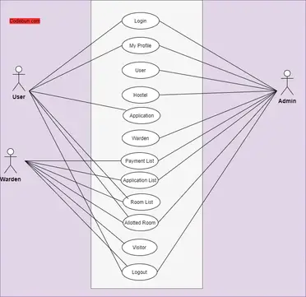

The use case diagram is usually referred to as behavior diagram used to describe the actions of all user in a system. All user describe in use case are actors and the functionality as action of system.

The Use case diagram is a collection of diagram and text together that make action on goal of a process.

* 1. **Data Flow Diagram’s:**

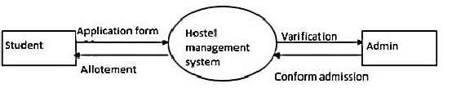

Figure 5.5.1

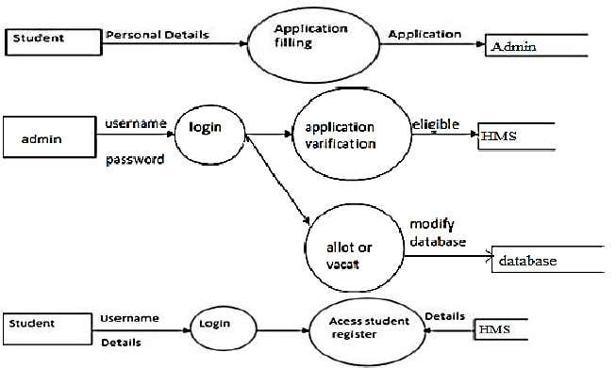

Figure 5.5.2

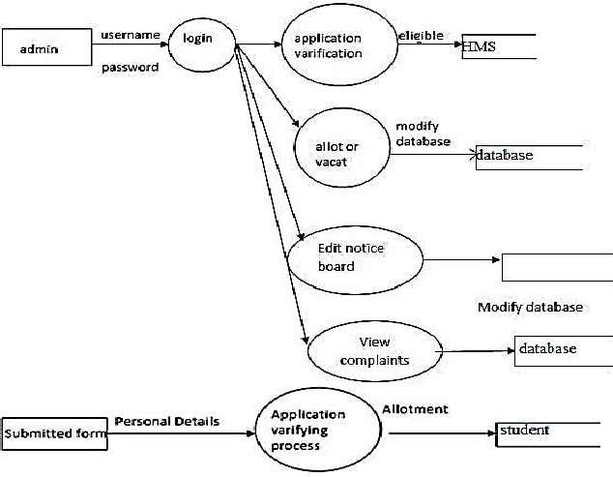

Figure 5.5.3

**5.6 ER-Diagram:**

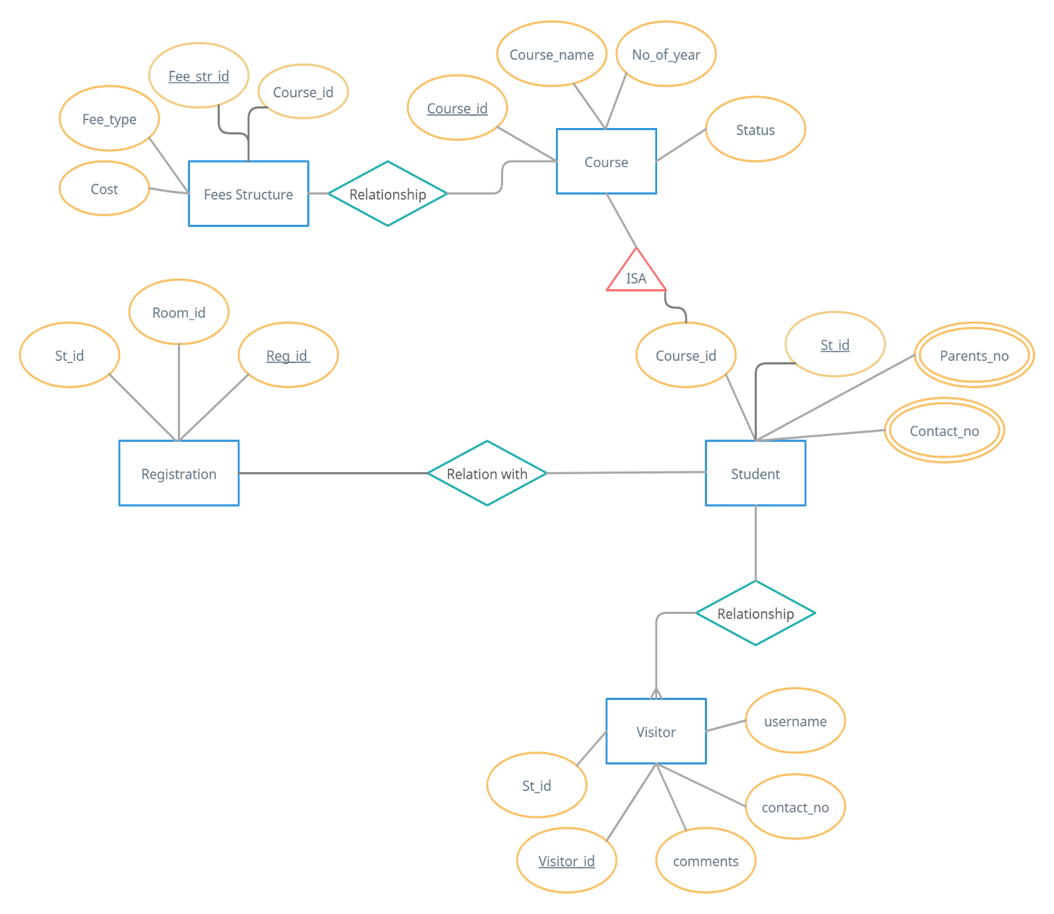

Continuation of fee structure and registration entity

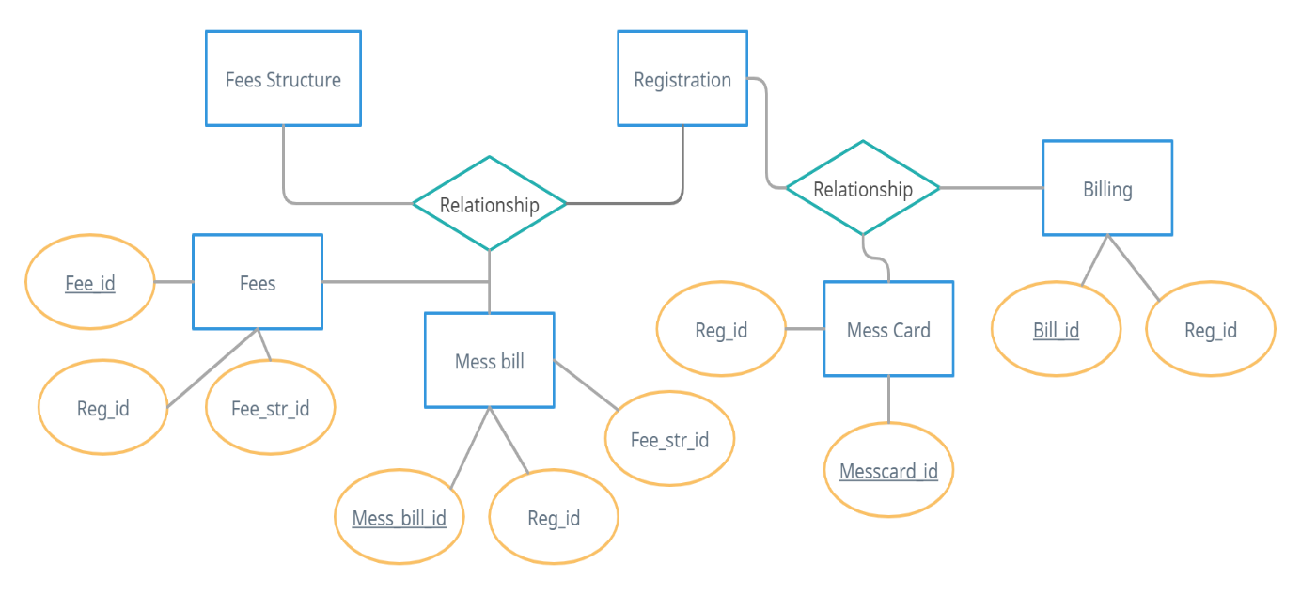

Continuation of course entity

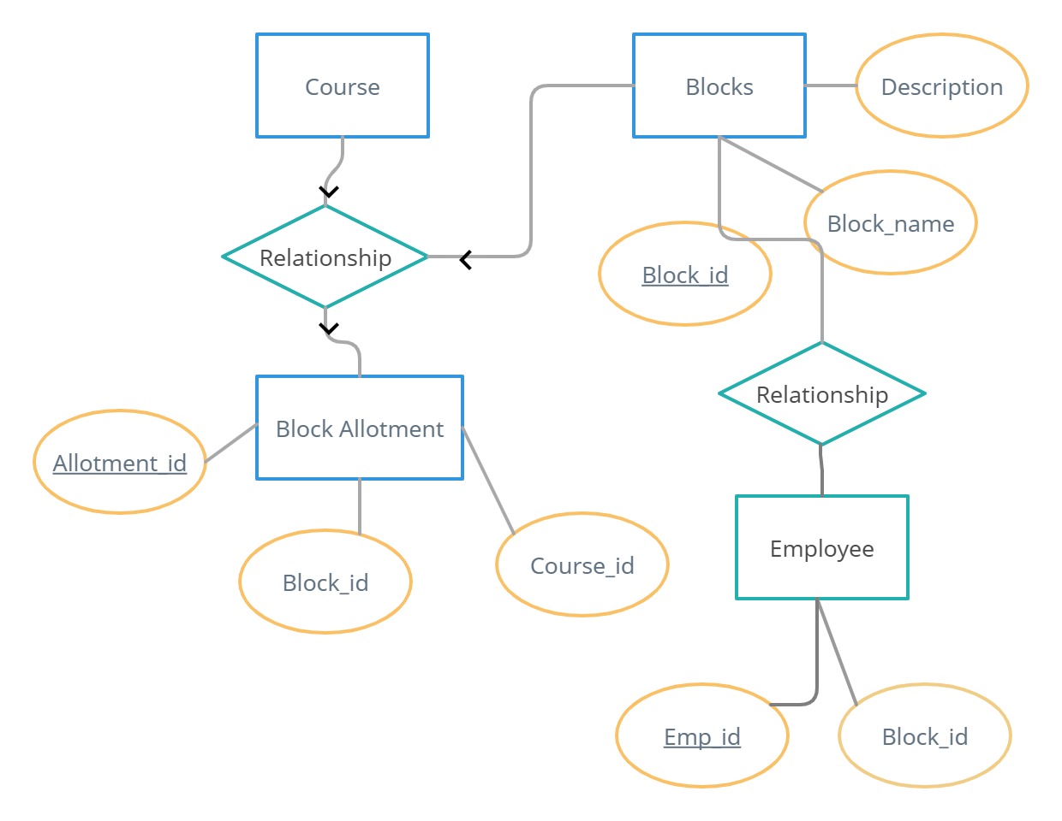

Figure 5.6.1

1. **.7 Database Tables:**

## **Billing Table**

|  |  |  |
| --- | --- | --- |
| Field | Type | Constraint |
| Bill_id | Int | Primary Key |
| Reg_id | Int | Not Null |
| Bill_type | Varchar(40) | Not Null |
| Paid_amt | Double | Not Null |
| Paid_date | Date | Not Null |

## **Blocks Table**

|  |  |  |
| --- | --- | --- |
| Field | Type | Constraint |
| Block_id | Int | Primary Key |
| Block_name | Varchar (50) | Not Null |
| Gender | Varchar | Not Null |
| Description | Varchar (50) | Not Null |
| Status | Varchar | Not Null |

## **Block Allotment Table**

|  |  |  |
| --- | --- | --- |
| Field | Type | Constraint |
| Allotment_id | Int | Primary Key |
| Block_id | Int | Not Null |
| Course_id | Int | Not Null |
| Status | Varchar | Not Null |

## **Course Table**

|  |  |  |
| --- | --- | --- |
| Field | Type | Constraint |
| Course_id | Int | Primary Key |
| Course_name | Varchar | Not Null |
| No_of_year | Int | Not Null |
| Status | Varchar | Not Null |

## **Employee Table**

|  |  |  |
| --- | --- | --- |
| Field | Type | Constraint |
| Emp_id | Int | Primary Key |
| Block_id | Int | Not Null |
| Login_id | Varchar | Not Null |
| Password | Varchar | Not Null |
| Emp_type | Varchar | Not Null |
| Emp_name | Varchar (50) | Not Null |
| Gender | Varchar | Not Null |
| DOB | Date | Not Null |
| DOJ | date | Not Null |

## **Fees Table**

|  |  |  |
| --- | --- | --- |
| Field | Type | Constraint |
| Fee_id | Int | Primary Key |
| Reg_id | Int | Not Null |
| Fee_str_id | Int | Not Null |
| Total_fees | Double | Not Null |
| Status | Varchar | Not Null |

## **Fees Structure Table**

|  |  |  |
| --- | --- | --- |
| Field | Type | Constraint |
| Fee_str_id | Int | Primary Key |
| Course_id | Int | Not Null |
| Fee_type | Varchar | Not Null |
| Cost | float | Not Null |

## **Mess Card Table**

|  |  |  |
| --- | --- | --- |
| Field | Type | Constraint |
| Messcard_id | Int | Primary Key |
| Reg_id | Int | Not Null |
| Messcard_type | Varchar | Not Null |
| Start date | Date | Not Null |
| Enddate | Date | Not Null |
| Status | Varchar | Not Null |

## **Mess Bill Table**

|  |  |  |
| --- | --- | --- |
| Field | Type | Constraint |
| Mess_bill_id | Int | Primary Key |
| Reg_id | Int | Not Null |
| Fee_str_id | Int | Not Null |
| Date | Date | Not Null |
| Mess_bill | Double | Not Null |
| Status | Varchar | Not Null |

## **Visitor Table**

|  |  |  |
| --- | --- | --- |
| Field | Type | Constraint |
| Visitor_id | Int | Primary Key |
| Stid | Int | Not Null |
| Name | Varchar | Not Null |
| Type | Varchar | Not Null |
| Username | Varchar | Not Null |
| Password | Varchar | Not Null |
| Contactno | Varchar | Not Null |
| Comments | Varchar | Not Null |
|  |  |  |
| Status | Varchar | Not Null |

## **Registration Table**

|  |  |  |
| --- | --- | --- |
| Field | Type | Constraint |
| Reg_id | Int | Primary Key |
| Stid | Int | Not Null |
| Room_id | Int | Not Null |
| Stud_type | Varchar | Not Null |
| Start_date | Date | Not Null |
| End_date | Date | Not Null |
| Food_type | Varchar | Not Null |
| Beverage_type | Varchar | Not Null |
| Status | Varchar | Not Null |

## **Student Table**

|  |  |  |
| --- | --- | --- |
| Field | Type | Constraint |
| Stid | Int | Primary Key |
| Courseid | Int | Not Null |
| Name | Varchar | Not Null |
| Rollno | Varchar | Not Null |
| DOB | Date | Not Null |
| Father_name | Varchar | Not Null |
| Mother_name | Varchar | Not Null |
| Gender | Varchar | Not Null |
| Contact_no | Varchar | Not Null |
| Parents_no | varchar | Not Null |
| Blood_group | Varchar | Not Null |
| Status | Varchar | Not Null |

# 6: CONCLUSION AND FUTURE ENHANCEMENT

**Conclusion:**

To conclude the description about the project, the project, developed using PHP with SQL is based on the requirement specification of the user and the analysis of the existing system, with flexibility for future enhancement. HOSTEL MANAGEMENT SYSTEM is very useful for hostel allotment and mess fee calculation. This hostel management software is designed for people who want to manage various activities in the hostel. For the past few years the numbers of educational institutions are increasing rapidly. Thereby the numbers of hostels are also increasing for the accommodation of the students studying in this institution. And hence there is a lot of strain on the person who are running the hostel and software’s are not usually used in this context.

This particular project deals with the problems on managing a hostel and avoids the problems which occur when carried manually. Identification of the drawbacks of the existing system leads to the designing of computerized system that will be compatible to the existing system with the system which is more user friendly and more GUI oriented.

**Scope for future development:**

An online hostel management system can benefit from many future developments. Here are some ideas:

Integration with Access Control Systems: Integrating the hostel management system with an access control system can automate the process of granting access to rooms, common areas, and facilities to guests and staff. This can also help to improve security and reduce the risk of theft and unauthorized access.

Online Payment System: Adding an online payment system can allow guests to pay for their bookings, deposits, and other fees online. This can help to improve the booking process and reduce the workload for the hostel staff.

Personalized Marketing: Developing a personalized marketing system can help to increase bookings and revenue. This system can use guest data to create targeted marketing campaigns that promote the hostel's facilities, services, and events.

Sustainability Metrics: Developing sustainability metrics can help to monitor and reduce the hostel's environmental impact. This system can track metrics like water and energy consumption, waste generation, and carbon emissions, and provide insights on how to improve sustainability.

# *ANNEXURE-B*

# 7: SOURCE CODE

The programming code that is written by a programmer in a particular computer language. It includes the instructions that tell a computer what to do and how to do it. Here is the Source Code for the Mini Project on ‘Hostel Management System’:

*🡪PHP CODES USED IN THE PROJECT:*

**Database connection Creation (Login.inc.php)**

<?php

if (isset($_POST['login-submit'])) {

  require 'config.inc.php';

  $roll = $_POST['student_roll_no'];

  $password = $_POST['pwd'];

  if (empty($roll) || empty($password)) {

    header("Location: ../index.php?error=emptyfields");

    exit();

  }

  else {

    $sql = "SELECT *FROM Student1 WHERE Student_id = '$roll'";

    $result = mysqli_query($conn, $sql);

    if($row = mysqli_fetch_assoc($result)){

      $pwdCheck = password_verify($password, $row['Pwd']);

      if($pwdCheck == false){

        header("Location: ../home.php?login=success");

        // header("Location: ../index.php?error=wrongpwd");

        exit();

      }

      else if($pwdCheck == true) {

        //session_start();

        $_SESSION['roll'] = $row['Student_id'];

        $_SESSION['fname'] = $row['Fname'];

        $_SESSION['lname'] = $row['Lname'];

        $_SESSION['mob_no'] = $row['Mob_no'];

        $_SESSION['department'] = $row['Dept'];

        $_SESSION['year_of_study'] = $row['Year_of_study'];

        $_SESSION['hostel_id'] = $row['Hostel_id'];

        $_SESSION['room_id'] = $row['Room_id'];

        if(isset($_SESSION['department'])){

          echo "<script type='text/javascript'>alert('Set')</script>";

        }

        else {

          echo "<script type='text/javascript'>alert('Not SET')</script>";

        }

        echo $_SESSION['lname'];

        header("Location: ../home.php?login=success");

        exit();

      }

      else {

        header("Location: ../index.php?error=strangeerr");

        exit();

      }

    }

    else{

      header("Location: ../index.php?error=nouser");

      exit();

    }

  }

}

else {

  header("Location: ../index.php");

  exit();

}

**Database Connection Check (config.inc.php)**

<?php

  session_start();

  $servername = "localhost"; //change this  accordingly

  $dBUsername = "root";

  $dBPassword = "";

  $dBName = "hostel_management_system";

 // session_start();

  $conn=mysqli_connect($servername, $dBUsername, $dBPassword, $dBName);

  if (!$conn) {

    die("Connection Failed: ".mysqli_connect_error());

  }

?>

**Login Page (index.php)**

<!DOCTYPE html>

<html lang="en">

<head>

    <title>HMS</title>

    <!-- meta tags -->

    <meta charset="UTF-8" />

    <meta name="viewport" content="width=device-width, initial-scale=1.0" />

    <meta name="keywords" content="Art Sign Up Form Responsive Widget, Audio and Video players, Login Form Web Template, Flat Pricing Tables, Flat Drop-Downs, Sign-Up Web Templates,

        Flat Web Templates, Login Sign-up Responsive Web Template, Smartphone Compatible Web Template, Free Web Designs for Nokia, Samsung, LG, Sony Ericsson, Motorola Web Design"

    />

    <!-- /meta tags -->

    <!-- custom style sheet -->

    <link href="web/css/style.css" rel="stylesheet" type="text/css" />

    <!-- /custom style sheet -->

    <!-- fontawesome css -->

    <link href="web/css/fontawesome-all.css" rel="stylesheet" />

    <!-- /fontawesome css -->

    <!-- google fonts-->

    <link href="//fonts.googleapis.com/css?family=Raleway:100,100i,200,200i,300,300i,400,400i,500,500i,600,600i,700,700i,800,800i,900,900i"

        rel="stylesheet">

    <!-- /google fonts-->

</head>

<body>

    <h1>Hostel Management System</h1>

    <div class=" w3l-login-form">

        <h2>Student Login</h2>

        <form action="includes/login.inc.php" method="POST">

            <div class=" w3l-form-group">

                <label>Student Roll No:</label>

                <div class="group">

                    <i class="fas fa-user"></i>

                    <input type="text" class="form-control" name="student_roll_no" placeholder="Roll No" required="required" />

                </div>

            </div>

            <div class=" w3l-form-group">

                <label>Password:</label>

                <div class="group">

                    <i class="fas fa-unlock"></i>

                    <input type="password" class="form-control" name="pwd" placeholder="Password" required="required" />

                </div>

            </div>

            <!--<div class="forgot">

                <a href="#">Forgot Password?</a>

                <p><input type="checkbox">Remember Me</p>

            </div>-->

            <button type="submit" name="login-submit">Login</button>

        </form>

          <p class=" w3l-register-p">Login as<a href="login-hostel_manager.php" class="register"> Hostel-Manager/Admin</a></p>

        <p class=" w3l-register-p">Don't have an account?<a href="signup.php" class="register"> Sign up</a></p>

    </div>

    <footer>

        <p class="copyright-agileinfo"> &copy; 2023 Final Project. All Rights Reserved | Design by <a href="https://www.linkedin.com/in/justin-thomas-b81885230">Justin Thomas</a></p>

    </footer>

</body>

</html>

**Hostel manager login Page (login-hostel_manager.php)**

<!DOCTYPE html>

<html lang="en">

<head>

    <title>HMS</title>

    <!-- meta tags -->

    <meta charset="UTF-8" />

    <meta name="viewport" content="width=device-width, initial-scale=1.0" />

    <meta name="keywords" content="Art Sign Up Form Responsive Widget, Audio and Video players, Login Form Web Template, Flat Pricing Tables, Flat Drop-Downs, Sign-Up Web Templates,

        Flat Web Templates, Login Sign-up Responsive Web Template, Smartphone Compatible Web Template, Free Web Designs for Nokia, Samsung, LG, Sony Ericsson, Motorola Web Design"

    />

    <!-- /meta tags -->

    <!-- custom style sheet -->

    <link href="web/css/style.css" rel="stylesheet" type="text/css" />

    <!-- /custom style sheet -->

    <!-- fontawesome css -->

    <link href="web/css/fontawesome-all.css" rel="stylesheet" />

    <!-- /fontawesome css -->

    <!-- google fonts-->

    <link href="//fonts.googleapis.com/css?family=Raleway:100,100i,200,200i,300,300i,400,400i,500,500i,600,600i,700,700i,800,800i,900,900i"

        rel="stylesheet">

    <!-- /google fonts-->

</head>

<body>

    <h1>Hostel Management System</h1>

    <div class=" w3l-login-form">

        <h2>Hostel-Manager/Admin Login</h2>

        <form action="includes/login-hm.inc.php" method="POST">

            <div class=" w3l-form-group">

                <label>Userid:</label>

                <div class="group">

                    <i class="fas fa-user"></i>

                    <input type="text" class="form-control" name="userid" placeholder="Userid" required="required" />

                </div>

            </div>

            <div class=" w3l-form-group">

                <label>Password:</label>

                <div class="group">

                    <i class="fas fa-unlock"></i>

                    <input type="password" class="form-control" name="pwd" placeholder="Password" required="required" />

                </div>

            </div>

            <!--<div class="forgot">

                <a href="#">Forgot Password?</a>

                <p><input type="checkbox">Remember Me</p>

            </div>-->

            <button type="submit" name="login-submit">Login</button>

        </form>

          <p class=" w3l-register-p">Login as<a href="index.php" class="register"> Student</a></p>

      <!--  <p class=" w3l-register-p">Don't have an account?<a href="signup.php" class="register"> Sign up</a></p>-->

    </div>

    <footer>

        <p class="copyright-agileinfo"> &copy; 2023 Final Project. All Rights Reserved | Design by <a href="https://www.linkedin.com/in/justin-thomas-b81885230">Justin Thomas</a></p>

    </footer>

</body>

</html>

**Sign up page (signup.php)**

<!DOCTYPE html>

<html lang="en">

<head>

    <title>SIGNUP PAGE</title>

    <!-- meta tags -->

    <meta charset="UTF-8" />

    <meta name="viewport" content="width=device-width, initial-scale=1.0" />

    <meta name="keywords" content="Art Sign Up Form Responsive Widget, Audio and Video players, Login Form Web Template, Flat Pricing Tables, Flat Drop-Downs, Sign-Up Web Templates,

        Flat Web Templates, Login Sign-up Responsive Web Template, Smartphone Compatible Web Template, Free Web Designs for Nokia, Samsung, LG, Sony Ericsson, Motorola Web Design"

    />

    <!-- /meta tags -->

    <!-- custom style sheet -->

    <link href="web/css/style.css" rel="stylesheet" type="text/css" />

    <!-- /custom style sheet -->

    <!-- fontawesome css -->

    <link href="web/css/fontawesome-all.css" rel="stylesheet" />

    <!-- /fontawesome css -->

    <!-- google fonts-->

<link href="//fonts.googleapis.com/css?family=Raleway:100,100i,200,200i,300,300i,400,400i,500,500i,600,600i,700,700i,800,800i,900,900i"

        rel="stylesheet">

    <!-- /google fonts-->

</head>

<body>

    <h1>Hostel Management System</h1>

    <div class=" w3l-login-form">

        <h2>Sign Up Here</h2>

        <form action="includes/signup.inc.php" method="POST">

            <div class=" w3l-form-group">

                <label>Student Roll No</label>

                <div class="group">

                    <i class="fas fa-id-badge"></i>

                    <input type="text" class="form-control" name="student_roll_no" placeholder="Roll No" required="required" />

                </div>

            </div>

            <div class=" w3l-form-group">

                <label>First Name</label>

                <div class="group">

                    <i class="fas fa-user"></i>

                    <input type="text" class="form-control" name="student_fname" placeholder="First Name" required="required" />

                </div>

            </div>

            <div class=" w3l-form-group">

                <label>Last Name</label>

                <div class="group">

                    <i class="fas fa-user"></i>

                    <input type="text" class="form-control" name="student_lname" placeholder="Last Name" required="required" />

                </div>

            </div>

            <div class=" w3l-form-group">

                <label>Mobile No</label>

                <div class="group">

                    <i class="fas fa-phone"></i>

                    <input type="text" class="form-control" name="mobile_no" placeholder="Mobile No" required="required" />

                </div>

</div>

            <div class=" w3l-form-group">

                <label>Department</label>

                <div class="group">

                    <i class="fas fa-graduation-cap"></i>

                    <input type="text" class="form-control" name="department" placeholder="Department" required="required" />

                </div>

            </div>

            <div class=" w3l-form-group">

                <label>Year of Study</label>

                <div class="group">

                    <i class="fas fa-calendar"></i>

                    <input type="text" class="form-control" name="year_of_study" placeholder="Year of Study" required="required" />

                </div>

            </div>

          <!--  <div class=" w3l-form-group">

                <label>Email:</label>

                <div class="group">

                    <i class="fas fa-envelope"></i>

                    <input type="text" class="form-control" name="mail" placeholder="Email" required="required" />

                </div>

            </div>-->

            <div class=" w3l-form-group">

                <label>Password:</label>

                <div class="group">

                    <i class="fas fa-unlock"></i>

                    <input type="password" class="form-control" name="pwd" placeholder="Password" required="required" />

                </div>

            </div>

            <div class=" w3l-form-group">

                <label>Confirm Password:</label>

                <div class="group">

                    <i class="fas fa-unlock"></i>

                    <input type="password" class="form-control" name="confirmpwd" placeholder="Confirm Password" required="required" />

                </div>

            </div>

            <!--<div class="forgot">

                <a href="#">Forgot Password?</a>

<p><input type="checkbox">Remember Me</p>

            </div>-->

            <button type="submit" name="signup-submit">Sign Up</button>

        </form>

        <p class=" w3l-register-p">Already a member?<a href="index.php" class="register"> Login</a></p>

    </div>

    <footer>

        <p class="copyright-agileinfo"> &copy; 2023 Final Project. All Rights Reserved | Design by <a href="https://www.linkedin.com/in/justin-thomas-b81885230">Justin Thomas</a></p>

    </footer>

</body>

</html>

**Sign up page configuration (signup.inc.php)**

<?php

if (isset($_POST['signup-submit'])) {

  require 'config.inc.php';

  $roll = $_POST['student_roll_no'];

  $fname = $_POST['student_fname'];

  $lname = $_POST['student_lname'];

  $mobile = $_POST['mobile_no'];

  $dept = $_POST['department'];

  $year = $_POST['year_of_study'];

  $password = $_POST['pwd'];

  $cnfpassword = $_POST['confirmpwd'];

  if(!preg_match("/^[a-zA-Z0-9]*$/",$roll)){

    header("Location: ../signup.php?error=invalidroll");

    exit();

  }

  else if($password !== $cnfpassword){

    header("Location: ../signup.php?error=passwordcheck");

    exit();

  }

  else {

    $sql = "SELECT Student_id FROM Student1 WHERE Student_id=?";

$stmt = mysqli_stmt_init($conn);

    if(!mysqli_stmt_prepare($stmt, $sql)){

      header("Location: ../signup.php?error=sqlerror");

      exit();

    }

    else {

      mysqli_stmt_bind_param($stmt, "s", $roll);

      mysqli_stmt_execute($stmt);

      mysqli_stmt_store_result($stmt);

      $resultCheck = mysqli_stmt_num_rows($stmt);

      if ($resultCheck > 0) {

        header("Location: ../signup.php?error=userexists");

        exit();

      }

      else {

        $sql = "INSERT INTO Student1 (Student_id, Fname, Lname, Mob_no, Dept, Year_of_study, Pwd) VALUES (?, ?, ?, ?, ?, ?, ?)";

        $stmt = mysqli_stmt_init($conn);

        if(!mysqli_stmt_prepare($stmt, $sql)){

          header("Location: ../signup.php?error=sqlerror");

          exit();

        }

        else {

          $hashedPwd = password_hash($password, PASSWORD_DEFAULT);

          mysqli_stmt_bind_param($stmt, "sssssss",$roll, $fname, $lname, $mobile, $dept, $year, $hashedPwd);

          mysqli_stmt_execute($stmt);

          header("Location: ../index.php?signup=success");

          exit();

        }

      }

    }

  }

  mysqli_stmt_close($stmt);

  mysqli_close($conn);

}

else {

  header("Location: ../signup.php");

  exit();

}

**Homepage (home.php)**

<?php

 require 'includes/config.inc.php';

?>

<!DOCTYPE html>

<html lang="en">

<head>

<title> Intrend Interior Category Flat Bootstrap Responsive Website Template | Index : W3layouts</title>

    <!-- Meta tag Keywords -->

    <meta name="viewport" content="width=device-width, initial-scale=1">

    <meta charset="utf-8">

    <meta name="keywords" content="Intrend Responsive web template, Bootstrap Web Templates, Flat Web Templates, Android Compatible web template,

    Smartphone Compatible web template, free webdesigns for Nokia, Samsung, LG, SonyEricsson, Motorola web design" />

    <script type="application/x-javascript">

        addEventListener("load", function () {

            setTimeout(hideURLbar, 0);

        }, false);

        function hideURLbar() {

            window.scrollTo(0, 1);

        }

    </script>

    <!--// Meta tag Keywords -->

    <link href="web_home/css_home/slider.css" type="text/css" rel="stylesheet" media="all">

    <!-- css files -->

    <link rel="stylesheet" href="web_home/css_home/bootstrap.css"> <!-- Bootstrap-Core-CSS -->

    <link rel="stylesheet" href="web_home/css_home/style.css" type="text/css" media="all"/> <!-- Style-CSS -->

    <link rel="stylesheet" href="web_home/css_home/fontawesome-all.css"> <!-- Font-Awesome-Icons-CSS -->

    <!-- //css files -->

    <!-- testimonials css -->

    <link rel="stylesheet" href="web_home/css_home/flexslider.css" type="text/css" media="screen" property="" /><!-- flexslider css -->

    <!-- //testimonials css -->

    <!-- web-fonts -->

    <link href="//fonts.googleapis.com/css?family=Poiret+One&amp;subset=cyrillic,latin-ext" rel="stylesheet">

    <!-- //web-fonts -->

</head>

<body>

<!-- banner -->

    <div class="banner" id="home">

        <div class="cd-radial-slider-wrapper">

<!--Header-->

<header>

    <div class="container agile-banner_nav">

        <nav class="navbar navbar-expand-lg navbar-light bg-light">

            <h1><a class="navbar-brand" href="home.php">HMS <span class="display"></span></a></h1>

            <button class="navbar-toggler" type="button" data-toggle="collapse" data-target="#navbarSupportedContent" aria-controls="navbarSupportedContent" aria-expanded="false" aria-label="Toggle navigation">

            <span class="navbar-toggler-icon"></span>

            </button>

            <div class="collapse navbar-collapse justify-content-center" id="navbarSupportedContent">

                <ul class="navbar-nav ml-auto">

                    <li class="nav-item active">

                        <a class="nav-link" href="home.php">Home <span class="sr-only">(current)</span></a>

                    </li>

                    <li class="nav-item">

                        <a class="nav-link" href="third.php">Hostels</a>

                    </li>

                    <li class="nav-item">

                        <a class="nav-link" href="contact.php">Contact</a>

                    </li>

                    <li class="nav-item">

                        <a class="nav-link" href="message_user.php">Message Received</a>

                    </li>

                    <li class="dropdown nav-item">

                        <a href="#" class="dropdown-toggle nav-link" data-toggle="dropdown"><?php echo $_SESSION['roll']; ?>

                            <b class="caret"></b>

                        </a>

                        <ul class="dropdown-menu agile_short_dropdown">

                            <li>

                                <a href="profile.php">My Profile</a>

                            </li>

                            <li>

                                <a href="includes/logout.inc.php">Logout</a>

                            </li>

                        </ul>

                    </li>

                </ul>

            </div>

        </nav>

    </div>

</header>

<!--Header-->

            <ul class="cd-radial-slider" data-radius1="60" data-radius2="1364" data-centerx1="110" data-centerx2="1290">

                <li class="visible">

                    <div class="svg-wrapper">

                        <svg viewBox="0 0 1400 800">

                            <title>Animated SVG</title>

                            <defs>

                                <clipPath id="cd-image-1">

                                    <circle id="cd-circle-1" cx="110" cy="400" r="1364"/>

                                </clipPath>

                            </defs>

                            <image height='800px' width="1400px" clip-path="url(#cd-image-1)" xlink:href="web_home/images/1.png"></image>

                        </svg>

                    </div> <!-- .svg-wrapper -->

                    <div class="cd-radial-slider-content">

                        <div class="wrapper">

                            <div class="text-center">

                                <h2>Hostel Management </h2>

                                <h3> System </h3>

                            </div>

                        </div>

                    </div> <!-- .cd-radial-slider-content -->

</li>

                <li class="next-slide">

                    <div class="svg-wrapper">

                        <svg viewBox="0 0 1400 800">

                            <title>Animated SVG</title>

                            <defs>

                                <clipPath id="cd-image-2">

                                    <circle id="cd-circle-2" cx="1290" cy="400" r="60"/>

                                </clipPath>

                            </defs>

                            <image height='800px' width="1400px" clip-path="url(#cd-image-2)" xlink:href="web_home/images/2.png"></image>

                        </svg>

                    </div> <!-- .svg-wrapper -->

                    <div class="cd-radial-slider-content text-center">

                        <div class="wrapper">

                            <div class="text-center">

                                <h3>Rooms</h3>

                            </div>

                        </div>

                    </div> <!-- .cd-radial-slider-content -->

                </li>

                <li>

                    <div class="svg-wrapper">

                        <svg viewBox="0 0 1400 800">

                            <title>Animated SVG</title>

                            <defs>

                                <clipPath id="cd-image-3">

                                    <circle id="cd-circle-3" cx="110" cy="400" r="60"/>

                                </clipPath>

                            </defs>

                            <image height='800px' width="1400px" clip-path="url(#cd-image-3)" xlink:href="web_home/images/3.png"></image>

                        </svg>

                    </div> <!-- .svg-wrapper -->

                    <div class="cd-radial-slider-content text-center">

                        <div class="wrapper">

                            <div class="text-center">

                                <h3>Hostels</h3>

                            </div>

                        </div>

                    </div> <!-- .cd-radial-slider-content -->

                </li>

            </ul> <!-- .cd-radial-slider -->

            <ul class="cd-radial-slider-navigation">

                <li><a href="#0" class="next"><i class="fas fa-chevron-right"></i></a></li>

                <li><a href="#0" class="prev"><i class="fas fa-chevron-left"></i></a></li>

            </ul> <!-- .cd-radial-slider-navigation -->

        </div> <!-- .cd-radial-slider-wrapper -->

    </div>

<!-- //banner -->

<!-- about -->

<!-- why choose us -->

<!-- team -->

<!-- Clients -->

<!-- footer -->

<footer class="py-5">

    <div class="container py-md-5">

        <div class="footer-logo mb-5 text-center">

            <a class="navbar-brand" href="#" target="_blank">HMS <span class="display"> JAIPUR</span></a>

        </div>

        <div class="footer-grid">

            <div class="list-footer">

                <ul class="footer-nav text-center">

                    <li>

                        <a href="home.php">Home</a>

                    </li>

                    <li>

                        <a href="third.php">Hostels</a>

                    </li>

                    <li>

                        <a href="contact.php">Contact</a>

                    </li>

                    <li>

                        <a href="profile.php">Profile</a>

                    </li>

  </ul>

            </div>

        </div>

    </div>

</footer>

<!-- footer -->

<!-- js-scripts -->

    <!-- js -->

    <script type="text/javascript" src="web_home/js/jquery-2.2.3.min.js"></script>

    <script type="text/javascript" src="web_home/js/bootstrap.js"></script> <!-- Necessary-JavaScript-File-For-Bootstrap -->

    <!-- //js -->

    <!-- banner js -->

    <script src="web_home/js/snap.svg-min.js"></script>

    <script src="web_home/js/main.js"></script> <!-- Resource jQuery -->

    <!-- //banner js -->

    <!-- flexSlider --><!-- for testimonials -->

    <script defer src="web_home/js/jquery.flexslider.js"></script>

    <script type="text/javascript">

        $(window).load(function(){

          $('.flexslider').flexslider({

            animation: "slide",

            start: function(slider){

              $('body').removeClass('loading');

            }

          });

        });

    </script>

    <!-- //flexSlider --><!-- for testimonials -->

    <!-- start-smoth-scrolling -->

    <script src="web_home/js/SmoothScroll.min.js"></script>

    <script type="text/javascript" src="web_home/js/move-top.js"></script>

    <script type="text/javascript" src="web_home/js/easing.js"></script>

    <script type="text/javascript">

        jQuery(document).ready(function($) {

            $(".scroll").click(function(event){

                event.preventDefault();

                $('html,body').animate({scrollTop:$(this.hash).offset().top},1000);

            });

        });

    </script>

    <!-- here stars scrolling icon -->

    <script type="text/javascript">

        $(document).ready(function() {

            /*

                var defaults = {

                containerID: 'toTop', // fading element id

                containerHoverID: 'toTopHover', // fading element hover id

                scrollSpeed: 1200,

                easingType: 'linear'

                };

            */

            $().UItoTop({ easingType: 'easeOutQuart' });

            });

    </script>

    <!-- //here ends scrolling icon -->

    <!-- start-smoth-scrolling -->

<!-- //js-scripts -->

</body>

</html>

**Hostels page (third.php)**

<!doctype html>

<html lang="en">

  <head>

    <meta charset="utf-8">

    <meta name="viewport" content="width=device-width, initial-scale=1">

    <title>Bootstrap demo</title>

    <link href="https://cdn.jsdelivr.net/npm/bootstrap@5.3.0-alpha1/dist/css/bootstrap.min.css" rel="stylesheet" integrity="sha384-GLhlTQ8iRABdZLl6O3oVMWSktQOp6b7In1Zl3/Jr59b6EGGoI1aFkw7cmDA6j6gD" crossorigin="anonymous">

    <script type="application/x-javascript">

        addEventListener("load", function () {

            setTimeout(hideURLbar, 0);

        }, false);

        function hideURLbar() {

            window.scrollTo(0, 1);

        }

    </script>

    <!--// Meta tag Keywords -->

    <!-- css files -->

    <link rel="stylesheet" href="web_home/css_home/bootstrap.css"> <!-- Bootstrap-Core-CSS -->

    <link rel="stylesheet" href="web_home/css_home/style.css" type="text/css" media="all" /> <!-- Style-CSS -->

    <link rel="stylesheet" href="web_home/css_home/fontawesome-all.css"> <!-- Font-Awesome-Icons-CSS -->

    <!-- //css files -->

    <!-- web-fonts -->

    <link href="//fonts.googleapis.com/css?family=Poiret+One&amp;subset=cyrillic,latin-ext" rel="stylesheet">

    <link href="//fonts.googleapis.com/css?family=Open+Sans:300,300i,400,400i,600,600i,700,700i,800,800i&amp;subset=cyrillic,cyrillic-ext,greek,greek-ext,latin-ext,vietnamese" rel="stylesheet">

    <!-- //web-fonts -->

</head>

<body style="background-image: url('images/bg-registration-form-7.jpg');">

    <!-- banner -->

<div class="inner-page-banner" id="home">

    <!--Header-->

    <header>

        <div class="container agile-banner_nav">

            <nav class="navbar navbar-expand-lg navbar-light bg-light">

                <h1><a class="navbar-brand" href="home.php">HMS <span class="display"></span></a></h1>

                <button class="navbar-toggler" type="button" data-toggle="collapse" data-target="#navbarSupportedContent" aria-controls="navbarSupportedContent" aria-expanded="false" aria-label="Toggle navigation">

                <span class="navbar-toggler-icon"></span>

                </button>

                <div class="collapse navbar-collapse justify-content-center" id="navbarSupportedContent">

                    <ul class="navbar-nav ml-auto">

                        <li class="nav-item">

                            <a class="nav-link" href="home.php">Home <span class="sr-only">(current)</span></a>

                        </li>

                        <li class="nav-item active">

                            <a class="nav-link" href="third.php">Hostels</a>

                        </li>

                        <li class="nav-item ">

                            <a class="nav-link" href="contact.php">Contact</a>

                        </li>

                        <li class="nav-item">

                        <a class="nav-link" href="message_user.php">Message Received</a>

                        </li>

                        <li class="dropdown nav-item">

                        <a href="#" class="dropdown-toggle nav-link" data-toggle="dropdown"><?php //echo $_SESSION['roll']; ?>

                            <b class="caret"></b>

                        </a>

                        <ul class="dropdown-menu agile_short_dropdown">

                            <li>

                                <a href="profile.php">My Profile</a>

                            </li>

                            <li>

                                <a href="includes/logout.inc.php">Logout</a>

                            </li>

                        </ul>

                    </li>

                    </ul>

                </div>

            </nav>

        </div>

    </header>

    <br><br><br><br><br>

    <!--Header-->

<div class="container">

    <div class="row gy-3">

        <div class="col-md-3">

            <div class="card">

            <img src="images/depositphotos_44731919-stock-photo-friends-showing-thumb-up-in.jpg" class="card-img-top" alt="...">

            <div class="card-body">

                <h5 class="card-title">Student Details</h5>

                <p class="card-text"> “The man who does not read books has no advantage over the one who cannot read them.” —Mark Twain</p>

                <a href="student_details.php" class="btn btn-primary">Go somewhere</a>

            </div>

            </div>

        </div>

        <div class="col-md-3">

            <div class="card">

            <img src="images/hostel-9-1024x682.jpg" class="card-img-top" alt="...">

            <div class="card-body">

                <h5 class="card-title">Room Reg.</h5>

                <p class="card-text">Some quick example text to build on the card title and make up the bulk of the card's content.</p>

                <a href="room.php" class="btn btn-primary">Go somewhere</a>

            </div>

            </div>

        </div>

        <div class="col-md-3">

            <div class="card">

            <img src="images/depositphotos_44731919-stock-photo-friends-showing-thumb-up-in.jpg" class="card-img-top" alt="...">

            <div class="card-body">

                <h5 class="card-title">Course</h5>

                <p class="card-text">Some quick example text to build on the card title and make up the bulk of the card's content.</p>

                <a href="course.php" class="btn btn-primary">Go somewhere</a>

            </div>

            </div>

        </div>

        <div class="col-md-3">

            <div class="card">

            <img src="images/IMG_6505.jpeg" class="card-img-top" alt="...">

            <div class="card-body">

                <h5 class="card-title">Blocks</h5>

                <p class="card-text">Some quick example text to build on the card title and make up the bulk of the card's content.</p>

                <a href="blocks.php" class="btn btn-primary">Go somewhere</a>

            </div>

            </div>

        </div>

    </div>

</div>   <br>

<div class="container">

    <div class="row gy-3">

        <div class="col-md-3">

                <div class="card" >

                    <img src="images/photo-1606787366850-de6330128bfc.jpeg" class="card-img-top" alt="...">

                    <div class="card-body">

                        <h5 class="card-title">Messcard</h5>

                        <p class="card-text">Some quick example text to build on the card title and make up the bulk of the card's content.</p>

                        <a href="mess_card.php" class="btn btn-primary">Go somewhere</a>

                    </div>

                </div>

        </div>

        <div class="col-md-3">

            <div class="card">

            <img src="images/IMG_6505.jpeg" class="card-img-top" alt="...">

            <div class="card-body">

                <h5 class="card-title">Room</h5>

                <p class="card-text">Some quick example text to build on the card title and make up the bulk of the card's content.</p>

                <a href="services.php" class="btn btn-primary">Go somewhere</a>

            </div>

            </div>

        </div>

    </div>

</div>

<br>

<!-- footer -->

<footer class="py-5">

    <div class="container py-md-5">

        <div class="footer-logo mb-5 text-center">

            <a class="navbar-brand" href="http://www.nitc.ac.in/" target="_blank">HMS <span class="display"> JAIPUR</span></a>

        </div>

        <div class="footer-grid">

            <div class="list-footer">

                <ul class="footer-nav text-center">

                    <li>

                        <a href="home.php">Home</a>

                    </li>

                    <li>

                        <a href="third.php">Hostels</a>

                    </li>

                    <li>

                        <a href="contact.php">Contact</a>

                    </li>

                    <li>

                        <a href="profile.php">Profile</a>

                    </li>

                </ul>

            </div>

        </div>

    </div>

</footer>

<!-- footer -->

<!-- js-scripts -->

    <!-- js -->

    <script type="text/javascript" src="web_home/js/jquery-2.2.3.min.js"></script>

    <script type="text/javascript" src="web_home/js/bootstrap.js"></script> <!-- Necessary-JavaScript-File-For-Bootstrap -->

    <!-- //js -->

    <!-- banner js -->

    <script src="web_home/js/snap.svg-min.js"></script>

    <script src="web_home/js/main.js"></script> <!-- Resource jQuery -->

    <!-- //banner js -->

    <!-- flexSlider --><!-- for testimonials -->

    <script defer src="web_home/js/jquery.flexslider.js"></script>

    <script type="text/javascript">

        $(window).load(function(){

          $('.flexslider').flexslider({

            animation: "slide",

            start: function(slider){

              $('body').removeClass('loading');

            }

          });

        });

    </script>

    <!-- //flexSlider --><!-- for testimonials -->

    <!-- start-smoth-scrolling -->

    <script src="web_home/js/SmoothScroll.min.js"></script>

    <script type="text/javascript" src="web_home/js/move-top.js"></script>

    <script type="text/javascript" src="web_home/js/easing.js"></script>

    <script type="text/javascript">

        jQuery(document).ready(function($) {

            $(".scroll").click(function(event){

                event.preventDefault();

                $('html,body').animate({scrollTop:$(this.hash).offset().top},1000);

            });

        });

    </script>

    <!-- here stars scrolling icon -->

    <script type="text/javascript">

        $(document).ready(function() {

            /*

                var defaults = {

                containerID: 'toTop', // fading element id

                containerHoverID: 'toTopHover', // fading element hover id

                scrollSpeed: 1200,

                easingType: 'linear'

                };

            */

            $().UItoTop({ easingType: 'easeOutQuart' });

            });

    </script>

    <!-- //here ends scrolling icon -->

    <!-- start-smoth-scrolling -->

<!-- //js-scripts -->

<script src="https://cdn.jsdelivr.net/npm/@popperjs/core@2.11.6/dist/umd/popper.min.js" integrity="sha384-oBqDVmMz9ATKxIep9tiCxS/Z9fNfEXiDAYTujMAeBAsjFuCZSmKbSSUnQlmh/jp3" crossorigin="anonymous"></script>

<script src="https://cdn.jsdelivr.net/npm/bootstrap@5.3.0-alpha1/dist/js/bootstrap.min.js" integrity="sha384-mQ93GR66B00ZXjt0YO5KlohRA5SY2XofN4zfuZxLkoj1gXtW8ANNCe9d5Y3eG5eD" crossorigin="anonymous"></script>

</body>

</html>

**Student Page (student_details.php)**

<!DOCTYPE html>

<html lang="en">

<head>

    <meta charset="UTF-8">

    <meta http-equiv="X-UA-Compatible" content="IE=edge">

    <meta name="viewport" content="width=device-width, initial-scale=1.0">

    <title>Student Table Form</title>

    <script type="application/x-javascript">

        addEventListener("load", function () {

            setTimeout(hideURLbar, 0);

        }, false);

        function hideURLbar() {

            window.scrollTo(0, 1);

        }

    </script>

    <!--// Meta tag Keywords -->

    <!-- css files -->

    <link rel="stylesheet" href="web_home/css_home/bootstrap.css"> <!-- Bootstrap-Core-CSS -->

    <link rel="stylesheet" href="web_home/css_home/style.css" type="text/css" media="all" /> <!-- Style-CSS -->

    <link rel="stylesheet" href="web_home/css_home/fontawesome-all.css"> <!-- Font-Awesome-Icons-CSS -->

    <!-- //css files -->

    <!-- web-fonts -->

    <link href="//fonts.googleapis.com/css?family=Poiret+One&amp;subset=cyrillic,latin-ext" rel="stylesheet">

    <link href="//fonts.googleapis.com/css?family=Open+Sans:300,300i,400,400i,600,600i,700,700i,800,800i&amp;subset=cyrillic,cyrillic-ext,greek,greek-ext,latin-ext,vietnamese" rel="stylesheet">

    <!-- //web-fonts -->

</head>

<body style="background-image: url('images/bg-registration-form-7.jpg');">

<!-- banner -->

<div class="inner-page-banner" id="home">

    <!--Header-->

    <header>

        <div class="container agile-banner_nav">

            <nav class="navbar navbar-expand-lg navbar-light bg-light">

                <h1><a class="navbar-brand" href="home.php">HMS <span class="display"></span></a></h1>

                <button class="navbar-toggler" type="button" data-toggle="collapse" data-target="#navbarSupportedContent" aria-controls="navbarSupportedContent" aria-expanded="false" aria-label="Toggle navigation">

                <span class="navbar-toggler-icon"></span>

                </button>

                <div class="collapse navbar-collapse justify-content-center" id="navbarSupportedContent">

                    <ul class="navbar-nav ml-auto">

                        <li class="nav-item">

                            <a class="nav-link" href="home.php">Home <span class="sr-only">(current)</span></a>

                        </li>

                        <li class="nav-item active">

                            <a class="nav-link" href="third.php">Hostels</a>

                        </li>

                        <li class="nav-item ">

                            <a class="nav-link" href="contact.php">Contact</a>

                        </li>

                        <li class="nav-item">

                        <a class="nav-link" href="message_user.php">Message Received</a>

                        </li>

                        <li class="dropdown nav-item">

                        <a href="#" class="dropdown-toggle nav-link" data-toggle="dropdown"><?php //echo $_SESSION['roll']; ?>

                            <b class="caret"></b>

                        </a>

                        <ul class="dropdown-menu agile_short_dropdown">

                            <li>

                                <a href="profile.php">My Profile</a>

                            </li>

                            <li>

                                <a href="includes/logout.inc.php">Logout</a>

                            </li>

                        </ul>

                    </li>

                    </ul>

                </div>

            </nav>

        </div>

    </header>

    <!--Header-->

 <section class="contact py-5">

    <div class="container"><br><br><br>

        <h2 class="heading text-capitalize mb-sm-5 mb-4"> Student Details </h2>

            <div class="mail_grid_w3l">

                <div class="row">

                    <div class="col-md-6 contact_left_grid" data-aos="fade-right">

                        <form action="Database/Student_table.php" method="post" id="myForm">

                        <table align="center" border="1" cellpadding="10" style="background-size:100% 100%;color:black;font-family:arial;background:#d1e2e6">

                            <tr>

                                <td>Course</td>

                                <td><input list="Courses" name="courses" placeholder="courses" required></td>

                                <datalist id="Courses">

                                    <option value="BCA"></option>

                                    <option value="MCA"></option>

                                    <option value="BBA"></option>

                                    <option value="B.Sc."></option>

                                    <option value="BCom"></option>

                                </datalist>

                            </tr>

                            <tr>

                                <td>Name</td>

                                <td><input type="text" name="name" autofocus maxlength="50" placeholder="Enter name" required size="20">

                                </td>

                            </tr>

                            <tr>

                                <td>Roll no</td>

                                <td><input type="number" name="rollno" autofocus maxlength="10" placeholder="Enter roll no" required

                                        size="20"></td>

                            </tr>

                            <tr>

                                <td>Date of Birth</td>

                                <td><input type="date" name="DOB"></td>

                            </tr>

                            <tr>

                                <td>Father's Name</td>

                                <td><input type="text" name="fname" autofocus maxlength="50" placeholder="Enter Father's name" required

                                        size="20"></td>

                            </tr>

                            <tr>

                                <td>Mother's Name</td>

                                <td><input type="text" name="mname" autofocus maxlength="50" placeholder="Enter Mother's name" required

                                        size="20"></td>

                            </tr>

                            <tr>

                                <td>Gender</td>

                                <td>

                                    <label for="male">Male:</label>

                                    <input type="radio" name="gender" value="male">&nbsp&nbsp

                                    <label for="female">Female:</label>

                                    <input type="radio" name="gender" value="female">

                                </td>

                            </tr>

                    </table>

                </div>

                <div class="col-md-6 contact_left_grid" data-aos="fade-left">

                <table align="center" border="1" cellpadding="10" style="background-size:100% 100%;color:black;font-family:arial;background:#d1e2e6">

                <tr>

                                <td>Address</td>

                                <td><textarea name="address" cols="30" rows="2"></textarea></td>

                            </tr>

                            <tr>

                                <td>Contact No</td>

                                <td><input type="tel" name="umobile" placeholder="Enter mobile" required size="20">

                                </td>

                            </tr>

                            <tr>

                                <td>Parents No</td>

                                <td><input type="tel" name="pmobile" placeholder="Enter Parent's mobile" required size="20"></td>

                            </tr>

                            <tr>

                                <td>Blood group</td>

                                <td>

                                    <input list="bgroup" name="bloodgroup" placeholder="bgroup" required>

                                    <datalist id="bgroup">

                                        <option value="A-">

                                        <option value="A+">

                                        <option value="B-">

                                        <option value="B+">

                                        <option value="AB-">

                                        <option value="AB+">

                                        <option value="O-">

                                        <option value="O+">

                                        <option value="Golden">

                                    </datalist>

                                </td>

                            </tr>

                            <tr>

                                <td>Status</td>

                                <td>

                                    <input list="status" name="status" placeholder="status" required>

                                    <datalist id="status">

                                        <option value="Enabled">

                                        <option value="Disabled">

                                    </datalist>

                                </td>

                            </tr>

                            <tr>

                                <td colspan="2" align="left"><input type="submit" class="submit-btn" onclick="msgpass()"></td>

                            </tr>

                        </table>

                    </form>

                </div>

            </div>

        </div>

    </div>

</section>

<script>

    function msgpass(link) {

        alert('data successfully Save By Masq.');

    };

</script>

<!-- footer -->

<footer class="py-5">

    <div class="container py-md-5">

        <div class="footer-logo mb-5 text-center">

            <a class="navbar-brand" href="http://www.nitc.ac.in/" target="_blank">HMS <span class="display"> JAIPUR</span></a>

        </div>

        <div class="footer-grid">

            <div class="list-footer">

                <ul class="footer-nav text-center">

                    <li>

                        <a href="home.php">Home</a>

                    </li>

                    <li>

                        <a href="services.php">Hostels</a>

                    </li>

                    <li>

                        <a href="contact.php">Contact</a>

                    </li>

                    <li>

                        <a href="profile.php">Profile</a>

                    </li>

                </ul>

            </div>

        </div>

    </div>

</footer>

<!-- footer -->

<!-- js-scripts -->

    <!-- js -->

    <script type="text/javascript" src="web_home/js/jquery-2.2.3.min.js"></script>

    <script type="text/javascript" src="web_home/js/bootstrap.js"></script> <!-- Necessary-JavaScript-File-For-Bootstrap -->

    <!-- //js -->

    <!-- banner js -->

    <script src="web_home/js/snap.svg-min.js"></script>

    <script src="web_home/js/main.js"></script> <!-- Resource jQuery -->

    <!-- //banner js -->

    <!-- flexSlider --><!-- for testimonials -->

    <script defer src="web_home/js/jquery.flexslider.js"></script>

    <script type="text/javascript">

        $(window).load(function(){

          $('.flexslider').flexslider({

            animation: "slide",

            start: function(slider){

              $('body').removeClass('loading');

            }

          });

        });

    </script>

    <!-- //flexSlider --><!-- for testimonials -->

    <!-- start-smoth-scrolling -->

    <script src="web_home/js/SmoothScroll.min.js"></script>

    <script type="text/javascript" src="web_home/js/move-top.js"></script>

    <script type="text/javascript" src="web_home/js/easing.js"></script>

    <script type="text/javascript">

        jQuery(document).ready(function($) {

            $(".scroll").click(function(event){

                event.preventDefault();

                $('html,body').animate({scrollTop:$(this.hash).offset().top},1000);

            });

        });

    </script>

    <!-- here stars scrolling icon -->

    <script type="text/javascript">

        $(document).ready(function() {

            /*

                var defaults = {

                containerID: 'toTop', // fading element id

                containerHoverID: 'toTopHover', // fading element hover id

                scrollSpeed: 1200,

                easingType: 'linear'

                };

            */

            $().UItoTop({ easingType: 'easeOutQuart' });

            });

    </script>

    <!-- //here ends scrolling icon -->

    <!-- start-smoth-scrolling -->

<!-- //js-scripts -->

</body>

</html>

**Room Page (room.php)**

<!DOCTYPE html>

<html lang="en">

<head>

    <meta charset="UTF-8">

    <meta http-equiv="X-UA-Compatible" content="IE=edge">

    <meta name="viewport" content="width=device-width, initial-scale=1.0">

    <title>Room Table Form</title>

    <script type="application/x-javascript">

        addEventListener("load", function () {

            setTimeout(hideURLbar, 0);

        }, false);

        function hideURLbar() {

            window.scrollTo(0, 1);

        }

    </script>

    <!--// Meta tag Keywords -->

    <!-- css files -->

    <link rel="stylesheet" href="web_home/css_home/bootstrap.css"> <!-- Bootstrap-Core-CSS -->

    <link rel="stylesheet" href="web_home/css_home/style.css" type="text/css" media="all" /> <!-- Style-CSS -->

    <link rel="stylesheet" href="web_home/css_home/fontawesome-all.css"> <!-- Font-Awesome-Icons-CSS -->

    <!-- //css files -->

    <!-- web-fonts -->

    <link href="//fonts.googleapis.com/css?family=Poiret+One&amp;subset=cyrillic,latin-ext" rel="stylesheet">

    <link href="//fonts.googleapis.com/css?family=Open+Sans:300,300i,400,400i,600,600i,700,700i,800,800i&amp;subset=cyrillic,cyrillic-ext,greek,greek-ext,latin-ext,vietnamese" rel="stylesheet">

    <!-- //web-fonts -->

</head>

<body style="background-image: url('images/bg-registration-form-7.jpg');">

    <!-- banner -->

<div class="inner-page-banner" id="home">

    <!--Header-->

    <header>

        <div class="container agile-banner_nav">

            <nav class="navbar navbar-expand-lg navbar-light bg-light">

                <h1><a class="navbar-brand" href="home.php">HMS <span class="display"></span></a></h1>

                <button class="navbar-toggler" type="button" data-toggle="collapse" data-target="#navbarSupportedContent" aria-controls="navbarSupportedContent" aria-expanded="false" aria-label="Toggle navigation">

                <span class="navbar-toggler-icon"></span>

                </button>

                <div class="collapse navbar-collapse justify-content-center" id="navbarSupportedContent">

                    <ul class="navbar-nav ml-auto">

                        <li class="nav-item">

                            <a class="nav-link" href="home.php">Home <span class="sr-only">(current)</span></a>

                        </li>

                        <li class="nav-item active">

                            <a class="nav-link" href="services.php">Hostels</a>

                        </li>

                        <li class="nav-item ">

                            <a class="nav-link" href="contact.php">Contact</a>

                        </li>

                        <li class="nav-item">

                        <a class="nav-link" href="message_user.php">Message Received</a>

                        </li>

                        <li class="dropdown nav-item">

                        <a href="#" class="dropdown-toggle nav-link" data-toggle="dropdown"><?php //echo $_SESSION['roll']; ?>

                            <b class="caret"></b>

                        </a>

                        <ul class="dropdown-menu agile_short_dropdown">

                            <li>

                                <a href="profile.php">My Profile</a>

                            </li>

                            <li>

                                <a href="includes/logout.inc.php">Logout</a>

                            </li>

                        </ul>

                    </li>

                    </ul>

                </div>

            </nav>

        </div>

    </header>

    <!--Header-->

 <section class="contact py-5">

    <div class="container"><br><br><br>

        <h2 class="heading text-capitalize mb-sm-5 mb-4"> Room Registration </h2>

            <div class="mail_grid_w3l">

                <div class="row">

                    <div class="col-md-6 contact_left_grid" data-aos="fade-right">

                    <form action="Database/Registration_table.php" method="post">

                    <table align="center" border="1" cellpadding="10"

                        style="background-size:100% 100%;color:black;font-family:arial;background:#d1e2e6">

                        <tr>

                            <td>Student details</td>

                            <td>

                                <p>Name: raj<br>Course:Bca<br>Roll No.: 232<br>DOB: 2014-01-09<br>Gender: Male</p>

                            </td>

                        </tr>

                        <tr>

                            <td>Room details</td>

                            <td>

                                <p>Room No.:<br>No. of Beds:<br>Block Name: ABC</p>

                            </td>

                        </tr>

                        <tr>

                            <td>Student type</td>

                            <td>

                                <input list="studenttype" placeholder="select" name="studtype" required>

                                <datalist id="studenttype" >

                                    <option value="Enabled">

                                    <option value="Disabled">

                                </datalist>

                            </td>

                        </tr>

                        <tr>

                            <td>Join date</td>

                            <td><input type="date" name="join-date"></td>

                        </tr>

                    </table>

                </div>

                <div class="col-md-6 contact_left_grid" data-aos="fade-left">

                <table align="center" border="1" cellpadding="10" style="background-size:100% 100%;color:black;font-family:arial;background:#d1e2e6">

                <tr>

                            <td>End date</td>

                            <td><input type="date" name="end-date"></td>

                        </tr>

                        <tr>

                            <td>Food type</td>

                            <td>

                                <input list="food" placeholder="select" name="food" required>

                                <datalist id="food">

                                    <option value="Banana">

                                    <option value="Burger">

                                </datalist>

                            </td>

                        </tr>

                        <tr>

                            <td>Beverage type</td>

                            <td>

                                <input list="beverage" placeholder="select" name="beverage" required>

                                <datalist id="beverage">

                                    <option value="Coca cola">

                                    <option value="Lemon-juice">

                                </datalist>

                            </td>

                        </tr>

                        <tr>

                            <td colspan="2" align="center"><input type="submit"></td>

                        </tr>

                        </table>

                    </form>

                </div>

            </div>

        </div>

    </div>

</section>

<!-- footer -->

<footer class="py-5">

    <div class="container py-md-5">

        <div class="footer-logo mb-5 text-center">

            <a class="navbar-brand" href="http://www.nitc.ac.in/" target="_blank">HMS <span class="display"> JAIPUR</span></a>

        </div>

        <div class="footer-grid">

            <div class="list-footer">

                <ul class="footer-nav text-center">

                    <li>

                        <a href="home.php">Home</a>

                    </li>

                    <li>

                        <a href="services.php">Hostels</a>

                    </li>

                    <li>

                        <a href="contact.php">Contact</a>

                    </li>

                    <li>

                        <a href="profile.php">Profile</a>

                    </li>

                </ul>

            </div>

        </div>

    </div>

</footer>

<!-- footer -->

<!-- js-scripts -->

    <!-- js -->

    <script type="text/javascript" src="web_home/js/jquery-2.2.3.min.js"></script>

    <script type="text/javascript" src="web_home/js/bootstrap.js"></script> <!-- Necessary-JavaScript-File-For-Bootstrap -->

    <!-- //js -->

    <!-- banner js -->

    <script src="web_home/js/snap.svg-min.js"></script>

    <script src="web_home/js/main.js"></script> <!-- Resource jQuery -->

    <!-- //banner js -->

    <!-- flexSlider --><!-- for testimonials -->

    <script defer src="web_home/js/jquery.flexslider.js"></script>

    <script type="text/javascript">

        $(window).load(function(){

          $('.flexslider').flexslider({

            animation: "slide",

            start: function(slider){

              $('body').removeClass('loading');

            }

          });

        });

    </script>

    <!-- //flexSlider --><!-- for testimonials -->

    <!-- start-smoth-scrolling -->

    <script src="web_home/js/SmoothScroll.min.js"></script>

    <script type="text/javascript" src="web_home/js/move-top.js"></script>

    <script type="text/javascript" src="web_home/js/easing.js"></script>

    <script type="text/javascript">

        jQuery(document).ready(function($) {

            $(".scroll").click(function(event){

                event.preventDefault();

                $('html,body').animate({scrollTop:$(this.hash).offset().top},1000);

            });

        });

    </script>

    <!-- here stars scrolling icon -->

    <script type="text/javascript">

        $(document).ready(function() {

            /*

                var defaults = {

                containerID: 'toTop', // fading element id

                containerHoverID: 'toTopHover', // fading element hover id

                scrollSpeed: 1200,

                easingType: 'linear'

                };

            */

            $().UItoTop({ easingType: 'easeOutQuart' });

            });

    </script>

    <!-- //here ends scrolling icon -->

    <!-- start-smoth-scrolling -->

<!-- //js-scripts -->

</body>

</html>

**Course page (course.php)**

<!DOCTYPE html>

<html lang="en">

<head>

    <meta charset="UTF-8">

    <meta http-equiv="X-UA-Compatible" content="IE=edge">

    <meta name="viewport" content="width=device-width, initial-scale=1.0">

    <title>Student Table Form</title>

    <script type="application/x-javascript">

        addEventListener("load", function () {

            setTimeout(hideURLbar, 0);

        }, false);

        function hideURLbar() {

            window.scrollTo(0, 1);

        }

    </script>

    <!--// Meta tag Keywords -->

    <!-- css files -->

    <link rel="stylesheet" href="web_home/css_home/bootstrap.css"> <!-- Bootstrap-Core-CSS -->

    <link rel="stylesheet" href="web_home/css_home/style.css" type="text/css" media="all" /> <!-- Style-CSS -->

    <link rel="stylesheet" href="web_home/css_home/fontawesome-all.css"> <!-- Font-Awesome-Icons-CSS -->

    <!-- //css files -->

    <!-- web-fonts -->

    <link href="//fonts.googleapis.com/css?family=Poiret+One&amp;subset=cyrillic,latin-ext" rel="stylesheet">

    <link href="//fonts.googleapis.com/css?family=Open+Sans:300,300i,400,400i,600,600i,700,700i,800,800i&amp;subset=cyrillic,cyrillic-ext,greek,greek-ext,latin-ext,vietnamese" rel="stylesheet">

    <!-- //web-fonts -->

</head>

<body style="background-image: url('images/bg-registration-form-7.jpg');">

<!-- banner -->

<div class="inner-page-banner" id="home">

    <!--Header-->

    <header>

        <div class="container agile-banner_nav">

            <nav class="navbar navbar-expand-lg navbar-light bg-light">

                <h1><a class="navbar-brand" href="home.php">HMS <span class="display"></span></a></h1>

                <button class="navbar-toggler" type="button" data-toggle="collapse" data-target="#navbarSupportedContent" aria-controls="navbarSupportedContent" aria-expanded="false" aria-label="Toggle navigation">

                <span class="navbar-toggler-icon"></span>

                </button>

                <div class="collapse navbar-collapse justify-content-center" id="navbarSupportedContent">

                    <ul class="navbar-nav ml-auto">

                        <li class="nav-item">

                            <a class="nav-link" href="home.php">Home <span class="sr-only">(current)</span></a>

                        </li>

                        <li class="nav-item active">

                            <a class="nav-link" href="services.php">Hostels</a>

                        </li>

                        <li class="nav-item ">

                            <a class="nav-link" href="contact.php">Contact</a>

                        </li>

                        <li class="nav-item">

                        <a class="nav-link" href="message_user.php">Message Received</a>

                        </li>

                        <li class="dropdown nav-item">

                        <a href="#" class="dropdown-toggle nav-link" data-toggle="dropdown"><?php //echo $_SESSION['roll']; ?>

                            <b class="caret"></b>

                        </a>

                        <ul class="dropdown-menu agile_short_dropdown">

                            <li>

                                <a href="profile.php">My Profile</a>

                            </li>

                            <li>

                                <a href="includes/logout.inc.php">Logout</a>

                            </li>

                        </ul>

                    </li>

                    </ul>

                </div>

            </nav>

        </div>

    </header>

    <!--Header-->

 <section class="contact py-5">

    <div class="container"><br><br><br>

        <h2 class="heading text-capitalize mb-sm-5 mb-4"> Course Details </h2>

            <div class="mail_grid_w3l">

                <div class="row">

                    <div class="col-md-6 contact_left_grid" data-aos="fade-right">

                        <form action="Database/Course_table.php" method="post" id="myForm">

                        <table align="center" border="1" cellpadding="10" style="background-size:100% 100%;color:black;font-family:arial;background:#d1e2e6">

                            <tr>

                                <td>Course</td>

                                <td><input list="Courses" name="course" placeholder="courses" required></td>

                                <datalist id="Courses">

                                    <option value="BCA"></option>

                                    <option value="MCA"></option>

                                    <option value="BBA"></option>

                                    <option value="B.Sc."></option>

                                    <option value="BCom"></option>

                                </datalist>

                            </tr>

                            <tr>

                                <td>No. of Year</td>

                                <td><input type="date" name="date"></td>

                            </tr>

                            <tr>

                            <td>Status</td>

                            <td>

                                <input list="studenttype" placeholder="select" name="status" required>

                                <datalist id="studenttype">

                                    <option value="Enabled">

                                    <option value="Disabled">

                                </datalist>

                            </td>

                        </tr>

                        <tr>

                                <td colspan="2" align="left"><input type="submit"></td>

                            </tr>

                        </table>

                        </form>

                </div>

            </div>

        </div>

    </div>

</section>

<!-- footer -->

<footer class="py-5">

    <div class="container py-md-5">

        <div class="footer-logo mb-5 text-center">

            <a class="navbar-brand" href="http://www.nitc.ac.in/" target="_blank">HMS <span class="display"> JAIPUR</span></a>

        </div>

        <div class="footer-grid">

            <div class="list-footer">

                <ul class="footer-nav text-center">

                    <li>

                        <a href="home.php">Home</a>

                    </li>

                    <li>

                        <a href="services.php">Hostels</a>

                    </li>

                    <li>

                        <a href="contact.php">Contact</a>

                    </li>

                    <li>

                        <a href="profile.php">Profile</a>

                    </li>

                </ul>

            </div>

        </div>

    </div>

</footer>

<!-- footer -->

<!-- js-scripts -->

    <!-- js -->

    <script type="text/javascript" src="web_home/js/jquery-2.2.3.min.js"></script>

    <script type="text/javascript" src="web_home/js/bootstrap.js"></script> <!-- Necessary-JavaScript-File-For-Bootstrap -->

    <!-- //js -->

    <!-- banner js -->

    <script src="web_home/js/snap.svg-min.js"></script>

    <script src="web_home/js/main.js"></script> <!-- Resource jQuery -->

    <!-- //banner js -->

    <!-- flexSlider --><!-- for testimonials -->

    <script defer src="web_home/js/jquery.flexslider.js"></script>

    <script type="text/javascript">

        $(window).load(function(){

          $('.flexslider').flexslider({

            animation: "slide",

            start: function(slider){

              $('body').removeClass('loading');

            }

          });

        });

    </script>

    <!-- //flexSlider --><!-- for testimonials -->

    <!-- start-smoth-scrolling -->

    <script src="web_home/js/SmoothScroll.min.js"></script>

    <script type="text/javascript" src="web_home/js/move-top.js"></script>

    <script type="text/javascript" src="web_home/js/easing.js"></script>

    <script type="text/javascript">

        jQuery(document).ready(function($) {

            $(".scroll").click(function(event){

                event.preventDefault();

                $('html,body').animate({scrollTop:$(this.hash).offset().top},1000);

            });

        });

    </script>

    <!-- here stars scrolling icon -->

    <script type="text/javascript">

        $(document).ready(function() {

            /*

                var defaults = {

                containerID: 'toTop', // fading element id

                containerHoverID: 'toTopHover', // fading element hover id

                scrollSpeed: 1200,

                easingType: 'linear'

                };

            */

            $().UItoTop({ easingType: 'easeOutQuart' });

            });

    </script>

    <!-- //here ends scrolling icon -->

    <!-- start-smoth-scrolling -->

<!-- //js-scripts -->

</body>

</html>

**Block Page (blocks.php)**

<!DOCTYPE html>

<html lang="en">

<head>

    <meta charset="UTF-8">

    <meta http-equiv="X-UA-Compatible" content="IE=edge">

    <meta name="viewport" content="width=device-width, initial-scale=1.0">

    <title>Blocks Table Form</title>

    <script type="application/x-javascript">

        addEventListener("load", function () {

            setTimeout(hideURLbar, 0);

        }, false);

        function hideURLbar() {

            window.scrollTo(0, 1);

        }

    </script>

    <!--// Meta tag Keywords -->

    <!-- css files -->

    <link rel="stylesheet" href="web_home/css_home/bootstrap.css"> <!-- Bootstrap-Core-CSS -->

    <link rel="stylesheet" href="web_home/css_home/style.css" type="text/css" media="all" /> <!-- Style-CSS -->

    <link rel="stylesheet" href="web_home/css_home/fontawesome-all.css"> <!-- Font-Awesome-Icons-CSS -->

    <!-- //css files -->

    <!-- web-fonts -->

    <link href="//fonts.googleapis.com/css?family=Poiret+One&amp;subset=cyrillic,latin-ext" rel="stylesheet">

    <link href="//fonts.googleapis.com/css?family=Open+Sans:300,300i,400,400i,600,600i,700,700i,800,800i&amp;subset=cyrillic,cyrillic-ext,greek,greek-ext,latin-ext,vietnamese" rel="stylesheet">

    <!-- //web-fonts -->

</head>

<body style="background-image: url('images/bg-registration-form-7.jpg');">

    <!-- banner -->

<div class="inner-page-banner" id="home">

    <!--Header-->

    <header>

        <div class="container agile-banner_nav">

            <nav class="navbar navbar-expand-lg navbar-light bg-light">

                <h1><a class="navbar-brand" href="home.php">HMS <span class="display"></span></a></h1>

                <button class="navbar-toggler" type="button" data-toggle="collapse" data-target="#navbarSupportedContent" aria-controls="navbarSupportedContent" aria-expanded="false" aria-label="Toggle navigation">

                <span class="navbar-toggler-icon"></span>

                </button>

                <div class="collapse navbar-collapse justify-content-center" id="navbarSupportedContent">

                    <ul class="navbar-nav ml-auto">

                        <li class="nav-item">

                            <a class="nav-link" href="home.php">Home <span class="sr-only">(current)</span></a>

                        </li>

                        <li class="nav-item active">

                            <a class="nav-link" href="services.php">Hostels</a>

                        </li>

                        <li class="nav-item ">

                            <a class="nav-link" href="contact.php">Contact</a>

                        </li>

                        <li class="nav-item">

                        <a class="nav-link" href="message_user.php">Message Received</a>

                        </li>

                        <li class="dropdown nav-item">

                        <a href="#" class="dropdown-toggle nav-link" data-toggle="dropdown"><?php //echo $_SESSION['roll']; ?>

                            <b class="caret"></b>

                        </a>

                        <ul class="dropdown-menu agile_short_dropdown">

                            <li>

                                <a href="profile.php">My Profile</a>

                            </li>

                            <li>

                                <a href="includes/logout.inc.php">Logout</a>

                            </li>

                        </ul>

                    </li>

                    </ul>

                </div>

            </nav>

        </div>

    </header>

    <!--Header-->

 <section class="contact py-5">

    <div class="container"><br><br><br>

        <h2 class="heading text-capitalize mb-sm-5 mb-4"> Blocks </h2>

            <div class="mail_grid_w3l">

                <div class="row">

                    <div class="col-md-6 contact_left_grid" data-aos="fade-right">

                    <form action="Database/Blocks_table.php" method="post">

                    <table align="center" border="1" cellpadding="10"

                        style="background-size:100% 100%;color:black;font-family:arial;background:#d1e2e6">

                        <tr>

                            <td>Block name</td>

                            <td><input type="text" placeholder="block name" name="name"></td>

                        </tr>

                        <tr>

                            <td>Gender</td>

                            <td>

                                <input list="gender" placeholder="select" name="gender" required>

                                <datalist id="gender">

                                    <option value="Male">

                                    <option value="Female">

                                </datalist>

                            </td>

                        </tr>

                        <tr>

                            <td>Description</td>

                            <td><textarea name="address" placeholder="TEST BLOCK" cols="30" rows="3"></textarea></td>

                        </tr>

                        <tr>

                            <td>Status</td>

                            <td>

                                <input list="studenttype" placeholder="select" name="status" required>

                                <datalist id="studenttype">

                                    <option value="Enabled">

                                    <option value="Disabled">

                                </datalist>

                            </td>

                        </tr>

                        <tr>

                            <td colspan="2" align="center"><input type="submit"></td>

                        </tr>

                    </table>

                </form>

                </div>

            </div>

        </div>

    </div>

</section>

<!-- footer -->

<footer class="py-5">

    <div class="container py-md-5">

        <div class="footer-logo mb-5 text-center">

            <a class="navbar-brand" href="http://www.nitc.ac.in/" target="_blank">HMS <span class="display"> JAIPUR</span></a>

        </div>

        <div class="footer-grid">

            <div class="list-footer">

                <ul class="footer-nav text-center">

                    <li>

                        <a href="home.php">Home</a>

                    </li>

                    <li>

                        <a href="services.php">Hostels</a>

                    </li>

                    <li>

                        <a href="contact.php">Contact</a>

                    </li>

                    <li>

                        <a href="profile.php">Profile</a>

                    </li>

                </ul>

            </div>

        </div>

    </div>

</footer>

<!-- footer -->

<!-- js-scripts -->

    <!-- js -->

    <script type="text/javascript" src="web_home/js/jquery-2.2.3.min.js"></script>

    <script type="text/javascript" src="web_home/js/bootstrap.js"></script> <!-- Necessary-JavaScript-File-For-Bootstrap -->

    <!-- //js -->

    <!-- banner js -->

    <script src="web_home/js/snap.svg-min.js"></script>

    <script src="web_home/js/main.js"></script> <!-- Resource jQuery -->

    <!-- //banner js -->

    <!-- flexSlider --><!-- for testimonials -->

    <script defer src="web_home/js/jquery.flexslider.js"></script>

    <script type="text/javascript">

        $(window).load(function(){

          $('.flexslider').flexslider({

            animation: "slide",

            start: function(slider){

              $('body').removeClass('loading');

            }

          });

        });

    </script>

    <!-- //flexSlider --><!-- for testimonials -->

    <!-- start-smoth-scrolling -->

    <script src="web_home/js/SmoothScroll.min.js"></script>

    <script type="text/javascript" src="web_home/js/move-top.js"></script>

    <script type="text/javascript" src="web_home/js/easing.js"></script>

    <script type="text/javascript">

        jQuery(document).ready(function($) {

            $(".scroll").click(function(event){

                event.preventDefault();

                $('html,body').animate({scrollTop:$(this.hash).offset().top},1000);

            });

        });

    </script>

    <!-- here stars scrolling icon -->

    <script type="text/javascript">

        $(document).ready(function() {

            /*

                var defaults = {

                containerID: 'toTop', // fading element id

                containerHoverID: 'toTopHover', // fading element hover id

                scrollSpeed: 1200,

                easingType: 'linear'

                };

            */

            $().UItoTop({ easingType: 'easeOutQuart' });

            });

    </script>

    <!-- //here ends scrolling icon -->

    <!-- start-smoth-scrolling -->

<!-- //js-scripts -->

</body>

</html>

**Messcard Page (mess_card.php)**

<!DOCTYPE html>

<html lang="en">

<head>

    <meta charset="UTF-8">

    <meta http-equiv="X-UA-Compatible" content="IE=edge">

    <meta name="viewport" content="width=device-width, initial-scale=1.0">

    <title>Student Table Form</title>

    <script type="application/x-javascript">

        addEventListener("load", function () {

            setTimeout(hideURLbar, 0);

        }, false);

        function hideURLbar() {

            window.scrollTo(0, 1);

        }

    </script>

    <!--// Meta tag Keywords -->

    <!-- css files -->

    <link rel="stylesheet" href="web_home/css_home/bootstrap.css"> <!-- Bootstrap-Core-CSS -->

    <link rel="stylesheet" href="web_home/css_home/style.css" type="text/css" media="all" /> <!-- Style-CSS -->

    <link rel="stylesheet" href="web_home/css_home/fontawesome-all.css"> <!-- Font-Awesome-Icons-CSS -->

    <!-- //css files -->

    <!-- web-fonts -->

    <link href="//fonts.googleapis.com/css?family=Poiret+One&amp;subset=cyrillic,latin-ext" rel="stylesheet">

    <link href="//fonts.googleapis.com/css?family=Open+Sans:300,300i,400,400i,600,600i,700,700i,800,800i&amp;subset=cyrillic,cyrillic-ext,greek,greek-ext,latin-ext,vietnamese" rel="stylesheet">

    <!-- //web-fonts -->

</head>

<body style="background-image: url('images/bg-registration-form-7.jpg');">

<!-- banner -->

<div class="inner-page-banner" id="home">

    <!--Header-->

    <header>

        <div class="container agile-banner_nav">

            <nav class="navbar navbar-expand-lg navbar-light bg-light">

                <h1><a class="navbar-brand" href="home.php">HMS <span class="display"></span></a></h1>

                <button class="navbar-toggler" type="button" data-toggle="collapse" data-target="#navbarSupportedContent" aria-controls="navbarSupportedContent" aria-expanded="false" aria-label="Toggle navigation">

                <span class="navbar-toggler-icon"></span>

                </button>

                <div class="collapse navbar-collapse justify-content-center" id="navbarSupportedContent">

                    <ul class="navbar-nav ml-auto">

                        <li class="nav-item">

                            <a class="nav-link" href="home.php">Home <span class="sr-only">(current)</span></a>

                        </li>

                        <li class="nav-item active">

                            <a class="nav-link" href="services.php">Hostels</a>

                        </li>

                        <li class="nav-item ">

                            <a class="nav-link" href="contact.php">Contact</a>

                        </li>

                        <li class="nav-item">

                        <a class="nav-link" href="message_user.php">Message Received</a>

                        </li>

                        <li class="dropdown nav-item">

                        <a href="#" class="dropdown-toggle nav-link" data-toggle="dropdown"><?php //echo $_SESSION['roll']; ?>

                            <b class="caret"></b>

                        </a>

                        <ul class="dropdown-menu agile_short_dropdown">

                            <li>

                                <a href="profile.php">My Profile</a>

                            </li>

                            <li>

                                <a href="includes/logout.inc.php">Logout</a>

                            </li>

                        </ul>

                    </li>

                    </ul>

                </div>

            </nav>

        </div>

    </header>

    <!--Header-->

 <section class="contact py-5">

    <div class="container"><br><br><br>

        <h2 class="heading text-capitalize mb-sm-5 mb-4"> Messcard Details </h2>

            <div class="mail_grid_w3l">

                <div class="row">

                    <div class="col-md-6 contact_left_grid" data-aos="fade-right">

                        <form action="Database/Mess_Card_table.php" method="post" id="myForm">

                        <table align="center" border="1" cellpadding="10"

                        style="background-size:100% 100%;color:black;font-family:arial;background:#d1e2e6">

                        <tr>

                            <td>Name</td>

                            <td><input type="text" placeholder="your name" name="name"></td>

                        </tr>

                        <tr>

                                <td>Roll no</td>

                                <td><input type="number" name="rollno" autofocus maxlength="10" placeholder="Enter roll no" required

                                        size="20"></td>

                        </tr>

                        <tr>

                                <td>Food Type</td>

                                <td>

                                    <input list="food-type" name="foodtype" placeholder="food-type" required>

                                    <datalist id="food-type">

                                        <option value="vegetarian">

                                        <option value="non-vegetarian">

                                    </datalist>

                                </td>

                        </tr>

                        <tr>

                                <td>Beverage Type</td>

                                <td>

                                    <input list="beverage-type" name="beveragetype" placeholder="beverage-type" required>

                                    <datalist id="beverage-type">

                                        <option value="Patties">

                                        <option value="cold coffee">

                                    </datalist>

                                </td>

                        </tr>

                        <tr>

                                <td>Messcard Type</td>

                                <td>

                                    <input list="messcard" name="messcardtype" placeholder="messcard-type" required>

                                    <datalist id="messcard">

                                        <option value="Temporay">

                                        <option value="Permanent">

                                    </datalist>

                                </td>

                        </tr>

                        </table>

                </div>

                <div class="col-md-6 contact_left_grid" data-aos="fade-left">

                <table align="center" border="1" cellpadding="10" style="background-size:100% 100%;color:black;font-family:arial;background:#d1e2e6">

                <tr>

                            <td>Start date</td>

                            <td><input type="date" name="start-date"></td>

                        </tr>

                        <tr>

                            <td>End date</td>

                            <td><input type="date" name="end-date"></td>

                        </tr>

                        <tr>

                                <td>Status</td>

                                <td>

                                    <input list="status" name="status" placeholder="status" required>

                                    <datalist id="status">

                                        <option value="Enabled">

                                        <option value="Disabled">

                                    </datalist>

                                </td>

                            </tr>

                            <tr>

                                <td colspan="2" align="left"><input type="submit"></td>

                            </tr>

                        </table>

                    </form>

                </div>

            </div>

        </div>

    </div>

</section>

<!-- footer -->

<footer class="py-5">

    <div class="container py-md-5">

        <div class="footer-logo mb-5 text-center">

            <a class="navbar-brand" href="http://www.nitc.ac.in/" target="_blank">HMS <span class="display"> JAIPUR</span></a>

        </div>

        <div class="footer-grid">

            <div class="list-footer">

                <ul class="footer-nav text-center">

                    <li>

                        <a href="home.php">Home</a>

                    </li>

                    <li>

                        <a href="services.php">Hostels</a>

                    </li>

                    <li>

                        <a href="contact.php">Contact</a>

                    </li>

                    <li>

                        <a href="profile.php">Profile</a>

                    </li>

                </ul>

            </div>

        </div>

    </div>

</footer>

<!-- footer -->

<!-- js-scripts -->

    <!-- js -->

    <script type="text/javascript" src="web_home/js/jquery-2.2.3.min.js"></script>

    <script type="text/javascript" src="web_home/js/bootstrap.js"></script> <!-- Necessary-JavaScript-File-For-Bootstrap -->

    <!-- //js -->

    <!-- banner js -->

    <script src="web_home/js/snap.svg-min.js"></script>

    <script src="web_home/js/main.js"></script> <!-- Resource jQuery -->

    <!-- //banner js -->

    <!-- flexSlider --><!-- for testimonials -->

    <script defer src="web_home/js/jquery.flexslider.js"></script>

    <script type="text/javascript">

        $(window).load(function(){

          $('.flexslider').flexslider({

            animation: "slide",

            start: function(slider){

              $('body').removeClass('loading');

            }

          });

        });

    </script>

    <!-- //flexSlider --><!-- for testimonials -->

    <!-- start-smoth-scrolling -->

    <script src="web_home/js/SmoothScroll.min.js"></script>

    <script type="text/javascript" src="web_home/js/move-top.js"></script>

    <script type="text/javascript" src="web_home/js/easing.js"></script>

    <script type="text/javascript">

        jQuery(document).ready(function($) {

            $(".scroll").click(function(event){

                event.preventDefault();

                $('html,body').animate({scrollTop:$(this.hash).offset().top},1000);

            });

        });

    </script>

    <!-- here stars scrolling icon -->

    <script type="text/javascript">

        $(document).ready(function() {

            /*

                var defaults = {

                containerID: 'toTop', // fading element id

                containerHoverID: 'toTopHover', // fading element hover id

                scrollSpeed: 1200,

                easingType: 'linear'

                };

            */

            $().UItoTop({ easingType: 'easeOutQuart' });

            });

    </script>

    <!-- //here ends scrolling icon -->

    <!-- start-smoth-scrolling -->

<!-- //js-scripts -->

</body>

</html>

**contact Page (contact.php)**

<!DOCTYPE html>

<html>

    <head>

        <meta charset="utf-8">

        <title>RegistrationForm_v7 by Colorlib</title>

        <meta name="viewport" content="width=device-width, initial-scale=1.0">

        <!-- MATERIAL DESIGN ICONIC FONT -->

        <link rel="stylesheet" href="fonts/material-design-iconic-font/css/material-design-iconic-font.min.css">

        <!-- STYLE CSS -->

        <link rel="stylesheet" href="css/style.css">

        <title>Student Table Form</title>

    <script type="application/x-javascript">

        addEventListener("load", function () {

            setTimeout(hideURLbar, 0);

        }, false);

        function hideURLbar() {

            window.scrollTo(0, 1);

        }

    </script>

    <!--// Meta tag Keywords -->

    <!-- css files -->

    <link rel="stylesheet" href="web_home/css_home/bootstrap.css"> <!-- Bootstrap-Core-CSS -->

    <link rel="stylesheet" href="web_home/css_home/style.css" type="text/css" media="all" /> <!-- Style-CSS -->

    <link rel="stylesheet" href="web_home/css_home/fontawesome-all.css"> <!-- Font-Awesome-Icons-CSS -->

    <!-- //css files -->

    <!-- web-fonts -->

    <link href="//fonts.googleapis.com/css?family=Poiret+One&amp;subset=cyrillic,latin-ext" rel="stylesheet">

    <link href="//fonts.googleapis.com/css?family=Open+Sans:300,300i,400,400i,600,600i,700,700i,800,800i&amp;subset=cyrillic,cyrillic-ext,greek,greek-ext,latin-ext,vietnamese" rel="stylesheet">

    <!-- //web-fonts -->

    </head>

    <body>

    <body>

<!-- banner -->

<div class="inner-page-banner" id="home">

    <!--Header-->

    <header>

        <div class="container agile-banner_nav">

            <nav class="navbar navbar-expand-lg navbar-light bg-light">

                <h1><a class="navbar-brand" href="home.php">HMS <span class="display"></span></a></h1>

                <button class="navbar-toggler" type="button" data-toggle="collapse" data-target="#navbarSupportedContent" aria-controls="navbarSupportedContent" aria-expanded="false" aria-label="Toggle navigation">

                <span class="navbar-toggler-icon"></span>

                </button>

                <div class="collapse navbar-collapse justify-content-center" id="navbarSupportedContent">

                    <ul class="navbar-nav ml-auto">

                        <li class="nav-item">

                            <a class="nav-link" href="home.php">Home <span class="sr-only">(current)</span></a>

                        </li>

                        <li class="nav-item">

                            <a class="nav-link" href="third.php">Hostels</a>

                        </li>

                        <li class="nav-item active ">

                            <a class="nav-link" href="contact.php">Contact</a>

                        </li>

                        <li class="nav-item">

                        <a class="nav-link" href="message_user.php">Message Received</a>

                        </li>

                        <li class="dropdown nav-item">

                        <a href="#" class="dropdown-toggle nav-link" data-toggle="dropdown"><?php //echo $_SESSION['roll']; ?>

                            <b class="caret"></b>

                        </a>

                        <ul class="dropdown-menu agile_short_dropdown">

                            <li>

                                <a href="profile.php">My Profile</a>

                            </li>

                            <li>

                                <a href="includes/logout.inc.php">Logout</a>

                            </li>

                        </ul>

                    </li>

                    </ul>

                </div>

            </nav>

        </div>

    </header>

    <!--Header-->

        <div class="wrapper">

            <div class="inner">

                <form action="Database/contact_table.php" method="post">

                    <h3><b>Contact Us<b></h3>

                    <p>"Hostel life is all about the journey, not the destination."</p>

                    <label class="form-group">

                        <input type="text" class="form-control" name="name" required>

                        <span>Your Name</span>

                        <span class="border"></span>

                    </label>

                    <label class="form-group">

                        <input type="text" class="form-control" name="mail" required>

                        <span for="">Your Mail</span>

                        <span class="border"></span>

                    </label>

                    <label class="form-group" >

                        <textarea name="message" id="" class="form-control" required></textarea>

                        <span for="">Your Message</span>

                        <span class="border"></span>

                    </label>

                    <button>Submit

                        <i class="zmdi zmdi-arrow-right"></i>

                    </button>

                </form>

            </div>

        </div>

<!-- footer -->

<footer class="py-5">

    <div class="container py-md-5">

        <div class="footer-logo mb-5 text-center">

            <a class="navbar-brand" href="http://www.nitc.ac.in/" target="_blank">HMS <span class="display"> JAIPUR</span></a>

        </div>

        <div class="footer-grid">

            <div class="list-footer">

                <ul class="footer-nav text-center">

                    <li>

                        <a href="home.php">Home</a>

                    </li>

                    <li>

                        <a href="services.php">Hostels</a>

                    </li>

                    <li>

                        <a href="contact.php">Contact</a>

                    </li>

                    <li>

                        <a href="profile.php">Profile</a>

                    </li>

                </ul>

            </div>

        </div>

    </div>

</footer>

<!-- footer -->

<!-- js-scripts -->

    <!-- js -->

    <script type="text/javascript" src="web_home/js/jquery-2.2.3.min.js"></script>

    <script type="text/javascript" src="web_home/js/bootstrap.js"></script> <!-- Necessary-JavaScript-File-For-Bootstrap -->

    <!-- //js -->

    <!-- banner js -->

    <script src="web_home/js/snap.svg-min.js"></script>

    <script src="web_home/js/main.js"></script> <!-- Resource jQuery -->

    <!-- //banner js -->

    <!-- flexSlider --><!-- for testimonials -->

    <script defer src="web_home/js/jquery.flexslider.js"></script>

    <script type="text/javascript">

        $(window).load(function(){

          $('.flexslider').flexslider({

            animation: "slide",

            start: function(slider){

              $('body').removeClass('loading');

            }

          });

        });

    </script>

    <!-- //flexSlider --><!-- for testimonials -->

    <!-- start-smoth-scrolling -->

    <script src="web_home/js/SmoothScroll.min.js"></script>

    <script type="text/javascript" src="web_home/js/move-top.js"></script>

    <script type="text/javascript" src="web_home/js/easing.js"></script>

    <script type="text/javascript">

        jQuery(document).ready(function($) {

            $(".scroll").click(function(event){

                event.preventDefault();

                $('html,body').animate({scrollTop:$(this.hash).offset().top},1000);

            });

        });

    </script>

    <!-- here stars scrolling icon -->

    <script type="text/javascript">

        $(document).ready(function() {

            /*

                var defaults = {

                containerID: 'toTop', // fading element id

                containerHoverID: 'toTopHover', // fading element hover id

                scrollSpeed: 1200,

                easingType: 'linear'

                };

            */

            $().UItoTop({ easingType: 'easeOutQuart' });

            });

    </script>

    <!-- //here ends scrolling icon -->

    <!-- start-smoth-scrolling -->

<!-- //js-scripts -->

    </body><!-- This templates was made by Colorlib (https://colorlib.com) -->

</html>

**Profile Page (profile.php)**

<?php

          require 'includes/config.inc.php';

 ?>

<!DOCTYPE html>

<html lang="en">

<head>

<title>User Profile</title>

<meta name="viewport" content="width=device-width, initial-scale=1">

<meta http-equiv="Content-Type" content="text/html; charset=utf-8" />

<meta name="keywords" content="Consultancy Profile Widget Responsive web template, Bootstrap Web Templates, Flat Web Templates, Android Compatible web template,

Smartphone Compatible web template, free webdesigns for Nokia, Samsung, LG, SonyEricsson, Motorola web design" />

<script type="application/x-javascript"> addEventListener("load", function() { setTimeout(hideURLbar, 0); }, false);

        function hideURLbar(){ window.scrollTo(0,1); } </script>

<!-- js -->

<script src="web_profile/js/jquery-2.1.3.min.js" type="text/javascript"></script>

<script type="text/javascript" src="web_profile/js/sliding.form.js"></script>

<!-- //js -->

<link href="web_profile/css/style.css" rel="stylesheet" type="text/css" media="all" />

<link rel="stylesheet" href="web_profile/css/font-awesome.min.css" />

<link rel="stylesheet" href="web_profile/css/smoothbox.css" type='text/css' media="all" />

<link href="//fonts.googleapis.com/css?family=Pathway+Gothic+One" rel="stylesheet">

<link href='//fonts.googleapis.com/css?family=Open+Sans:400,300,300italic,400italic,600,600italic,700,700italic,800,800italic' rel='stylesheet' type='text/css'>

<script type="application/x-javascript">

    addEventListener("load", function () {

        setTimeout(hideURLbar, 0);

    }, false);

    function hideURLbar() {

        window.scrollTo(0, 1);

    }

</script>

<!--// Meta tag Keywords -->

<link href="web_home/css_home/slider.css" type="text/css" rel="stylesheet" media="all">

<!-- css files -->

<link rel="stylesheet" href="web_home/css_home/bootstrap.css"> <!-- Bootstrap-Core-CSS -->

<link rel="stylesheet" href="web_home/css_home/style.css" type="text/css" media="all" /> <!-- Style-CSS -->

<link rel="stylesheet" href="web_home/css_home/fontawesome-all.css"> <!-- Font-Awesome-Icons-CSS -->

<!-- //css files -->

<!-- testimonials css -->

<link rel="stylesheet" href="web_home/css_home/flexslider.css" type="text/css" media="screen" property="" /><!-- flexslider css -->

<!-- //testimonials css -->

<!-- web-fonts -->

<link href="//fonts.googleapis.com/css?family=Poiret+One&amp;subset=cyrillic,latin-ext" rel="stylesheet">

<!-- //web-fonts -->

</head>

<body>

    <!-- banner -->

        <div class="banner" id="home">

            <div class="cd-radial-slider-wrapper">

    <!--Header-->

    <header>

        <div class="container agile-banner_nav">

            <nav class="navbar navbar-expand-lg navbar-light bg-light">

                <h1><a class="navbar-brand" href="home.php">HMS <span class="display"></span></a></h1>

                <button class="navbar-toggler" type="button" data-toggle="collapse" data-target="#navbarSupportedContent" aria-controls="navbarSupportedContent" aria-expanded="false" aria-label="Toggle navigation">

                <span class="navbar-toggler-icon"></span>

                </button>

                <div class="collapse navbar-collapse justify-content-center" id="navbarSupportedContent">

                    <ul class="navbar-nav ml-auto">

                        <li class="nav-item active">

                            <a class="nav-link" href="home.php">Home <span class="sr-only">(current)</span></a>

                        </li>

                        <li class="nav-item">

                            <a class="nav-link" href="third.php">Hostels</a>

                        </li>

                        <li class="nav-item">

                            <a class="nav-link" href="contact.php">Contact</a>

                        </li>

                        <li class="dropdown nav-item">

                            <!--<a href="#" class="dropdown-toggle nav-link" data-toggle="dropdown"><?php echo $_SESSION['roll']; ?>

                                <b class="caret"></b>

                            </a>

                            <ul class="dropdown-menu agile_short_dropdown">

                                <li>

                                    <a href="profile.php">My Profile</a>

                                </li>-->

                                <li>

                                    <a href="includes/logout.inc.php" class="nav-link">Logout</a>

                                </li>

                            </ul>

                        </li>

                    </ul>

                </div>

            </nav>

        </div>

    </header>

    <!--Header-->

<br><br><br><br><br>

    <div class="main">

        <div id="navigation" style="display:none;" class="w3_agile">

            <ul>

                <li class="selected">

                    <a href="#"><i class="fa fa-list-ul" aria-hidden="true"></i><span>Info</span></a>

                </li>

                <li>

                    <a href="#"><i class="fa fa-folder" aria-hidden="true"></i><span>Hostel</span></a>

                </li>

                <li>

                    <a href="#"><i class="fa fa-envelope" aria-hidden="true"></i><span>Contact</span></a>

                </li>

            </ul>

        </div>

        <div id="wrapper" class="w3ls_wrapper w3layouts_wrapper">

            <div id="steps" style="margin:0 auto;" class="agileits w3_steps">

                <form id="formElem" name="formElem" action="#" method="post" class="w3_form w3l_form_fancy">

                    <fieldset class="step agileinfo w3ls_fancy_step">

                        <legend>Personal Info</legend>

                        <div class="abt-agile">

                            <div class="abt-agile-left">

                            </div>

                            <div class="abt-agile-right">

                                <h3><?php echo $_SESSION['fname']." ".$_SESSION['lname']; ?></h3>

                                <h5>Student</h5>

                                <ul class="address">

                                    <li>

                                        <ul class="address-text">

                                            <li><b>Roll No </b></li>

                                            <li>: <?php echo $_SESSION['roll']; ?></li>

                                        </ul>

                                    </li>

                                    <li>

                                        <ul class="address-text">

                                            <li><b>PHONE </b></li>

                                            <li>: <?php echo $_SESSION['mob_no']; ?></li>

                                        </ul>

                                    </li>

                                    <li>

                                        <ul class="address-text">

                                            <li><b>DEPT </b></li>

                                            <li>: <?php echo $_SESSION['department']; ?></li>

                                        </ul>

                                    </li>

                                    <li>

                                        <ul class="address-text">

                                            <li><b>YEAR OF STUDY </b></li>

                                            <li>: <?php echo $_SESSION['year_of_study']; ?></li>

                                        </ul>

                                    </li>

                                </ul>

                            </div>

                                <div class="clear"></div>

                        </div>

                </fieldset>

                <fieldset class="step agileinfo w3ls_fancy_step">

                    <legend>Hostel Info</legend>

                    <div class="abt-agile">

                        <div class="abt-agile-left-hostel">

                        </div>

                        <div class="abt-agile-right">

                            <h3><?php echo $_SESSION['fname']." ".$_SESSION['lname']; ?></h3>

                            <h5>Student</h5>

                            <ul class="address">

                                <li>

                                    <ul class="address-text">

                                        <li><b>HOSTEL </b></li>

                                        <?php

                                            $hostelId = $_SESSION['hostel_id'];

                                            if($hostelId == NULL){

                                                $hostelName = 'None';

                                            }

                                            else {

                                                $sql = "SELECT * FROM Hostel WHERE Hostel_id = '$hostelId'";

                                                $result = mysqli_query($conn, $sql);

                                                if($row = mysqli_fetch_assoc($result)){

                                                    $hostelName = $row['Hostel_name'];

                                                }

                                                else {

                                                    echo "<script type='text/javascript'>alert('Foreign Key Error-hostenName!!')</script>";

                                                }

                                            }

                                         ?>

                                        <li>: <?php echo $hostelName; ?></li>

                                    </ul>

                                </li>

                                <li>

                                    <ul class="address-text">

                                        <li><b>ROOM NO </b></li>

                                        <?php

                                            $roomId = $_SESSION['room_id'];

                                            if($hostelId == NULL || $roomId == NULL){

                                                $roomNo = 'None';

                                            }

                                            else {

                                                $sql = "SELECT * FROM Room WHERE Room_id = '$roomId'";

                                                $result = mysqli_query($conn, $sql);

                                                if($row = mysqli_fetch_assoc($result)){

                                                    $roomNo = $row['Room_No'];

                                                }

                                                else {

                                                    echo "<script type='text/javascript'>alert('Foreign Key Error-roomNo!!')</script>";

                                                }

                                            }

                                         ?>

                                        <li>: <?php echo $roomNo; ?></li>

                                    </ul>

                                </li>

                            </ul>

                        </div>

                            <div class="clear"></div>

                    </div>

            </fieldset>

                    <!--    <fieldset class="step wthree">

                        <legend>Work</legend>

                        <div class="work-w3agile">

                            <div class="work-w3agile-top">

                                <div class="agileits_w3layouts_work_grid1 w3layouts_work_grid1 hover14 column">

                                    <div class="w3_agile_work_effect">

                                        <ul>

                                            <li>

                                                <a href="web_profile/images/c1.jpg" class="sb" title="Quis Nostrud Exercitation Ullamco Laboris Quis Autem Vel Eum Iure Reprehenderit">

                                                    <figure>

                                                        <img src="web_profile/images/c1.jpg" alt=" " class="img-responsive" />

                                                    </figure>

                                                </a>

                                            </li>

                                            <li>

                                                <a href="web_profile/images/c2.jpg" class="sb" title="Quis Nostrud Exercitation Ullamco Laboris Quis Autem Vel Eum Iure Reprehenderit">

                                                    <figure>

                                                        <img src="web_profile/images/c2.jpg" alt=" " class="img-responsive" />

                                                    </figure>

                                                </a>

                                            </li>

                                            <li>

                                                <a href="web_profile/images/c3.jpg" class="sb" title="Quis Nostrud Exercitation Ullamco Laboris Quis Autem Vel Eum Iure Reprehenderit">

                                                    <figure>

                                                        <img src="web_profile/images/c3.jpg" alt=" " class="img-responsive" />

                                                    </figure>

                                                </a>

                                            </li>

                                            <li>

                                                <a href="web_profile/images/c4.jpg" class="sb" title="Quis Nostrud Exercitation Ullamco Laboris Quis Autem Vel Eum Iure Reprehenderit">

                                                    <figure>

                                                        <img src="web_profile/images/c4.jpg" alt=" " class="img-responsive" />

                                                    </figure>

                                                </a>

                                            </li>

                                            <li>

                                                <a href="web_profile/images/c5.jpg" class="sb" title="Quis Nostrud Exercitation Ullamco Laboris Quis Autem Vel Eum Iure Reprehenderit">

                                                    <figure>

                                                        <img src="web_profile/images/c5.jpg" alt=" " class="img-responsive" />

                                                    </figure>

                                                </a>

                                            </li>

                                            <li>

                                                <a href="web_profile/images/c6.jpg" class="sb" title="Quis Nostrud Exercitation Ullamco Laboris Quis Autem Vel Eum Iure Reprehenderit">

                                                    <figure>

                                                        <img src="web_profile/images/c6.jpg" alt=" " class="img-responsive" />

                                                    </figure>

                                                </a>

                                            </li>

                                                <div class="clear"></div>

                                        </ul>

                                    </div>

                                </div>

                            </div>

                        </div>

                    </fieldset>-->

                    <fieldset class="step agileinfo w3ls_fancy_step">

                        <legend>Hostel Manager Info</legend>

                        <div class="abt-agile">

                            <div class="abt-agile-left">

                            </div>

                            <div class="abt-agile-right">

                                <?php

                                    $Hid = $_SESSION['hostel_id'];

                                    $sql1 = "SELECT * FROM Hostel_Manager WHERE Hostel_id = '$Hid'";

                                    $result1 = mysqli_query($conn, $sql1);

                                    if($row1 = mysqli_fetch_assoc($result1)){

                                        $hmfname = $row1['Fname'];

                                        $hmlname = $row1['Lname'];

                                        $hmMob  = $row1['Mob_no'];

                                        $hmemail = $row1['Email'];

                                    }

                                    else {

                                        $hmfname = 'none';

                                        $hmlname = 'none';

                                        $hmMob  = 'none';

                                        $hmemail = 'none';

                                    }

                                 ?>

                                <h3><?php echo $hmfname." ".$hmlname; ?></h3>

                                <h5>Admin</h5>

                                <ul class="address">

                                    <li>

                                        <ul class="address-text">

                                            <li><b>PHONE </b></li>

                                            <li>: <?php echo $hmMob; ?></li>

                                        </ul>

                                    </li>

                                    <li>

                                        <ul class="address-text">

                                            <li><b>Email </b></li>

                                            <li>: <?php echo $hmemail; ?></li>

                                        </ul>

                                    </li>

                                </ul>

                            </div>

                                <div class="clear"></div>

                        </div>

                </fieldset>

                </form>

            </div>

        </div>

    </div>

    <script type="text/javascript" src="web_profile/js/smoothbox.jquery2.js"></script>

</body>

</html>

**Logout Page (logout.inc.php)**

<?php

  session_start();

  session_unset();

  session_destroy();

  header("Location: ../index.php")

 ?>

**Manager side**

**Admin homePage (admin_home.php)**

<?php

 require '../includes/config.inc.php';

?>

<!DOCTYPE html>

<html lang="en">

<head>

<title> Intrend Interior Category Flat Bootstrap Responsive Website Template | Index : W3layouts</title>

    <!-- Meta tag Keywords -->

    <meta name="viewport" content="width=device-width, initial-scale=1">

    <meta charset="utf-8">

    <meta name="keywords" content="Intrend Responsive web template, Bootstrap Web Templates, Flat Web Templates, Android Compatible web template,

    Smartphone Compatible web template, free webdesigns for Nokia, Samsung, LG, SonyEricsson, Motorola web design" />

    <script type="application/x-javascript">

        addEventListener("load", function () {

            setTimeout(hideURLbar, 0);

        }, false);

        function hideURLbar() {

            window.scrollTo(0, 1);

        }

    </script>

    <!--// Meta tag Keywords -->

    <link href="../web_home/css_home/slider.css" type="text/css" rel="stylesheet" media="all">

    <!-- css files -->

    <link rel="stylesheet" href="../web_home/css_home/bootstrap.css"> <!-- Bootstrap-Core-CSS -->

    <link rel="stylesheet" href="../web_home/css_home/style.css" type="text/css" media="all" /> <!-- Style-CSS -->

    <link rel="stylesheet" href="../web_home/css_home/fontawesome-all.css"> <!-- Font-Awesome-Icons-CSS -->

    <!-- //css files -->

    <!-- testimonials css -->

    <link rel="stylesheet" href="../web_home/css_home/flexslider.css" type="text/css" media="screen" property="" /><!-- flexslider css -->

    <!-- //testimonials css -->

    <!-- web-fonts -->

    <link href="//fonts.googleapis.com/css?family=Poiret+One&amp;subset=cyrillic,latin-ext" rel="stylesheet">

    <!-- //web-fonts -->

</head>

<body>

<!-- banner -->

    <div class="banner" id="home">

        <div class="cd-radial-slider-wrapper">

<!--Header-->

<header>

    <div class="container agile-banner_nav">

        <nav class="navbar navbar-expand-lg navbar-light bg-light">

            <h1><a class="navbar-brand" href="admin_home.php">HMS <span class="display"></span></a></h1>

            <button class="navbar-toggler" type="button" data-toggle="collapse" data-target="#navbarSupportedContent" aria-controls="navbarSupportedContent" aria-expanded="false" aria-label="Toggle navigation">

            <span class="navbar-toggler-icon"></span>

            </button>

            <div class="collapse navbar-collapse justify-content-center" id="navbarSupportedContent">

                <ul class="navbar-nav ml-auto">

                    <li class="nav-item active">

                        <a class="nav-link" href="admin_home.php">Home <span class="sr-only">(current)</span></a>

                    </li>

          <li class="nav-item">

                        <a class="nav-link" href="create_hm.php">Appoint/Remove Hostel Manager</a>

                    </li>

                    <li class="nav-item">

                        <a class="nav-link" href="students.php">Students</a>

                    </li>

                    <li class="nav-item">

                        <a class="nav-link" href="../contact.php">Contact</a>

                    </li>

                    <li class="dropdown nav-item">

                        <a href="#" class="dropdown-toggle nav-link" data-toggle="dropdown">

                            <b class="caret"></b>

                        </a>

                        <ul class="dropdown-menu agile_short_dropdown">

                            <li>

                                <a href="admin_profile.php">My Profile</a>

                            </li>

                            <li>

                                <a href="../includes/logout.inc.php">Logout</a>

                            </li>

                        </ul>

                    </li>

                </ul>

            </div>

        </nav>

    </div>

</header>

<!--Header-->

            <ul class="cd-radial-slider" data-radius1="60" data-radius2="1364" data-centerx1="110" data-centerx2="1290">

                <li class="visible">

                    <div class="svg-wrapper">

                        <svg viewBox="0 0 1400 800">

                            <title>Animated SVG</title>

                            <defs>

                                <clipPath id="cd-image-1">

                                    <circle id="cd-circle-1" cx="110" cy="400" r="1364"/>

                                </clipPath>

                            </defs>

                            <image height='800px' width="1400px" clip-path="url(#cd-image-1)" xlink:href="../web_home/images/1.png"></image>

                        </svg>

                    </div> <!-- .svg-wrapper -->

                    <div class="cd-radial-slider-content">

                        <div class="wrapper">

                            <div class="text-center">

                                <h2>Hostel Management </h2>

                                <h3> System </h3>

                            </div>

                        </div>

                    </div> <!-- .cd-radial-slider-content -->

                </li>

                <li class="next-slide">

                    <div class="svg-wrapper">

                        <svg viewBox="0 0 1400 800">

                            <title>Animated SVG</title>

                            <defs>

                                <clipPath id="cd-image-2">

                                    <circle id="cd-circle-2" cx="1290" cy="400" r="60"/>

                                </clipPath>

                            </defs>

                            <image height='800px' width="1400px" clip-path="url(#cd-image-2)" xlink:href="../web_home/images/2.png"></image>

                        </svg>

                    </div> <!-- .svg-wrapper -->

                    <div class="cd-radial-slider-content text-center">

                        <div class="wrapper">

                            <div class="text-center">

                                <h3>Rooms</h3>

                            </div>

                        </div>

                    </div> <!-- .cd-radial-slider-content -->

                </li>

                <li>

                    <div class="svg-wrapper">

                        <svg viewBox="0 0 1400 800">

                            <title>Animated SVG</title>

                            <defs>

                                <clipPath id="cd-image-3">

                                    <circle id="cd-circle-3" cx="110" cy="400" r="60"/>

                                </clipPath>

                            </defs>

                            <image height='800px' width="1400px" clip-path="url(#cd-image-3)" xlink:href="../web_home/images/3.png"></image>

                        </svg>

                    </div> <!-- .svg-wrapper -->

                    <div class="cd-radial-slider-content text-center">

                        <div class="wrapper">

                            <div class="text-center">

                                <h3>Hostels </h3>

                            </div>

                        </div>

                    </div> <!-- .cd-radial-slider-content -->

                </li>

            </ul> <!-- .cd-radial-slider -->

            <ul class="cd-radial-slider-navigation">

                <li><a href="#0" class="next"><i class="fas fa-chevron-right"></i></a></li>

                <li><a href="#0" class="prev"><i class="fas fa-chevron-left"></i></a></li>

            </ul> <!-- .cd-radial-slider-navigation -->

        </div> <!-- .cd-radial-slider-wrapper -->

    </div>

<!-- //banner -->

<!-- about -->

<!-- //about -->

<!-- why choose us -->

<!-- team -->

<!-- //team -->

<!-- Clients -->

<!--// Clients -->

<!-- latest news -->

<!-- //latest news -->

<!-- footer -->

<footer class="py-5">

    <div class="container py-md-5">

        <div class="footer-logo mb-5 text-center">

            <a class="navbar-brand" href="http://www.nitc.ac.in/" target="_blank">HMS<span class="display"> JAIPUR</span></a>

        </div>

        <div class="footer-grid">

            <div class="list-footer">

                <ul class="footer-nav text-center">

                    <li>

                        <a href="admin_home.php">Home</a>

                    </li>

                    <li>

                        <a href="create_hm.php">Appoint</a>

                    </li>

                    <li>

                        <a href="students.php">Student</a>

                    </li>

                    <li>

                        <a href="../contact.php">Contact</a>

                    </li>

                    <li>

                        <a href="admin_profile.php">Profile</a>

                    </li>

                </ul>

            </div>

        </div>

    </div>

</footer>

<!-- footer -->

<!-- js-scripts -->

    <!-- js -->

    <script type="text/javascript" src="../web_home/js/jquery-2.2.3.min.js"></script>

    <script type="text/javascript" src="../web_home/js/bootstrap.js"></script> <!-- Necessary-JavaScript-File-For-Bootstrap -->

    <!-- //js -->

    <!-- banner js -->

    <script src="../web_home/js/snap.svg-min.js"></script>

    <script src="../web_home/js/main.js"></script> <!-- Resource jQuery -->

    <!-- //banner js -->

    <!-- flexSlider --><!-- for testimonials -->

    <script defer src="../web_home/js/jquery.flexslider.js"></script>

    <script type="text/javascript">

        $(window).load(function(){

          $('.flexslider').flexslider({

            animation: "slide",

            start: function(slider){

              $('body').removeClass('loading');

            }

          });

        });

    </script>

    <!-- //flexSlider --><!-- for testimonials -->

    <!-- start-smoth-scrolling -->

    <script src="../web_home/js/SmoothScroll.min.js"></script>

    <script type="text/javascript" src="../web_home/js/move-top.js"></script>

    <script type="text/javascript" src="../web_home/js/easing.js"></script>

    <script type="text/javascript">

        jQuery(document).ready(function($) {

            $(".scroll").click(function(event){

                event.preventDefault();

                $('html,body').animate({scrollTop:$(this.hash).offset().top},1000);

            });

        });

    </script>

    <!-- here stars scrolling icon -->

    <script type="text/javascript">

        $(document).ready(function() {

            /*

                var defaults = {

                containerID: 'toTop', // fading element id

                containerHoverID: 'toTopHover', // fading element hover id

                scrollSpeed: 1200,

                easingType: 'linear'

                };

            */

            $().UItoTop({ easingType: 'easeOutQuart' });

            });

    </script>

    <!-- //here ends scrolling icon -->

    <!-- start-smoth-scrolling -->

<!-- //js-scripts -->

</body>

</html>

**Appointing and removing manager (create_hm.php)**

<?php

          require '../includes/config.inc.php';

 ?>

<!DOCTYPE html>

<html lang="en">

<head>

<title>User Profile</title>

<meta name="viewport" content="width=device-width, initial-scale=1">

<meta http-equiv="Content-Type" content="text/html; charset=utf-8" />

<meta name="keywords" content="Consultancy Profile Widget Responsive web template, Bootstrap Web Templates, Flat Web Templates, Android Compatible web template,

Smartphone Compatible web template, free webdesigns for Nokia, Samsung, LG, SonyEricsson, Motorola web design" />

<script type="application/x-javascript">

    addEventListener("load", function()

    {

        setTimeout(hideURLbar, 0);

    }, false);

        function hideURLbar(){

            window.scrollTo(0,1);

} </script>

<!-- js -->

<script src="../web_profile/js/jquery-2.1.3.min.js" type="text/javascript"></script>

<script type="text/javascript" src="../web_profile/js/sliding.form.js"></script>

<!-- //js -->

<link href="../web_profile/css/style.css" rel="stylesheet" type="text/css" media="all" />

<link rel="stylesheet" href="../web_profile/css/font-awesome.min.css" />

<link rel="stylesheet" href="../web_profile/css/smoothbox.css" type='text/css' media="all" />

<link href="//fonts.googleapis.com/css?family=Pathway+Gothic+One" rel="stylesheet">

<link href='//fonts.googleapis.com/css?family=Open+Sans:400,300,300italic,400italic,600,600italic,700,700italic,800,800italic' rel='stylesheet' type='text/css'>

<script type="application/x-javascript">

    addEventListener("load", function () {

        setTimeout(hideURLbar, 0);

    }, false);

    function hideURLbar() {

        window.scrollTo(0, 1);

    }

</script>

<!--// Meta tag Keywords -->

<link href="../web_home/css_home/slider.css" type="text/css" rel="stylesheet" media="all">

<!-- css files -->

<link rel="stylesheet" href="../web_home/css_home/bootstrap.css"> <!-- Bootstrap-Core-CSS -->

<link rel="stylesheet" href="../web_home/css_home/style.css" type="text/css" media="all" /> <!-- Style-CSS -->

<link rel="stylesheet" href="../web_home/css_home/fontawesome-all.css"> <!-- Font-Awesome-Icons-CSS -->

<!-- //css files -->

<!-- testimonials css -->

<link rel="stylesheet" href="../web_home/css_home/flexslider.css" type="text/css" media="screen" property="" /><!-- flexslider css -->

<!-- //testimonials css -->

<!-- web-fonts -->

<link href="//fonts.googleapis.com/css?family=Poiret+One&amp;subset=cyrillic,latin-ext" rel="stylesheet">

<!-- //web-fonts -->

</head>

<body>

    <!-- banner -->

        <div class="banner" id="home">

            <div class="cd-radial-slider-wrapper">

    <!--Header-->

    <header>

        <div class="container agile-banner_nav">

            <nav class="navbar navbar-expand-lg navbar-light bg-light">

                <h1><a class="navbar-brand" href="admin_home.php">HMS <span class="display"></span></a></h1>

                <button class="navbar-toggler" type="button" data-toggle="collapse" data-target="#navbarSupportedContent" aria-controls="navbarSupportedContent" aria-expanded="false" aria-label="Toggle navigation">

                <span class="navbar-toggler-icon"></span>

                </button>

                <div class="collapse navbar-collapse justify-content-center" id="navbarSupportedContent">

                    <ul class="navbar-nav ml-auto">

                        <li class="nav-item active">

                            <a class="nav-link" href="admin_home.php">Home <span class="sr-only">(current)</span></a>

                        </li>

                        <li class="nav-item">

                            <a class="nav-link" href="create_hm.php">Appoint Hostel Manager</a>

                        </li>

                        <li class="nav-item">

                            <a class="nav-link" href="students.php">Students</a>

                        </li>

                        <li class="nav-item">

                            <a class="nav-link" href="admin_contact.php">Contact</a>

                        </li>

                        <li class="dropdown nav-item">

                                <li>

                                    <a href="../includes/logout.inc.php" class="nav-link">Logout</a>

                                </li>

                            </ul>

                        </li>

                    </ul>

                </div>

            </nav>

        </div>

    </header>

    <!--Header-->

<br><br><br><br><br>

    <div class="main">

        <div id="navigation" style="display:none;" class="w3_agile">

            <ul>

                <li class="selected">

                    <a href="#"><i class="fa fa-check" aria-hidden="true"></i><span>Appoint</span></a>

                </li>

                <li>

                    <a href="#"><i class="fa fa-close" aria-hidden="true"></i><span>Remove</span></a>

                </li>

            </ul>

        </div>

        <div id="navigation" style="display:none;" class="w3_agile">

        </div>

        <div id="wrapper" class="w3ls_wrapper w3layouts_wrapper">

            <div id="steps" style="margin:0 auto;" class="agileits w3_steps">

                <form id="formElem" name="formElem" action="../includes/hm_signup.php" method="post" class="w3_form w3l_form_fancy">

                <!--    <fieldset class="step agileinfo w3ls_fancy_step">

                        <legend>Personal Info</legend>

                        <div class="abt-agile">

                            <div class="abt-agile-left">

                            </div>

                            <div class="abt-agile-right">

                                <h3><?php echo $_SESSION['fname']." ".$_SESSION['lname']; ?></h3>

                                <h5>Admin</h5>

                                <ul class="address">

                                    <li>

                                        <ul class="address-text">

                                            <li><b>Username </b></li>

                                            <li>: <?php echo $_SESSION['username']; ?></li>

                                        </ul>

                                    </li>

                                    <li>

                                        <ul class="address-text">

                                            <li><b>PHONE </b></li>

                                            <li>: <?php echo $_SESSION['mob_no']; ?></li>

                                        </ul>

                                    </li>

                                    <li>

                                        <ul class="address-text">

                                            <li><b>Email </b></li>

                                            <li>: <?php echo $_SESSION['email']; ?></li>

                                        </ul>

                                    </li>

                                </ul>

                            </div>

                                <div class="clear"></div>

                        </div>

                </fieldset>-->

        <fieldset class="step w3_agileits">

          <legend>Appoint Hostel Manager</legend>

            <div class="agilecontactw3ls-grid">

              <div class="agile-con-centre">

                <form action="../includes/hm_signup.php" method="POST">

                  <input type="text" name="hm_uname" placeholder="USERNAME" required="required">

                  <input type="text" name="hm_fname" placeholder="FIRST NAME" required="required">

                  <input type="text" name="hm_lname" placeholder="LAST NAME" required="required">

                  <input type="text" name="hm_mobile" placeholder="MOBILE NO" required="required">

                  <input type="text" name="hostel_name" placeholder="HOSTEL NAME" required="required">

                  <input type="email" name="Email" placeholder="EMAIL" required="required">

                  <input type="password" name="pass" placeholder="HOSTEL MANAGER'S PASSWORD" required="required">

                  <input type="password" name="confpass" placeholder="CONFIRM HOSTEL MANAGER'S PASSWORD" required="required">

                  <div class="send-button">

                    <input type="submit" name="hm_signup_submit">

                  </div>

                </form>

              </div>

              <div class="clear"></div>

            </div>

        </fieldset>

                </form>

                <form id="formElem" name="formElem" action="../includes/hm_remove.php" method="post" class="w3_form w3l_form_fancy">

                <fieldset class="step w3_agileits">

          <legend>Remove Hostel Manager</legend>

            <div class="agilecontactw3ls-grid">

              <div class="agile-con-centre">

                <form action="../includes/hm_remove.php" method="POST">

                  <input type="text" name="hm_uname" placeholder="USERNAME" required="required">

                  <input type="text" name="hostel_name" placeholder="HOSTEL NAME" required="required">

                  <input type="password" name="pass" placeholder="ADMIN PASSWORD" required="required">

                  <div class="send-button">

                    <input type="submit" name="hm_remove_submit">

                  </div>

                </form>

              </div>

              <div class="clear"></div>

            </div>

        </fieldset>

            </form>

            </div>

        </div>

    </div>

    <script type="text/javascript" src="../web_profile/js/smoothbox.jquery2.js"></script>

</body>

</html>

**students Page (students.php)**

<?php

  require '../includes/config.inc.php';

?>

<!DOCTYPE html>

<html lang="en">

<head>

<title> Allocated Rooms</title>

    <!-- Meta tag Keywords -->

    <meta name="viewport" content="width=device-width, initial-scale=1">

    <meta charset="utf-8">

    <meta name="keywords" content="Intrend Responsive web template, Bootstrap Web Templates, Flat Web Templates, Android Compatible web template,

    Smartphone Compatible web template, free webdesigns for Nokia, Samsung, LG, SonyEricsson, Motorola web design" />

    <script type="application/x-javascript">

        addEventListener("load", function () {

            setTimeout(hideURLbar, 0);

        }, false);

        function hideURLbar() {

            window.scrollTo(0, 1);

        }

    </script>

    <!--bootsrap -->

    <!--// Meta tag Keywords -->

    <!-- css files -->

    <link rel="stylesheet" href="../web_home/css_home/bootstrap.css"> <!-- Bootstrap-Core-CSS -->

    <link rel="stylesheet" href="../web_home/css_home/style.css" type="text/css" media="all" /> <!-- Style-CSS -->

    <link rel="stylesheet" href="../web_home/css_home/fontawesome-all.css"> <!-- Font-Awesome-Icons-CSS -->

    <!-- //css files -->

    <!-- web-fonts -->

    <link href="//fonts.googleapis.com/css?family=Poiret+One&amp;subset=cyrillic,latin-ext" rel="stylesheet">

    <link href="//fonts.googleapis.com/css?family=Open+Sans:300,300i,400,400i,600,600i,700,700i,800,800i&amp;subset=cyrillic,cyrillic-ext,greek,greek-ext,latin-ext,vietnamese" rel="stylesheet">

    <!-- //web-fonts -->

</head>

<body>

<!-- banner -->

<div class="inner-page-banner" id="home">

    <!--Header-->

    <header>

        <div class="container agile-banner_nav">

            <nav class="navbar navbar-expand-lg navbar-light bg-light">

                <h1><a class="navbar-brand" href="admin_home.php">HMS <span class="display"> </span></a></h1>

                <button class="navbar-toggler" type="button" data-toggle="collapse" data-target="#navbarSupportedContent" aria-controls="navbarSupportedContent" aria-expanded="false" aria-label="Toggle navigation">

                <span class="navbar-toggler-icon"></span>

                </button>

                <div class="collapse navbar-collapse justify-content-center" id="navbarSupportedContent">

                    <ul class="navbar-nav ml-auto">

                        <li class="nav-item active">

                            <a class="nav-link" href="admin_home.php">Home <span class="sr-only">(current)</span></a>

                        </li>

                        <li class="nav-item">

                            <a class="nav-link" href="create_hm.php">Appoint Hostel Manager</a>

                        </li>

                        <li class="nav-item">

                            <a class="nav-link" href="students.php">Students</a>

                        </li>

                        <li class="nav-item">

                            <a class="nav-link" href="admin_contact.php">Contact</a>

                        </li>

                        <li class="dropdown nav-item">

                        <a href="#" class="dropdown-toggle nav-link" data-toggle="dropdown">

                            <b class="caret"></b>

                        </a>

                        <ul class="dropdown-menu agile_short_dropdown">

                            <li>

                                <a href="admin_profile.php">My Profile</a>

                            </li>

                            <li>

                                <a href="../includes/logout.inc.php">Logout</a>

                            </li>

                        </ul>

                    </li>

                    </ul>

                </div>

            </nav>

        </div>

    </header>

    <!--Header-->

</div>

<!-- //banner -->

<div class="container">

    <h2 class="heading text-capitalize mb-sm-5 mb-4"> Student Details </h2>

                    <?php

                        // Connect to MySQL database

                        $servername = "localhost";

                        $username = "root";

                        $password = "";

                        $database = "hostel_management_system";

                        // Create connection

                        $conn = new mysqli($servername, $username, $password, $database);

                        // Check connection

                        if ($conn->connect_error) {

                        die("Connection failed: " . $conn->connect_error);

                        }

                        // Get data from users table

                        $sql = "SELECT * FROM student";

                        $result = mysqli_query($conn, $sql);

                        // Display data in a table

                        echo "<table border=2>";

                        echo "<tr><th>Course_ID</th><th>Name</th><th>Roll_no</th><th>DOB</th><th>Father Name</th>

                        <th>Mother Name</th><th>Gender</th><th>Contact</th><th>Parent no.</th><th>Blood group</th>

                        <th>Status</th><th>Action</th></tr>";

                        while ($row = mysqli_fetch_assoc($result)) {

                            //course_id int, name varchar(50), roll_no int, DOB date, Father_name varchar(50), Mother_name

                        // varchar(50), gender varchar(50), contact int, parent_no int, blood_group varchar(10), status varchar(50),

                            echo "<tr>";

                            echo "<td>" . $row["course_id"] . "</td>";

                            echo "<td>" . $row["name"] . "</td>";

                            echo "<td>" . $row["roll_no"] . "</td>";

                            echo "<td>" . $row["DOB"] . "</td>";

                            echo "<td>" . $row["Father_name"] . "</td>";

                            echo "<td>" . $row["Mother_name"] . "</td>";

                            echo "<td>" . $row["gender"] . "</td>";

                            echo "<td>" . $row["contact"] . "</td>";

                            echo "<td>" . $row["parent_no"] . "</td>";

                            echo "<td>" . $row["blood_group"] . "</td>";

                            echo "<td>" . $row["status"] . "</td>";

                            echo "<td><a href='../student_details.php?id=" . $row["course_id"] . "'>Edit</a> | <a href='../student_details.php?id=" . $row["course_id"] . "'>Delete</a></td>";

                            echo "</tr>";

                        }

                        echo "</table>";

                        // Close MySQL connection

                        mysqli_close($conn);

                        ?>

</div>

<div class="container">

    <h2 class="heading text-capitalize mb-sm-5 mb-4"> Registration Details </h2>

                    <?php

                        // Connect to MySQL database

                        $servername = "localhost";

                        $username = "root";

                        $password = "";

                        $database = "hostel_management_system";

                        // Create connection

                        $conn = new mysqli($servername, $username, $password, $database);

                        // Check connection

                        if ($conn->connect_error) {

                        die("Connection failed: " . $conn->connect_error);

                        }

                        // Get data from users table

                        $sql = "SELECT * FROM Registration";

                        $result = mysqli_query($conn, $sql);

                        // Display data in a table

                        echo "<table border=2>";

                        echo "<tr><th>Reg_ID</th><th>Stud_Type</th><th>Start date</th><th>End date</th><th>Food type</th>

                        <th>Beverage type</th><th>Status</th><th>Action</th></tr>";

                        while ($row = mysqli_fetch_assoc($result)) {

                            //Reg_id int PRIMARY KEY,st_id int,Room_id int,stud_type varchar(50),startdate date,enddate date,food_type

// varchar(50),beverage_type varchar(50),status_ varchar(50)

                            echo "<tr>";

                            echo "<td>" . $row["Reg_id"] . "</td>";

                            echo "<td>" . $row["stud_type"] . "</td>";

                            echo "<td>" . $row["startdate"] . "</td>";

                            echo "<td>" . $row["enddate"] . "</td>";

                            echo "<td>" . $row["food_type"] . "</td>";

                            echo "<td>" . $row["beverage_type"] . "</td>";

                            echo "<td>" . $row["status_"] . "</td>";

                            echo "<td><a href='../student_details.php?id=" . $row["Reg_id"] . "'>Edit</a> | <a href='../student_details.php?id=" . $row["Reg_id"] . "'>Delete</a></td>";

                            echo "</tr>";

                        }

                        echo "</table>";

                        // Close MySQL connection

                        mysqli_close($conn);

                        ?>

</div>

<div class="container">

    <h2 class="heading text-capitalize mb-sm-5 mb-4"> Course Details </h2>

                    <?php

                        // Connect to MySQL database

                        $servername = "localhost";

                        $username = "root";

                        $password = "";

                        $database = "hostel_management_system";

                        // Create connection

                        $conn = new mysqli($servername, $username, $password, $database);

                        // Check connection

                        if ($conn->connect_error) {

                        die("Connection failed: " . $conn->connect_error);

                        }

                        // Get data from users table

                        $sql = "SELECT * FROM Course";

                        $result = mysqli_query($conn, $sql);

                        // Display data in a table

                        echo "<table border=2>";

                        echo "<tr><th>course_ID</th><th>Course name</th><th>no_of_year</th>

                        <th>Status</th><th>Action</th></tr>";

                        while ($row = mysqli_fetch_assoc($result)) {

                            //$sql = "CREATE TABLE Course(course_id int PRIMARY KEY,course_name varchar(50)

                            //NOT NULL,no_of_year int NOT NULL,status_ varchar(50))";

                            echo "<tr>";

                            echo "<td>" . $row["course_id"] . "</td>";

                            echo "<td>" . $row["course_name"] . "</td>";

                            echo "<td>" . $row["no_of_year"] . "</td>";

                            echo "<td>" . $row["status_"] . "</td>";

                            echo "<td><a href='../student_details.php?id=" . $row["course_id"] . "'>Edit</a> | <a href='../student_details.php?id=" . $row["course_id"] . "'>Delete</a></td>";

                            echo "</tr>";

                        }

                        echo "</table>";

                        // Close MySQL connection

                        mysqli_close($conn);

                        ?>

</div>

<div class="container">

    <h2 class="heading text-capitalize mb-sm-5 mb-4"> Room Block Details </h2>

                    <?php

                        // Connect to MySQL database

                        $servername = "localhost";

                        $username = "root";

                        $password = "";

                        $database = "hostel_management_system";

                        // Create connection

                        $conn = new mysqli($servername, $username, $password, $database);

                        // Check connection

                        if ($conn->connect_error) {

                        die("Connection failed: " . $conn->connect_error);

                        }

                        // Get data from users table

                        $sql = "SELECT * FROM Blocks";

                        $result = mysqli_query($conn, $sql);

                        // Display data in a table

                        echo "<table border=2>";

                        echo "<tr><th>Block_ID</th><th>Block name</th><th>Gender</th><th>Description</th>

                        <th>Status</th><th>Action</th></tr>";

                        while ($row = mysqli_fetch_assoc($result)) {

//                          $sql = "CREATE TABLE Blocks(block_id int primary key, block_name varchar(50),

//gender varchar(10), description varchar(50), status varchar

// (50) )";

                            echo "<tr>";

                            echo "<td>" . $row["block_id"] . "</td>";

                            echo "<td>" . $row["block_name"] . "</td>";

                            echo "<td>" . $row["gender"] . "</td>";

                            echo "<td>" . $row["description"] . "</td>";

                            echo "<td>" . $row["status"] . "</td>";

                            echo "<td><a href='../student_details.php?id=" . $row["block_id"] . "'>Edit</a> | <a href='../student_details.php?id=" . $row["block_id"] . "'>Delete</a></td>";

                            echo "</tr>";

                        }

                        echo "</table>";

                        // Close MySQL connection

                        mysqli_close($conn);

                        ?>

</div>

<br>

<br>

<br>

<!-- footer -->

<footer class="py-5">

    <div class="container py-md-5">

        <div class="footer-logo mb-5 text-center">

            <a class="navbar-brand" href="#" target="_blank">HMS <span class="display"> JAIPUR</span></a>

        </div>

        <div class="footer-grid">

            <div class="list-footer">

                <ul class="footer-nav text-center">

                    <li>

                        <a href="admin_home.php">Home</a>

                    </li>

                    <li>

                        <a href="create_hm.php">Appoint</a>

                    </li>

                    <li>

                        <a href="students.php">Students</a>

                    </li>

                    <li>

                        <a href="admin_contact.php">Contact</a>

                    </li>

                    <li>

                        <a href="admin_profile.php">Profile</a>

                    </li>

                </ul>

            </div>

        </div>

    </div>

</footer>

<!-- footer -->

<!-- js-scripts -->

    <!-- js -->

    <script type="text/javascript" src="../web_home/js/jquery-2.2.3.min.js"></script>

    <script type="text/javascript" src="../web_home/js/bootstrap.js"></script> <!-- Necessary-JavaScript-File-For-Bootstrap -->

    <!-- //js -->

    <!-- banner js -->

    <script src="web_home/js/snap.svg-min.js"></script>

    <script src="web_home/js/main.js"></script> <!-- Resource jQuery -->

    <!-- //banner js -->

    <!-- flexSlider --><!-- for testimonials -->

    <script defer src="web_home/js/jquery.flexslider.js"></script>

    <script type="text/javascript">

        $(window).load(function(){

          $('.flexslider').flexslider({

            animation: "slide",

            start: function(slider){

              $('body').removeClass('loading');

            }

          });

        });

    </script>

    <!-- //flexSlider --><!-- for testimonials -->

    <!-- start-smoth-scrolling -->

    <script src="web_home/js/SmoothScroll.min.js"></script>

    <script type="text/javascript" src="web_home/js/move-top.js"></script>

    <script type="text/javascript" src="web_home/js/easing.js"></script>

    <script type="text/javascript">

        jQuery(document).ready(function($) {

            $(".scroll").click(function(event){

                event.preventDefault();

                $('html,body').animate({scrollTop:$(this.hash).offset().top},1000);

            });

        });

    </script>

    <!-- here stars scrolling icon -->

    <script type="text/javascript">

        $(document).ready(function() {

            /*

                var defaults = {

                containerID: 'toTop', // fading element id

                containerHoverID: 'toTopHover', // fading element hover id

                scrollSpeed: 1200,

                easingType: 'linear'

                };

            */

            $().UItoTop({ easingType: 'easeOutQuart' });

            });

    </script>

    <!-- //here ends scrolling icon -->

    <!-- start-smoth-scrolling -->

<!-- //js-scripts -->

</body>

</html>

**Admin profile Page (admin_profile.php)**

<?php

          require '../includes/config.inc.php';

 ?>

<!DOCTYPE html>

<html lang="en">

<head>

<title>User Profile</title>

<meta name="viewport" content="width=device-width, initial-scale=1">

<meta http-equiv="Content-Type" content="text/html; charset=utf-8" />

<meta name="keywords" content="Consultancy Profile Widget Responsive web template, Bootstrap Web Templates, Flat Web Templates, Android Compatible web template,

Smartphone Compatible web template, free webdesigns for Nokia, Samsung, LG, SonyEricsson, Motorola web design" />

<script type="application/x-javascript"> addEventListener("load", function() { setTimeout(hideURLbar, 0); }, false);

        function hideURLbar(){ window.scrollTo(0,1); } </script>

<!-- js -->

<script src="../web_profile/js/jquery-2.1.3.min.js" type="text/javascript"></script>

<script type="text/javascript" src="../web_profile/js/sliding.form.js"></script>

<!-- //js -->

<link href="../web_profile/css/style.css" rel="stylesheet" type="text/css" media="all" />

<link rel="stylesheet" href="../web_profile/css/font-awesome.min.css" />

<link rel="stylesheet" href="../web_profile/css/smoothbox.css" type='text/css' media="all" />

<link href="//fonts.googleapis.com/css?family=Pathway+Gothic+One" rel="stylesheet">

<link href='//fonts.googleapis.com/css?family=Open+Sans:400,300,300italic,400italic,600,600italic,700,700italic,800,800italic' rel='stylesheet' type='text/css'>

<script type="application/x-javascript">

    addEventListener("load", function () {

        setTimeout(hideURLbar, 0);

    }, false);

    function hideURLbar() {

        window.scrollTo(0, 1);

    }

</script>

<!--// Meta tag Keywords -->

<link href="../web_home/css_home/slider.css" type="text/css" rel="stylesheet" media="all">

<!-- css files -->

<link rel="stylesheet" href="../web_home/css_home/bootstrap.css"> <!-- Bootstrap-Core-CSS -->

<link rel="stylesheet" href="../web_home/css_home/style.css" type="text/css" media="all" /> <!-- Style-CSS -->

<link rel="stylesheet" href="../web_home/css_home/fontawesome-all.css"> <!-- Font-Awesome-Icons-CSS -->

<!-- //css files -->

<!-- testimonials css -->

<link rel="stylesheet" href="../web_home/css_home/flexslider.css" type="text/css" media="screen" property="" /><!-- flexslider css -->

<!-- //testimonials css -->

<!-- web-fonts -->

<link href="//fonts.googleapis.com/css?family=Poiret+One&amp;subset=cyrillic,latin-ext" rel="stylesheet">

<!-- //web-fonts -->

</head>

<body>

    <!-- banner -->

        <div class="banner" id="home">

            <div class="cd-radial-slider-wrapper">

    <!--Header-->

    <header>

        <div class="container agile-banner_nav">

            <nav class="navbar navbar-expand-lg navbar-light bg-light">

                <h1><a class="navbar-brand" href="admin_home.php">NITC <span class="display"> </span></a></h1>

                <button class="navbar-toggler" type="button" data-toggle="collapse" data-target="#navbarSupportedContent" aria-controls="navbarSupportedContent" aria-expanded="false" aria-label="Toggle navigation">

                <span class="navbar-toggler-icon"></span>

                </button>

                <div class="collapse navbar-collapse justify-content-center" id="navbarSupportedContent">

                    <ul class="navbar-nav ml-auto">

                        <li class="nav-item active">

                        <a class="nav-link" href="admin_home.php">Home <span class="sr-only">(current)</span></a>

                    </li>

          <li class="nav-item">

                        <a class="nav-link" href="create_hm.php">Appoint/Remove Hostel Manager</a>

                    </li>

                    <li class="nav-item">

                        <a class="nav-link" href="students.php">Students</a>

                    </li>

                    <li class="nav-item">

                        <a class="nav-link" href="admin_contact.php">Contact</a>

                    </li>

                        <li class="dropdown nav-item">

                                <li>

                                    <a href="../includes/logout.inc.php" class="nav-link">Logout</a>

                                </li>

                            </ul>

                        </li>

                    </ul>

                </div>

            </nav>

        </div>

    </header>

    <!--Header-->

<br><br><br><br><br>

    <div class="main">

        <div id="navigation" style="display:none;" class="w3_agile">

        </div>

        <div id="wrapper" class="w3ls_wrapper w3layouts_wrapper">

            <div id="steps" style="margin:0 auto;" class="agileits w3_steps">

                <form id="formElem" name="formElem" action="#" method="post" class="w3_form w3l_form_fancy">

                    <fieldset class="step agileinfo w3ls_fancy_step">

                        <legend>Personal Info</legend>

                        <div class="abt-agile">

                            <div class="abt-agile-left">

                            </div>

                            <div class="abt-agile-right">

                                <h3></h3>

                                <h5>Admin</h5>

                                <ul class="address">

                                    <li>

                                        <ul class="address-text">

                                            <li><b>Username </b></li>

                                            <li></li>

                                        </ul>

                                    </li>

                                    <li>

                                        <ul class="address-text">

                                            <li><b>PHONE </b></li>

                                            <li></li>

                                        </ul>

                                    </li>

                                    <li>

                                        <ul class="address-text">

                                            <li><b>Email </b></li>

                                            <li></li>

                                        </ul>

                                    </li>

                                </ul>

                            </div>

                                <div class="clear"></div>

                        </div>

                </fieldset>

                </form>

            </div>

        </div>

    </div>

    <script type="text/javascript" src="../web_profile/js/smoothbox.jquery2.js"></script>

</body>

</html>

**Styles used in the pages**

**(style.css)**

@font-face {

  font-family: "Montserrat-Regular";

  src: url("../fonts/Montserrat/Montserrat-Regular.ttf"); }

@font-face {

  font-family: "Montserrat-Bold";

  src: url("../fonts/Montserrat/Montserrat-Bold.ttf"); }

@font-face {

  font-family: "Montserrat-SemiBold";

  src: url("../fonts/Montserrat/Montserrat-SemiBold.ttf"); }

* {

  -webkit-box-sizing: border-box;

  -moz-box-sizing: border-box;

  box-sizing: border-box; }

body {

  font-family: "Montserrat-Regular";

  color: #fff;

  font-size: 15px;

  margin: 0; }

input, textarea, select, button {

  font-family: "Montserrat-Regular";

  color: #fff;

  font-size: 15px; }

p, h1, h2, h3, h4, h5, h6, ul {

  margin: 0; }

img {

  max-width: 100%; }

ul {

  padding-left: 0;

  margin-bottom: 0; }

a:hover {

  text-decoration: none; }

:focus {

  outline: none; }

.wrapper {

  min-height: 100vh;

  display: flex;

  align-items: center;

  background: url("../images/bg-registration-form-7.jpg") no-repeat;

  background-size: cover; }

.inner {

  max-width: 758px;

  margin: auto;

  background: #39459b;

  border: 10px solid #0d99d7;

  padding: 77px 99px 87px;

  box-shadow: 0px 0px 10px 0px rgba(0, 0, 0, 0.2);

  -webkit-box-shadow: 0px 0px 10px 0px rgba(0, 0, 0, 0.2);

  -moz-box-shadow: 0px 0px 10px 0px rgba(0, 0, 0, 0.2);

  -ms-box-shadow: 0px 0px 10px 0px rgba(0, 0, 0, 0.2);

  -o-box-shadow: 0px 0px 10px 0px rgba(0, 0, 0, 0.2); }

textarea {

  resize: none; }

h3 {

  text-transform: uppercase;

  font-size: 45px;

  font-family: "Montserrat-Bold";

  text-align: center;

  margin-bottom: 12px; }

p {

  text-align: center;

  padding: 0 10px;

  margin-bottom: 55px;

  line-height: 1.8; }

.form-group {

  position: relative;

  display: block;

  margin-bottom: 48px; }

  .form-group span {

    font-size: 15px;

    color: #00ade6;

    position: absolute;

    top: 11px;

    transition: all .2s ease;

    transform-origin: 0 0;

    cursor: text; }

  .form-group span.border {

    height: 2px;

    display: block;

    position: absolute;

    width: 100%;

    left: 0;

    top: 41px;

    transform: scaleX(0);

    transition: all .15s ease;

    background: #fff; }

.form-control {

  border: none;

  border-bottom: 2px solid #00ade6;

  display: block;

  width: 100%;

  height: 43px;

  font-size: 15px;

  background: none;

  font-family: "Montserrat-SemiBold"; }

  .form-control:focus, .form-control:valid {

    border-bottom: 2px solid #fff; }

    .form-control:focus + span, .form-control:valid + span {

      transform: translateY(-22px) scale(0.8); }

      .form-control:focus + span + .border, .form-control:valid + span + .border {

        transform: scaleX(1); }

textarea.form-control {

  padding-top: 10px;

  padding-bottom: 10px; }

button {

  border: none;

  width: 162px;

  height: 51px;

  border: 2px solid #fff;

  margin: auto;

  margin-top: 60px;

  cursor: pointer;

  display: flex;

  align-items: center;

  justify-content: center;

  padding: 0;

  background: none;

  color: #fff;

  text-transform: uppercase;

  font-family: "Montserrat-SemiBold";

  -webkit-transform: perspective(1px) translateZ(0);

  transform: perspective(1px) translateZ(0);

  position: relative;

  -webkit-transition-property: color;

  transition-property: color;

  -webkit-transition-duration: 0.3s;

  transition-duration: 0.3s; }

  button i {

    margin-left: 10px;

    -webkit-transform: translateZ(0);

    transform: translateZ(0);

    -webkit-transition-duration: 0.1s;

    transition-duration: 0.1s;

    -webkit-transition-property: transform;

    transition-property: transform;

    -webkit-transition-timing-function: ease-out;

    transition-timing-function: ease-out; }

  button:before {

    content: "";

    position: absolute;

    z-index: -1;

    top: 0;

    left: 0;

    right: 0;

    bottom: 0;

    background: #2098D1;

    -webkit-transform: scaleX(0);

    transform: scaleX(0);

    -webkit-transform-origin: 0 50%;

    transform-origin: 0 50%;

    -webkit-transition-property: transform;

    transition-property: transform;

    -webkit-transition-duration: 0.3s;

    transition-duration: 0.3s;

    -webkit-transition-timing-function: ease-out;

    transition-timing-function: ease-out; }

  button:hover {

    border-color: transparent; }

    button:hover:before {

      -webkit-transform: scaleX(1);

      transform: scaleX(1); }

    button:hover i {

      -webkit-transform: translateX(4px);

      transform: translateX(4px); }

@media (max-width: 767px) {

  h3 {

    font-size: 38px; }

  p {

    font-size: 14px;

    padding: 0; }

  .inner {

    padding: 27px 20px 37px;

    border: none;

    box-shadow: none;

    -webkit-box-shadow: none;

    -moz-box-shadow: none;

    -ms-box-shadow: none;

    -o-box-shadow: none; }

  .wrapper {

    background: #39459b;

    border: 10px solid #0d99d7; } }

/*# sourceMappingURL=style.css.map */

**(style.css.map)**

{

"version": 3,

"mappings": "AAAA,UAGC;EAFA,WAAW,EAAE,oBAAoB;EACjC,GAAG,EAAE,iDAAiD;AAEvD,UAGC;EAFA,WAAW,EAAE,iBAAiB;EAC9B,GAAG,EAAE,8CAA8C;AAEpD,UAGC;EAFA,WAAW,EAAE,qBAAqB;EAClC,GAAG,EAAE,kDAAkD;AAExD,CAAE;EACE,kBAAkB,EAAE,UAAU;EAC9B,eAAe,EAAE,UAAU;EAC3B,UAAU,EAAE,UAAU;;AAE1B,IAAK;EACJ,WAAW,EAAE,oBAAoB;EACjC,KAAK,EAAE,IAAI;EACX,SAAS,EAAE,IAAI;EACf,MAAM,EAAE,CAAC;;AAEV,+BAAgC;EAC/B,WAAW,EAAE,oBAAoB;EACjC,KAAK,EAAE,IAAI;EACX,SAAS,EAAE,IAAI;;AAEhB,6BAA8B;EAC7B,MAAM,EAAE,CAAC;;AAEV,GAAI;EACH,SAAS,EAAE,IAAI;;AAEhB,EAAG;EACF,YAAY,EAAE,CAAC;EACf,aAAa,EAAE,CAAC;;AAEjB,OAAQ;EACP,eAAe,EAAE,IAAI;;AAEtB,MAAO;EACH,OAAO,EAAE,IAAI;;AAEjB,QAAS;EACR,UAAU,EAAE,KAAK;EACjB,OAAO,EAAE,IAAI;EACb,WAAW,EAAE,MAAM;EACnB,UAAU,EAAE,qDAAqD;EACjE,eAAe,EAAE,KAAK;;AAEvB,MAAO;EACN,SAAS,EAAE,KAAK;EAChB,MAAM,EAAE,IAAI;EACZ,UAAU,EAAE,OAAO;EACnB,MAAM,EAAE,kBAAkB;EAC1B,OAAO,EAAE,cAAc;EACvB,UAAU,EAAE,mCAAmC;EAC/C,kBAAkB,EAAE,mCAAmC;EACpD,eAAe,EAAE,mCAAmC;EACpD,cAAc,EAAE,mCAAmC;EACnD,aAAa,EAAE,mCAAmC;;AAEtD,QAAS;EACR,MAAM,EAAE,IAAI;;AAEb,EAAG;EACF,cAAc,EAAE,SAAS;EACzB,SAAS,EAAE,IAAI;EACf,WAAW,EAAE,iBAAiB;EAC9B,UAAU,EAAE,MAAM;EAClB,aAAa,EAAE,IAAI;;AAEpB,CAAE;EACD,UAAU,EAAE,MAAM;EAClB,OAAO,EAAE,MAAM;EACf,aAAa,EAAE,IAAI;EACnB,WAAW,EAAE,GAAG;;AAEjB,WAAY;EACX,QAAQ,EAAE,QAAQ;EAClB,OAAO,EAAE,KAAK;EACd,aAAa,EAAE,IAAI;EACnB,gBAAK;IACJ,SAAS,EAAE,IAAI;IACf,KAAK,EAAE,OAAO;IACd,QAAQ,EAAE,QAAQ;IAClB,GAAG,EAAE,IAAI;IACT,UAAU,EAAE,YAAY;IACxB,gBAAgB,EAAE,GAAG;IACrB,MAAM,EAAE,IAAI;EAEb,uBAAY;IACX,MAAM,EAAE,GAAG;IACX,OAAO,EAAE,KAAK;IACd,QAAQ,EAAE,QAAQ;IAClB,KAAK,EAAE,IAAI;IACX,IAAI,EAAE,CAAC;IACP,GAAG,EAAE,IAAI;IACT,SAAS,EAAE,SAAS;IACpB,UAAU,EAAE,aAAa;IACzB,UAAU,EAAE,IAAI;;AAGlB,aAAc;EACb,MAAM,EAAE,IAAI;EACZ,aAAa,EAAE,iBAAiB;EAChC,OAAO,EAAE,KAAK;EACd,KAAK,EAAE,IAAI;EACX,MAAM,EAAE,IAAI;EACZ,SAAS,EAAE,IAAI;EACf,UAAU,EAAE,IAAI;EAChB,WAAW,EAAE,qBAAqB;EAClC,wCAAiB;IAChB,aAAa,EAAE,cAAc;IAC7B,sDAAS;MACR,SAAS,EAAE,4BAA2B;MACtC,0EAAY;QACX,SAAS,EAAE,SAAS;;AAKxB,qBAAsB;EACrB,WAAW,EAAE,IAAI;EACjB,cAAc,EAAE,IAAI;;AAErB,MAAO;EACN,MAAM,EAAE,IAAI;EACZ,KAAK,EAAE,KAAK;EACZ,MAAM,EAAE,IAAI;EACZ,MAAM,EAAE,cAAc;EACtB,MAAM,EAAE,IAAI;EACZ,UAAU,EAAE,IAAI;EAChB,MAAM,EAAE,OAAO;EACf,OAAO,EAAE,IAAI;EACb,WAAW,EAAE,MAAM;EACnB,eAAe,EAAE,MAAM;EACvB,OAAO,EAAE,CAAC;EACV,UAAU,EAAE,IAAI;EAChB,KAAK,EAAE,IAAI;EACX,cAAc,EAAE,SAAS;EACzB,WAAW,EAAE,qBAAqB;EAClC,iBAAiB,EAAE,8BAA8B;EACjD,SAAS,EAAE,8BAA8B;EACzC,QAAQ,EAAE,QAAQ;EAClB,2BAA2B,EAAE,KAAK;EAClC,mBAAmB,EAAE,KAAK;EAC1B,2BAA2B,EAAE,IAAI;EACjC,mBAAmB,EAAE,IAAI;EACzB,QAAE;IACD,WAAW,EAAE,IAAI;IACjB,iBAAiB,EAAE,aAAa;IAChC,SAAS,EAAE,aAAa;IACxB,2BAA2B,EAAE,IAAI;IACjC,mBAAmB,EAAE,IAAI;IACzB,2BAA2B,EAAE,SAAS;IACtC,mBAAmB,EAAE,SAAS;IAC9B,kCAAkC,EAAE,QAAQ;IAC5C,0BAA0B,EAAE,QAAQ;EAErC,aAAS;IACR,OAAO,EAAE,EAAE;IACX,QAAQ,EAAE,QAAQ;IAClB,OAAO,EAAE,EAAE;IACX,GAAG,EAAE,CAAC;IACN,IAAI,EAAE,CAAC;IACP,KAAK,EAAE,CAAC;IACR,MAAM,EAAE,CAAC;IACT,UAAU,EAAE,OAAO;IACnB,iBAAiB,EAAE,SAAS;IAC5B,SAAS,EAAE,SAAS;IACpB,wBAAwB,EAAE,KAAK;IAC/B,gBAAgB,EAAE,KAAK;IACvB,2BAA2B,EAAE,SAAS;IACtC,mBAAmB,EAAE,SAAS;IAC9B,2BAA2B,EAAE,IAAI;IACjC,mBAAmB,EAAE,IAAI;IACzB,kCAAkC,EAAE,QAAQ;IAC5C,0BAA0B,EAAE,QAAQ;EAErC,YAAQ;IACP,YAAY,EAAE,WAAW;IACzB,mBAAS;MACR,iBAAiB,EAAE,SAAS;MAC5B,SAAS,EAAE,SAAS;IAErB,cAAE;MACD,iBAAiB,EAAE,eAAe;MAClC,SAAS,EAAE,eAAe;;AAU7B,yBAA0B;EACzB,EAAG;IACF,SAAS,EAAE,IAAI;;EAEhB,CAAE;IACD,SAAS,EAAE,IAAI;IACf,OAAO,EAAE,CAAC;;EAEX,MAAO;IACN,OAAO,EAAE,cAAc;IACvB,MAAM,EAAE,IAAI;IACZ,UAAU,EAAE,IAAI;IAChB,kBAAkB,EAAE,IAAI;IACrB,eAAe,EAAE,IAAI;IACrB,cAAc,EAAE,IAAI;IACpB,aAAa,EAAE,IAAI;;EAEvB,QAAS;IACR,UAAU,EAAE,OAAO;IACnB,MAAM,EAAE,kBAAkB",

"sources": ["style.scss"],

"names": [],

"file": "style.css"

}

**(style.scss)**

@font-face {

    font-family: "Montserrat-Regular";

    src: url('../fonts/Montserrat/Montserrat-Regular.ttf');

}

@font-face {

    font-family: "Montserrat-Bold";

    src: url('../fonts/Montserrat/Montserrat-Bold.ttf');

}

@font-face {

    font-family: "Montserrat-SemiBold";

    src: url('../fonts/Montserrat/Montserrat-SemiBold.ttf');

}

* {

    -webkit-box-sizing: border-box;

    -moz-box-sizing: border-box;

    box-sizing: border-box;

}

body {

    font-family: "Montserrat-Regular";

    color: #fff;

    font-size: 15px;

    margin: 0;

}

input, textarea, select, button {

    font-family: "Montserrat-Regular";

    color: #fff;

    font-size: 15px;

}

p, h1, h2, h3, h4, h5, h6, ul {

    margin: 0;

}

img {

    max-width: 100%;

}

ul {

    padding-left: 0;

    margin-bottom: 0;

}

a:hover {

    text-decoration: none;

}

:focus {

    outline: none;

}

.wrapper {

    min-height: 100vh;

    display: flex;

    align-items: center;

    background: url('../images/bg-registration-form-7.jpg') no-repeat;

    background-size: cover;

}

.inner {

    max-width: 758px;

    margin: auto;

    background: #39459b;

    border: 10px solid #0d99d7;

    padding: 77px 99px 87px;

    box-shadow: 0px 0px 10px 0px rgba(0, 0, 0, 0.2);

    -webkit-box-shadow: 0px 0px 10px 0px rgba(0, 0, 0, 0.2);

    -moz-box-shadow: 0px 0px 10px 0px rgba(0, 0, 0, 0.2);

    -ms-box-shadow: 0px 0px 10px 0px rgba(0, 0, 0, 0.2);

    -o-box-shadow: 0px 0px 10px 0px rgba(0, 0, 0, 0.2);

}

textarea {

    resize: none;

}

h3 {

    text-transform: uppercase;

    font-size: 45px;

    font-family: "Montserrat-Bold";

    text-align: center;

    margin-bottom: 12px;

}

p {

    text-align: center;

    padding: 0 10px;

    margin-bottom: 55px;

    line-height: 1.8;

}

.form-group {

    position: relative;

    display: block;

    margin-bottom: 48px;

    span {

        font-size: 15px;

        color: #00ade6;

        position: absolute;

        top: 11px;

        transition: all .2s ease;

        transform-origin: 0 0;

        cursor: text;

    }

    span.border {

        height: 2px;

        display: block;

        position: absolute;

        width: 100%;

        left: 0;

        top: 41px;

        transform: scaleX(0);

        transition: all .15s ease;

        background: #fff;

    }

}

.form-control {

    border: none;

    border-bottom: 2px solid #00ade6;

    display: block;

    width: 100%;

    height: 43px;

    font-size: 15px;

    background: none;

    font-family: "Montserrat-SemiBold";

    &:focus, &:valid {

        border-bottom: 2px solid #fff;

        & + span {

            transform: translateY(-22px) scale(.8);

            & + .border {

                transform: scaleX(1);

            }

        }

    }

}

textarea.form-control {

    padding-top: 10px;

    padding-bottom: 10px;

}

button {

    border: none;

    width: 162px;

    height: 51px;

    border: 2px solid #fff;

    margin: auto;

    margin-top: 60px;

    cursor: pointer;

    display: flex;

    align-items: center;

    justify-content: center;

    padding: 0;

    background: none;

    color: #fff;

    text-transform: uppercase;

    font-family: "Montserrat-SemiBold";

    -webkit-transform: perspective(1px) translateZ(0);

    transform: perspective(1px) translateZ(0);

    position: relative;

    -webkit-transition-property: color;

    transition-property: color;

    -webkit-transition-duration: 0.3s;

    transition-duration: 0.3s;

    i {

        margin-left: 10px;

        -webkit-transform: translateZ(0);

        transform: translateZ(0);

        -webkit-transition-duration: 0.1s;

        transition-duration: 0.1s;

        -webkit-transition-property: transform;

        transition-property: transform;

        -webkit-transition-timing-function: ease-out;

        transition-timing-function: ease-out;

    }

    &:before {

        content: "";

        position: absolute;

        z-index: -1;

        top: 0;

        left: 0;

        right: 0;

        bottom: 0;

        background: #2098D1;

        -webkit-transform: scaleX(0);

        transform: scaleX(0);

        -webkit-transform-origin: 0 50%;

        transform-origin: 0 50%;

        -webkit-transition-property: transform;

        transition-property: transform;

        -webkit-transition-duration: 0.3s;

        transition-duration: 0.3s;

        -webkit-transition-timing-function: ease-out;

        transition-timing-function: ease-out;

    }

    &:hover {

        border-color: transparent;

        &:before {

            -webkit-transform: scaleX(1);

            transform: scaleX(1);

        }

        i {

            -webkit-transform: translateX(4px);

            transform: translateX(4px);

        }

    }

}

@media (max-width: 1199px) {

}

@media (max-width: 991px) {

}

@media (max-width: 767px) {

    h3 {

        font-size: 38px;

    }

    p {

        font-size: 14px;

        padding: 0;

    }

    .inner {

        padding: 27px 20px 37px;

        border: none;

        box-shadow: none;

        -webkit-box-shadow: none;

        -moz-box-shadow: none;

        -ms-box-shadow: none;

        -o-box-shadow: none;

    }

    .wrapper {

        background: #39459b;

        border: 10px solid #0d99d7;

    }

}

*🡪MySQL Query USED IN THE PROJECT:*

**Queries used at database side**

-- phpMyAdmin SQL Dump

-- version 5.2.0

-- https://www.phpmyadmin.net/

--

-- Host: 127.0.0.1

-- Generation Time: May 09, 2023 at 08:02 PM

-- Server version: 10.4.24-MariaDB

-- PHP Version: 8.1.6

SET SQL_MODE = "NO_AUTO_VALUE_ON_ZERO";

START TRANSACTION;

SET time_zone = "+00:00";

/*!40101 SET @OLD_CHARACTER_SET_CLIENT=@@CHARACTER_SET_CLIENT */;

/*!40101 SET @OLD_CHARACTER_SET_RESULTS=@@CHARACTER_SET_RESULTS */;

/*!40101 SET @OLD_COLLATION_CONNECTION=@@COLLATION_CONNECTION */;

/*!40101 SET NAMES utf8mb4 */;

--

-- Database: `hostel_management_system`

--

-- --------------------------------------------------------

--

-- Table structure for table `application`

--

CREATE TABLE `application` (

`Application_id` int(100) NOT NULL,

`Student_id` varchar(255) NOT NULL,

`Hostel_id` int(10) NOT NULL,

`Application_status` tinyint(1) DEFAULT NULL,

`Room_No` int(10) DEFAULT NULL,

`Message` varchar(255) DEFAULT NULL

) ENGINE=InnoDB DEFAULT CHARSET=latin1;

--

-- Dumping data for table `application`

--

INSERT INTO `application` (`Application_id`, `Student_id`, `Hostel_id`, `Application_status`, `Room_No`, `Message`) VALUES

(2, '12234', 1, 1, NULL, 'hello');

-- --------------------------------------------------------

--

-- Table structure for table `billing`

--

CREATE TABLE `billing` (

`bill_id` int(11) NOT NULL,

`reg_id` int(11) DEFAULT NULL,

`bill_type` varchar(20) DEFAULT NULL,

`paid_amt` int(11) DEFAULT NULL,

`paid_date` date DEFAULT NULL

) ENGINE=InnoDB DEFAULT CHARSET=utf8mb4;

-- --------------------------------------------------------

--

-- Table structure for table `blocks`

--

CREATE TABLE `blocks` (

`block_id` int(11) NOT NULL,

`block_name` varchar(50) DEFAULT NULL,

`gender` varchar(10) DEFAULT NULL,

`description` varchar(50) DEFAULT NULL,

`status` varchar(50) DEFAULT NULL

) ENGINE=InnoDB DEFAULT CHARSET=utf8mb4;

--

-- Dumping data for table `blocks`

--

INSERT INTO `blocks` (`block_id`, `block_name`, `gender`, `description`, `status`) VALUES

(1, 'Justin Thomas', 'Male', 'hello', 'Enabled');

-- --------------------------------------------------------

--

-- Table structure for table `block_allotment`

--

CREATE TABLE `block_allotment` (

`allotment_id` int(11) NOT NULL,

`block_id` int(11) DEFAULT NULL,

`course_id` int(11) DEFAULT NULL,

`status` varchar(50) DEFAULT NULL

) ENGINE=InnoDB DEFAULT CHARSET=utf8mb4;

-- --------------------------------------------------------

--

-- Table structure for table `contact_form`

--

CREATE TABLE `contact_form` (

`name` varchar(50) NOT NULL,

`Email` varchar(50) NOT NULL,

`message` varchar(50) NOT NULL

) ENGINE=InnoDB DEFAULT CHARSET=utf8mb4;

--

-- Dumping data for table `contact_form`

--

INSERT INTO `contact_form` (`name`, `Email`, `message`) VALUES

('Justin Thomas', 'justin@gmail.com', 'message not set in GET Method.'),

('john', 'john@gmail.com', 'hi how you doin');

-- --------------------------------------------------------

--

-- Table structure for table `course`

--

CREATE TABLE `course` (

`course_id` int(11) NOT NULL,

`course_name` varchar(50) NOT NULL,

`no_of_year` int(11) NOT NULL,

`status_` varchar(50) DEFAULT NULL

) ENGINE=InnoDB DEFAULT CHARSET=utf8mb4;

--

-- Dumping data for table `course`

--

INSERT INTO `course` (`course_id`, `course_name`, `no_of_year`, `status_`) VALUES

(1, 'BBA', 2023, 'Enabled');

-- --------------------------------------------------------

--

-- Table structure for table `employee`

--

CREATE TABLE `employee` (

`emp_id` int(11) NOT NULL,

`block_id` int(11) DEFAULT NULL,

`login_id` int(11) DEFAULT NULL,

`password` varchar(50) DEFAULT NULL,

`emp_type` varchar(50) DEFAULT NULL,

`emp_name` varchar(50) DEFAULT NULL,

`gender` varchar(20) DEFAULT NULL,

`DOB` date DEFAULT NULL,

`DOJ` date DEFAULT NULL

) ENGINE=InnoDB DEFAULT CHARSET=utf8mb4;

--

-- Dumping data for table `employee`

--

INSERT INTO `employee` (`emp_id`, `block_id`, `login_id`, `password`, `emp_type`, `emp_name`, `gender`, `DOB`, `DOJ`) VALUES

(1, NULL, NULL, '123', NULL, NULL, NULL, NULL, NULL);

-- --------------------------------------------------------

--

-- Table structure for table `fees`

--

CREATE TABLE `fees` (

`fee_id` int(11) NOT NULL,

`reg_id` int(11) DEFAULT NULL,

`fee_str_id` int(11) DEFAULT NULL,

`total_fee` int(11) DEFAULT NULL,

`status` varchar(50) DEFAULT NULL

) ENGINE=InnoDB DEFAULT CHARSET=utf8mb4;

-- --------------------------------------------------------

--

-- Table structure for table `fee_structure`

--

CREATE TABLE `fee_structure` (

`fee_str_id` int(11) NOT NULL,

`course_id` int(11) DEFAULT NULL,

`fee_type` varchar(50) DEFAULT NULL,

`cost` int(11) DEFAULT NULL

) ENGINE=InnoDB DEFAULT CHARSET=utf8mb4;

-- --------------------------------------------------------

--

-- Table structure for table `hostel`

--

CREATE TABLE `hostel` (

`Hostel_id` int(10) NOT NULL,

`Hostel_name` varchar(255) NOT NULL,

`current_no_of_rooms` varchar(255) DEFAULT NULL,

`No_of_rooms` varchar(255) DEFAULT NULL,

`No_of_students` varchar(255) DEFAULT NULL

) ENGINE=InnoDB DEFAULT CHARSET=latin1;

--

-- Dumping data for table `hostel`

--

INSERT INTO `hostel` (`Hostel_id`, `Hostel_name`, `current_no_of_rooms`, `No_of_rooms`, `No_of_students`) VALUES

(1, 'A', NULL, '400', NULL),

(2, 'B', NULL, '400', NULL),

(3, 'C', NULL, '400', NULL),

(4, 'D', NULL, '400', NULL),

(5, 'E', NULL, '400', NULL),

(6, 'F', NULL, '400', NULL);

-- --------------------------------------------------------

--

-- Table structure for table `hostel_manager`

--

CREATE TABLE `hostel_manager` (

`Hostel_man_id` int(10) NOT NULL,

`Username` varchar(255) NOT NULL,

`Fname` varchar(255) NOT NULL,

`Lname` varchar(255) NOT NULL,

`Mob_no` varchar(255) NOT NULL,

`Hostel_id` int(10) NOT NULL,

`Pwd` longtext NOT NULL,

`Isadmin` tinyint(1) DEFAULT 0

) ENGINE=InnoDB DEFAULT CHARSET=latin1;

-- --------------------------------------------------------

--

-- Table structure for table `login`

--

CREATE TABLE `login` (

`id` int(11) NOT NULL,

`username` varchar(50) NOT NULL,

`password` varchar(255) NOT NULL

) ENGINE=InnoDB DEFAULT CHARSET=utf8mb4;

--

-- Dumping data for table `login`

--

INSERT INTO `login` (`id`, `username`, `password`) VALUES

(1, 'Justin Thomas', 'just@2202');

-- --------------------------------------------------------

--

-- Table structure for table `mess_bill`

--

CREATE TABLE `mess_bill` (

`messbill_id` int(11) NOT NULL,

`reg_id` int(11) DEFAULT NULL,

`fee_str_id` int(11) DEFAULT NULL,

`currentdate` date DEFAULT NULL,

`messbill` int(11) DEFAULT NULL,

`status` varchar(50) DEFAULT NULL

) ENGINE=InnoDB DEFAULT CHARSET=utf8mb4;

-- --------------------------------------------------------

--

-- Table structure for table `mess_card`

--

CREATE TABLE `mess_card` (

`messcard_id` int(11) NOT NULL,

`reg_id` int(11) DEFAULT NULL,

`messcard_type` varchar(50) DEFAULT NULL,

`startdate` date DEFAULT NULL,

`enddate` date DEFAULT NULL,

`status` varchar(50) DEFAULT NULL

) ENGINE=InnoDB DEFAULT CHARSET=utf8mb4;

--

-- Dumping data for table `mess_card`

--

INSERT INTO `mess_card` (`messcard_id`, `reg_id`, `messcard_type`, `startdate`, `enddate`, `status`) VALUES

(1, NULL, 'Temporay', '2023-03-23', '2023-04-29', 'Enabled');

-- --------------------------------------------------------

--

-- Table structure for table `registration`

--

CREATE TABLE `registration` (

`Reg_id` int(11) NOT NULL,

`st_id` int(11) DEFAULT NULL,

`Room_id` int(11) DEFAULT NULL,

`stud_type` varchar(50) DEFAULT NULL,

`startdate` date DEFAULT NULL,

`enddate` date DEFAULT NULL,

`food_type` varchar(50) DEFAULT NULL,

`beverage_type` varchar(50) DEFAULT NULL,

`status_` varchar(50) DEFAULT NULL

) ENGINE=InnoDB DEFAULT CHARSET=utf8mb4;

--

-- Dumping data for table `registration`

--

INSERT INTO `registration` (`Reg_id`, `st_id`, `Room_id`, `stud_type`, `startdate`, `enddate`, `food_type`, `beverage_type`, `status_`) VALUES

(1, NULL, NULL, 'Enabled', '2023-03-15', '0000-00-00', 'Burger', 'Coca cola', 'enabled'),

(2, NULL, NULL, 'Enabled', '2023-03-15', '2023-03-16', 'Burger', 'Coca cola', 'enabled');

-- --------------------------------------------------------

--

-- Table structure for table `room`

--

CREATE TABLE `room` (

`Room_id` int(10) NOT NULL,

`Hostel_id` int(10) NOT NULL,

`Room_No` int(10) NOT NULL,

`Allocated` tinyint(1) DEFAULT 0

) ENGINE=InnoDB DEFAULT CHARSET=latin1;

-- --------------------------------------------------------

--

-- Table structure for table `student`

--

CREATE TABLE `student` (

`St_id` int(11) NOT NULL,

`course_id` varchar(10) DEFAULT NULL,

`name` varchar(50) DEFAULT NULL,

`roll_no` int(11) DEFAULT NULL,

`DOB` date DEFAULT NULL,

`Father_name` varchar(50) DEFAULT NULL,

`Mother_name` varchar(50) DEFAULT NULL,

`gender` varchar(10) DEFAULT NULL,

`contact` varchar(10) DEFAULT NULL,

`parent_no` varchar(10) DEFAULT NULL,

`blood_group` varchar(10) DEFAULT NULL,

`status` varchar(50) DEFAULT NULL

) ENGINE=InnoDB DEFAULT CHARSET=utf8mb4;

--

-- Dumping data for table `student`

--

INSERT INTO `student` (`St_id`, `course_id`, `name`, `roll_no`, `DOB`, `Father_name`, `Mother_name`, `gender`, `contact`, `parent_no`, `blood_group`, `status`) VALUES

(1, 'BCA', 'Justin Thomas', 12, '2023-03-19', 'thomas alex', 'lovely thomas', 'male', '7427867660', '9782426635', 'O+', 'Enabled'),

(2, 'BCA', 'Jency', 18, '2023-03-17', 'thomas alex', 'lovely thomas', 'female', '9782426635', '9782426635', 'O+', 'Disabled'),

(3, 'MCA', 'Justin Thomas', 12, '2023-03-31', 'thomas ', 'lovely', 'male', '9782426635', '9782426635', 'O+', 'Enabled'),

(4, 'BCA', 'ashfaq', 91, '2002-09-24', 'MJ', 'JB', 'male', '9358235335', '9782426635', 'AB+', 'Enabled'),

(5, 'BCA', 'sameep rungta', 9, '2023-03-09', 'MJ', 'JB', 'male', '9782426635', '9782426635', 'B-', 'Disabled'),

(6, 'MCA', 'Justin', 2, '2023-03-02', 'MJ', 'yeh bhi nahi pata', 'male', '9782426635', '9782426635', 'AB-', 'Enabled'),

(7, 'MCA', 'Justin', 2, '2023-03-02', 'MJ', 'yeh bhi nahi pata', 'male', '9782426635', '9782426635', 'AB-', 'Enabled'),

(8, 'BCom', 'Justin', 776, '2023-03-19', 'MJ', 'JB', 'male', '9782426635', '9782426635', 'A-', 'Enabled');

-- --------------------------------------------------------

--

-- Table structure for table `student1`

--

CREATE TABLE `student1` (

`Student_id` varchar(255) NOT NULL,

`Fname` varchar(255) NOT NULL,

`Lname` varchar(255) NOT NULL,

`Mob_no` varchar(255) NOT NULL,

`Dept` varchar(255) NOT NULL,

`Year_of_study` varchar(255) NOT NULL,

`Pwd` longtext NOT NULL,

`Hostel_id` int(10) DEFAULT NULL,

`Room_id` int(10) DEFAULT NULL

) ENGINE=InnoDB DEFAULT CHARSET=latin1;

--

-- Dumping data for table `student1`

--

INSERT INTO `student1` (`Student_id`, `Fname`, `Lname`, `Mob_no`, `Dept`, `Year_of_study`, `Pwd`, `Hostel_id`, `Room_id`) VALUES

('12234', 'Justin', 'alex', '9782426635', 'bca', '2020', '$2y$10$3LDMmLuQIbwM1WEy.SbTF.04./z/jgVB4yLv2DBPGnny1DGQwknDC', NULL, NULL),

('21', 'Justin', 'Thomas', '9782426635', 'bca', '2020', '$2y$10$Pg2M3nBiY8t4GNnIOWNUbOJilwdG4tJR/IeSPaluyCMGzamV6yR3i', NULL, NULL),

('23', 'Justin', 'Thomas', '9782426635', 'bca', '2020', 'admin', 1, NULL);

-- --------------------------------------------------------

--

-- Table structure for table `visitor`

--

CREATE TABLE `visitor` (

`visitor_id` int(11) NOT NULL,

`st_id` int(11) DEFAULT NULL,

`name` varchar(50) DEFAULT NULL,

`type` varchar(50) DEFAULT NULL,

`username` varchar(50) DEFAULT NULL,

`password` varchar(50) DEFAULT NULL,

`contact` int(11) DEFAULT NULL,

`comments` varchar(50) DEFAULT NULL,

`status` varchar(50) DEFAULT NULL

) ENGINE=InnoDB DEFAULT CHARSET=utf8mb4;

--

-- Indexes for dumped tables

--

--

-- Indexes for table `application`

--

ALTER TABLE `application`

ADD PRIMARY KEY (`Application_id`),

ADD KEY `Student_id` (`Student_id`),

ADD KEY `Hostel_id` (`Hostel_id`);

--

-- Indexes for table `billing`

--

ALTER TABLE `billing`

ADD PRIMARY KEY (`bill_id`),

ADD KEY `reg_id` (`reg_id`);

--

-- Indexes for table `blocks`

--

ALTER TABLE `blocks`

ADD PRIMARY KEY (`block_id`);

--

-- Indexes for table `block_allotment`

--

ALTER TABLE `block_allotment`

ADD PRIMARY KEY (`allotment_id`),

ADD KEY `block_id` (`block_id`),

ADD KEY `course_id` (`course_id`);

--

-- Indexes for table `course`

--

ALTER TABLE `course`

ADD PRIMARY KEY (`course_id`);

--

-- Indexes for table `employee`

--

ALTER TABLE `employee`

ADD PRIMARY KEY (`emp_id`),

ADD KEY `block_id` (`block_id`);

--

-- Indexes for table `fees`

--

ALTER TABLE `fees`

ADD PRIMARY KEY (`fee_id`),

ADD KEY `reg_id` (`reg_id`),

ADD KEY `fee_str_id` (`fee_str_id`);

--

-- Indexes for table `fee_structure`

--

ALTER TABLE `fee_structure`

ADD PRIMARY KEY (`fee_str_id`),

ADD KEY `course_id` (`course_id`);

--

-- Indexes for table `hostel`

--

ALTER TABLE `hostel`

ADD PRIMARY KEY (`Hostel_id`);

--

-- Indexes for table `hostel_manager`

--

ALTER TABLE `hostel_manager`

ADD PRIMARY KEY (`Hostel_man_id`),

ADD UNIQUE KEY `Username` (`Username`),

ADD KEY `Hostel_id` (`Hostel_id`);

--

-- Indexes for table `login`

--

ALTER TABLE `login`

ADD PRIMARY KEY (`id`);

--

-- Indexes for table `mess_bill`

--

ALTER TABLE `mess_bill`

ADD PRIMARY KEY (`messbill_id`),

ADD KEY `reg_id` (`reg_id`),

ADD KEY `fee_str_id` (`fee_str_id`);

--

-- Indexes for table `mess_card`

--

ALTER TABLE `mess_card`

ADD PRIMARY KEY (`messcard_id`),

ADD KEY `reg_id` (`reg_id`);

--

-- Indexes for table `registration`

--

ALTER TABLE `registration`

ADD PRIMARY KEY (`Reg_id`),

ADD KEY `st_id` (`st_id`);

--

-- Indexes for table `room`

--

ALTER TABLE `room`

ADD PRIMARY KEY (`Room_id`),

ADD KEY `Hostel_id` (`Hostel_id`);

--

-- Indexes for table `student`

--

ALTER TABLE `student`

ADD PRIMARY KEY (`St_id`),

ADD KEY `course_id` (`course_id`);

--

-- Indexes for table `student1`

--

ALTER TABLE `student1`

ADD PRIMARY KEY (`Student_id`),

ADD KEY `Hostel_id` (`Hostel_id`),

ADD KEY `Room_id` (`Room_id`);

--

-- Indexes for table `visitor`

--

ALTER TABLE `visitor`

ADD PRIMARY KEY (`visitor_id`),

ADD KEY `st_id` (`st_id`);

--

-- AUTO_INCREMENT for dumped tables

--

--

-- AUTO_INCREMENT for table `application`

--

ALTER TABLE `application`

MODIFY `Application_id` int(100) NOT NULL AUTO_INCREMENT, AUTO_INCREMENT=3;

--

-- AUTO_INCREMENT for table `blocks`

--

ALTER TABLE `blocks`

MODIFY `block_id` int(11) NOT NULL AUTO_INCREMENT, AUTO_INCREMENT=2;

--

-- AUTO_INCREMENT for table `course`

--

ALTER TABLE `course`

MODIFY `course_id` int(11) NOT NULL AUTO_INCREMENT, AUTO_INCREMENT=2;

--

-- AUTO_INCREMENT for table `hostel`

--

ALTER TABLE `hostel`

MODIFY `Hostel_id` int(10) NOT NULL AUTO_INCREMENT, AUTO_INCREMENT=7;

--

-- AUTO_INCREMENT for table `hostel_manager`

--

ALTER TABLE `hostel_manager`

MODIFY `Hostel_man_id` int(10) NOT NULL AUTO_INCREMENT;

--

-- AUTO_INCREMENT for table `login`

--

ALTER TABLE `login`

MODIFY `id` int(11) NOT NULL AUTO_INCREMENT,

AUTO_INCREMENT=2;

--

-- AUTO_INCREMENT for table `mess_card`

--

ALTER TABLE `mess_card`

MODIFY `messcard_id` int(11) NOT NULL AUTO_INCREMENT, AUTO_INCREMENT=2;

--

-- AUTO_INCREMENT for table `registration`

--

ALTER TABLE `registration`

MODIFY `Reg_id` int(11) NOT NULL AUTO_INCREMENT, AUTO_INCREMENT=3;

--

-- AUTO_INCREMENT for table `room`

--

ALTER TABLE `room`

MODIFY `Room_id` int(10) NOT NULL AUTO_INCREMENT;

--

-- AUTO_INCREMENT for table `student`

--

ALTER TABLE `student`

MODIFY `St_id` int(11) NOT NULL AUTO_INCREMENT, AUTO_INCREMENT=9;

--

-- Constraints for dumped tables

--

--

-- Constraints for table `application`

--

ALTER TABLE `application`

ADD CONSTRAINT `Application_ibfk_1` FOREIGN KEY (`Student_id`) REFERENCES `student1` (`Student_id`),

ADD CONSTRAINT `Application_ibfk_2` FOREIGN KEY (`Hostel_id`) REFERENCES `hostel` (`Hostel_id`);

--

-- Constraints for table `fees`

--

ALTER TABLE `fees`

ADD CONSTRAINT `fees_ibfk_2` FOREIGN KEY (`fee_str_id`) REFERENCES `fee_structure` (`fee_str_id`);

--

-- Constraints for table `hostel_manager`

--

ALTER TABLE `hostel_manager`

ADD CONSTRAINT `Hostel_Manager_ibfk_1` FOREIGN KEY (`Hostel_id`) REFERENCES `hostel` (`Hostel_id`);

--

-- Constraints for table `mess_bill`

--

ALTER TABLE `mess_bill`

ADD CONSTRAINT `mess_bill_ibfk_2` FOREIGN KEY (`fee_str_id`) REFERENCES `fee_structure` (`fee_str_id`);

--

-- Constraints for table `room`

--

ALTER TABLE `room`

ADD CONSTRAINT `Room_ibfk_1` FOREIGN KEY (`Hostel_id`) REFERENCES `hostel` (`Hostel_id`);

--

-- Constraints for table `student1`

--

ALTER TABLE `student1`

ADD CONSTRAINT `Student_ibfk_1` FOREIGN KEY (`Hostel_id`) REFERENCES `hostel` (`Hostel_id`),

ADD CONSTRAINT `Student_ibfk_2` FOREIGN KEY (`Room_id`) REFERENCES `room` (`Room_id`);

COMMIT;

/*!40101 SET CHARACTER_SET_CLIENT=@OLD_CHARACTER_SET_CLIENT */;

/*!40101 SET CHARACTER_SET_RESULTS=@OLD_CHARACTER_SET_RESULTS */;

/*!40101 SET COLLATION_CONNECTION=@OLD_COLLATION_CONNECTION */;

*ANNEXURE-C*

**8: SCREENSHOTS:**

1. **LOG IN:**

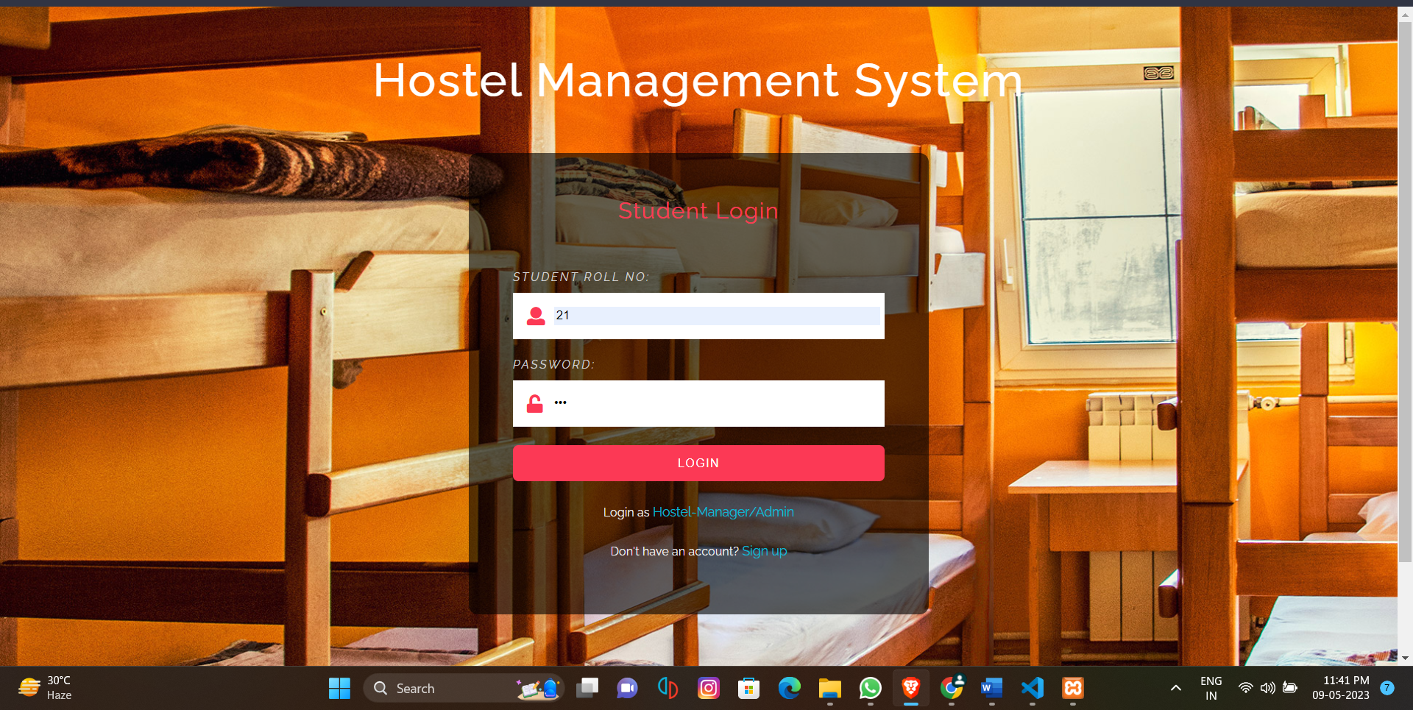

1. **SIGN UP:**

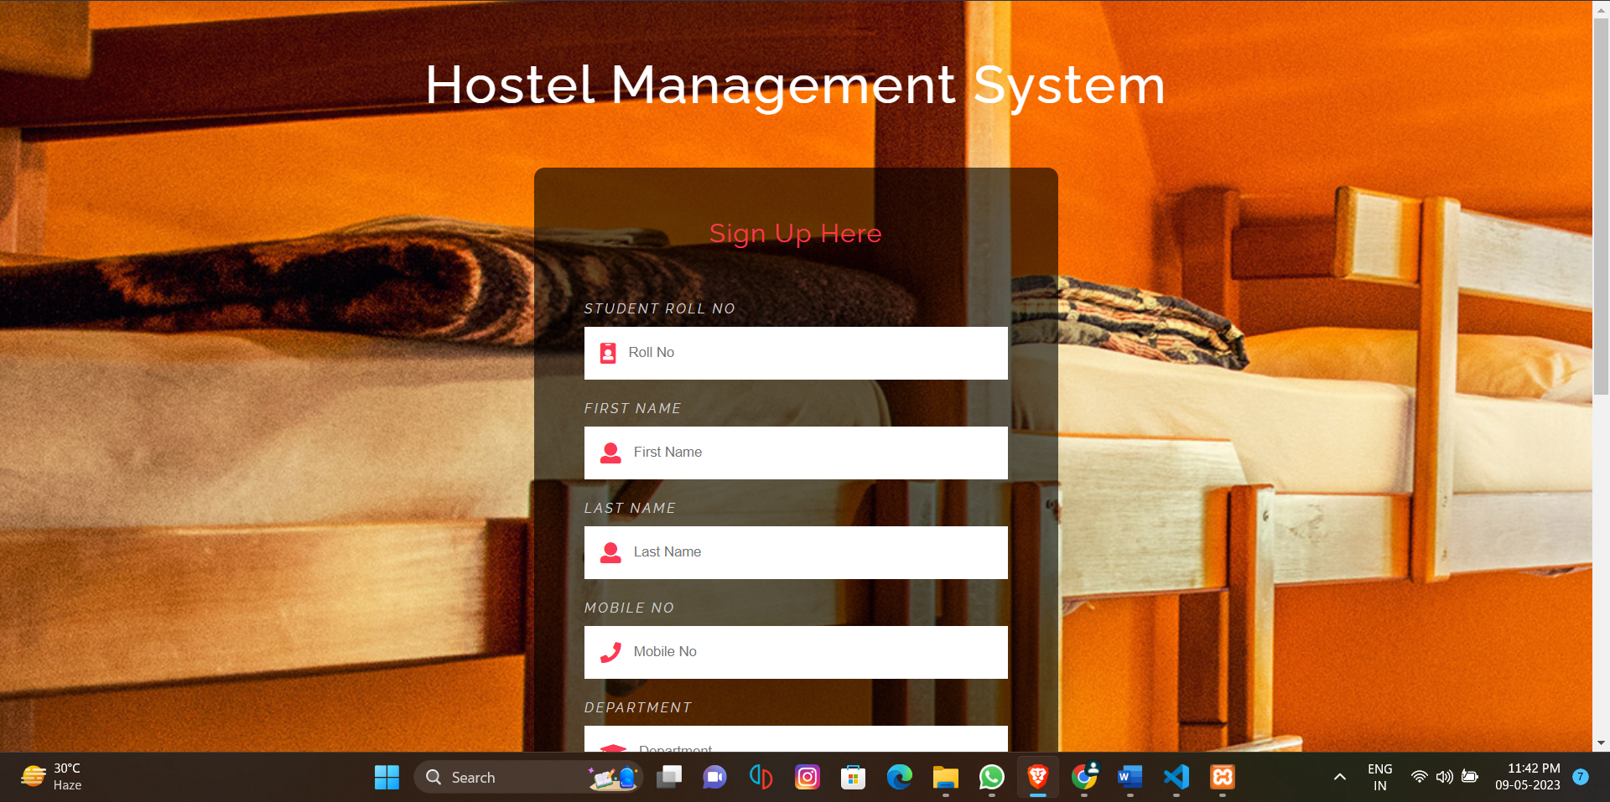

1. **ADMIN LOGIN**

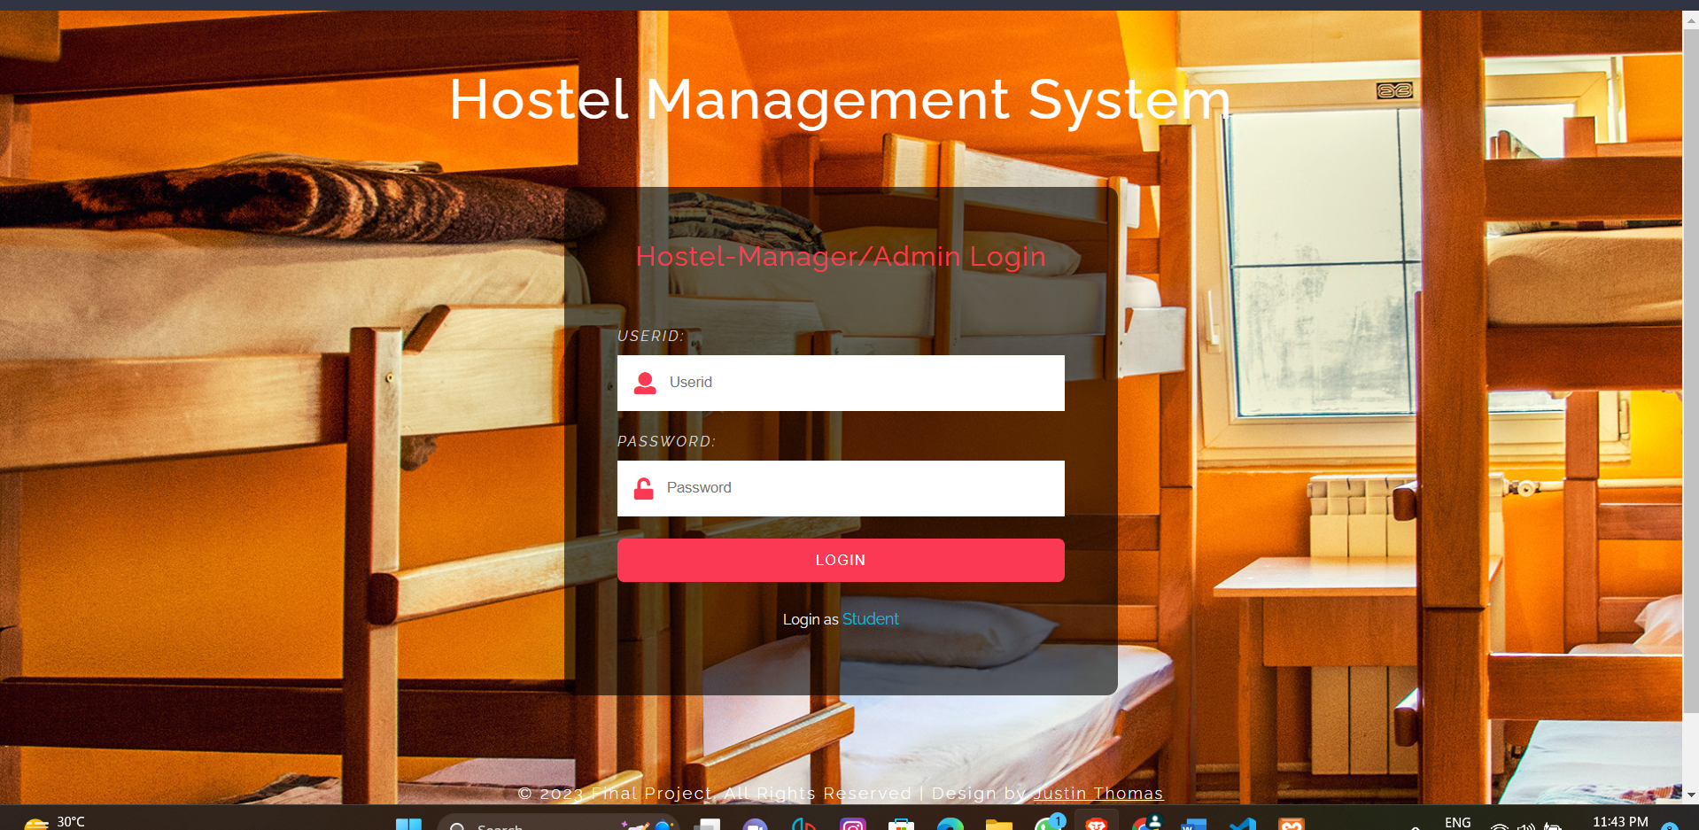

1. **HOME**

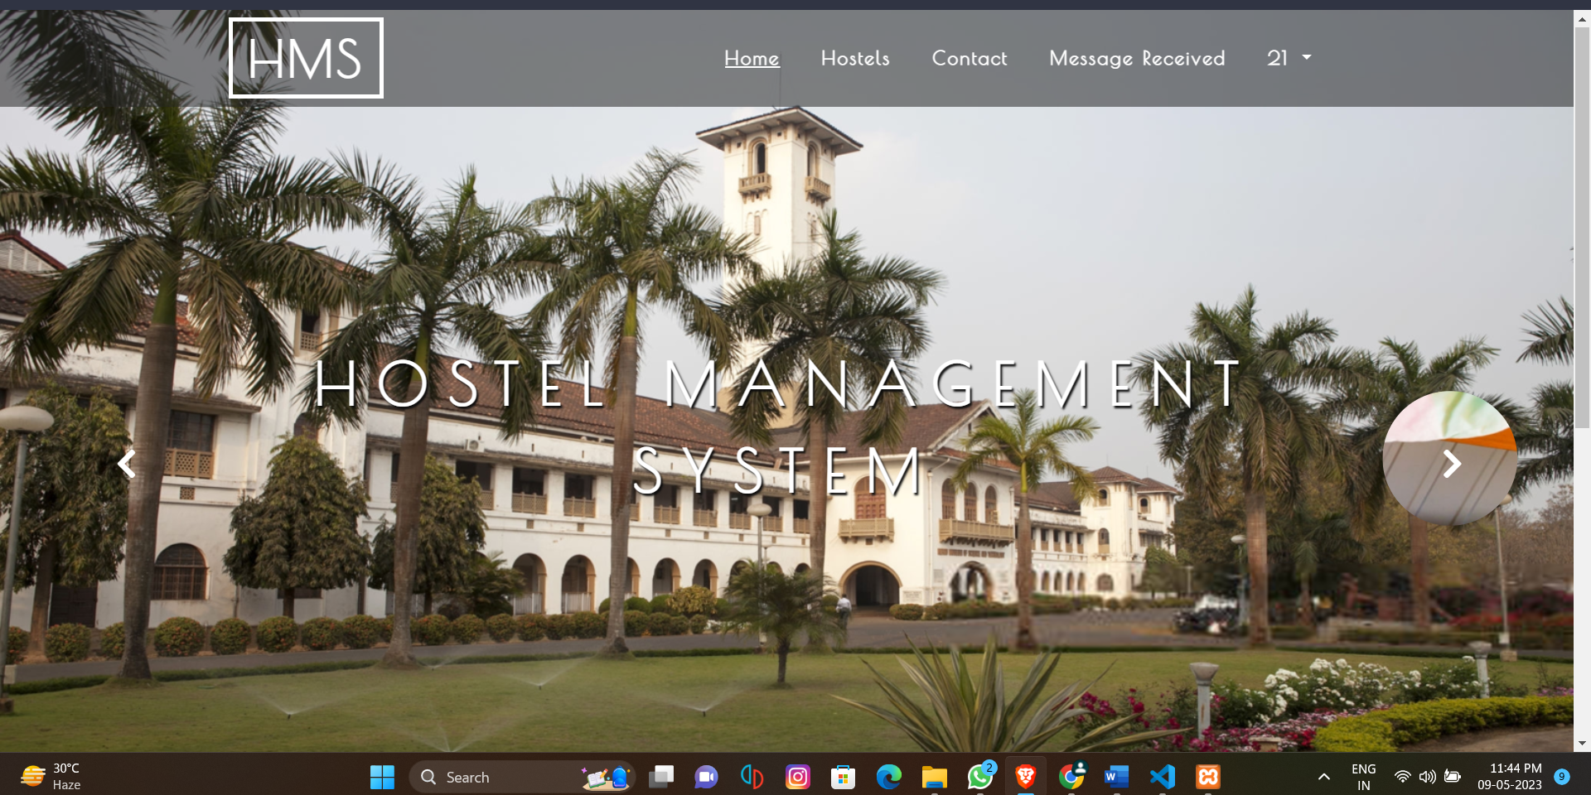

1. **HOSTELS**

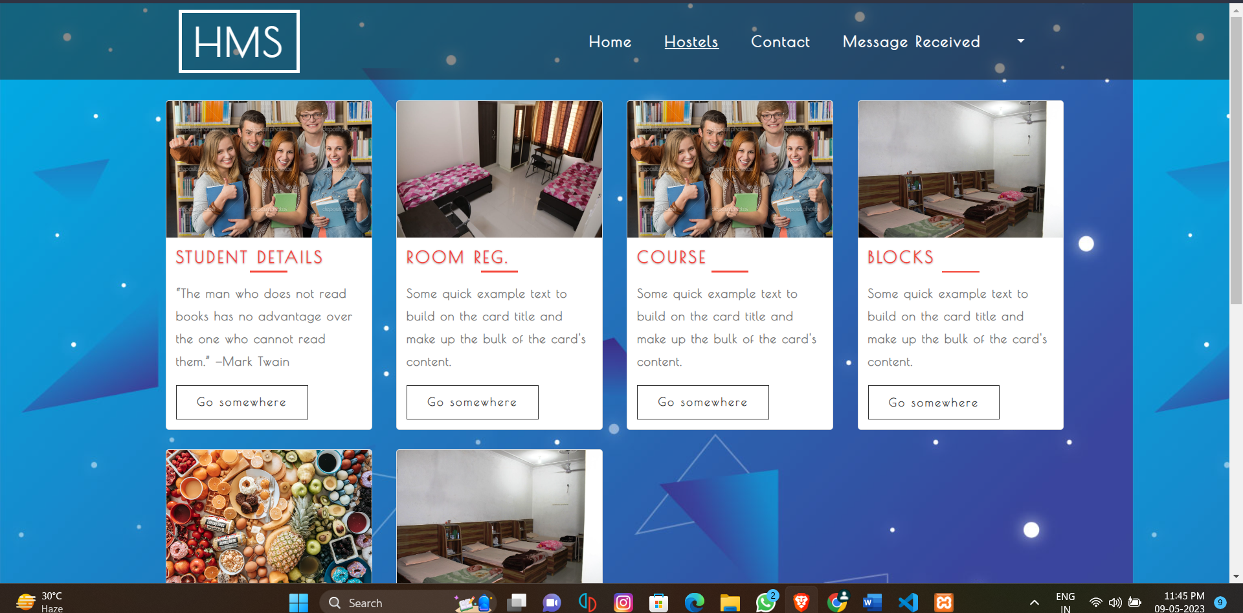

1. **STUDENT REGISTRATION**

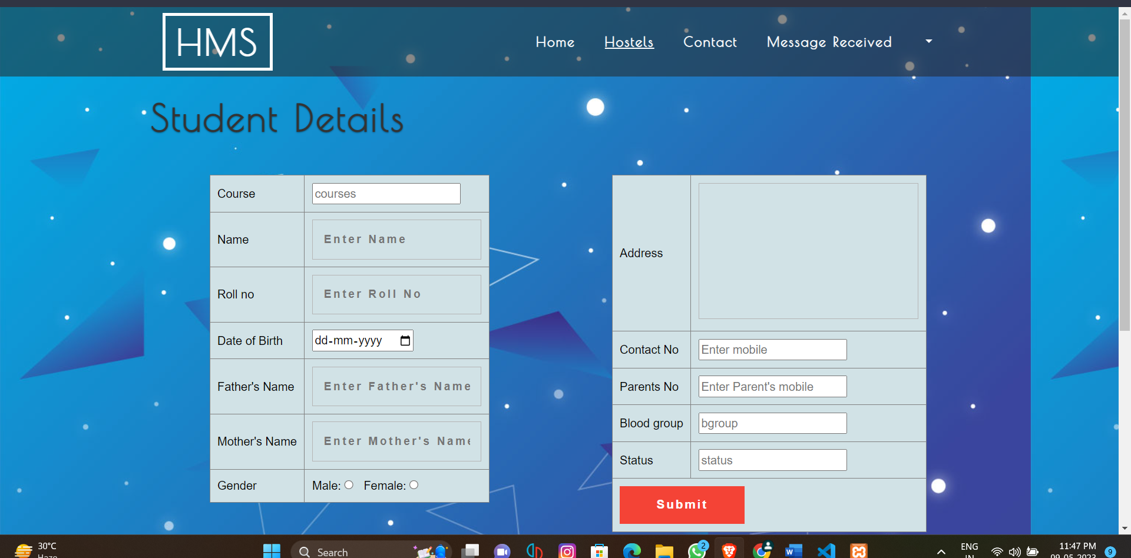

1. **ROOM REGISTRATION**

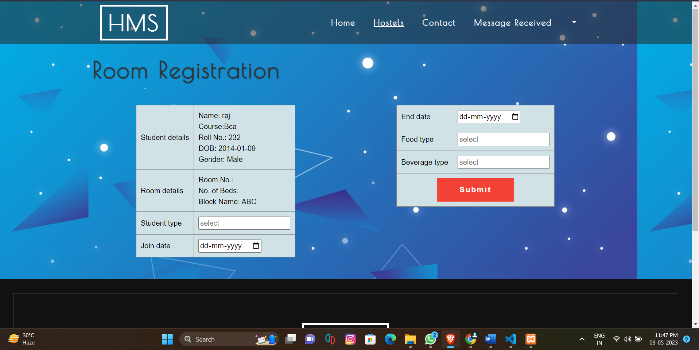

1. **COURSE DETAILS**

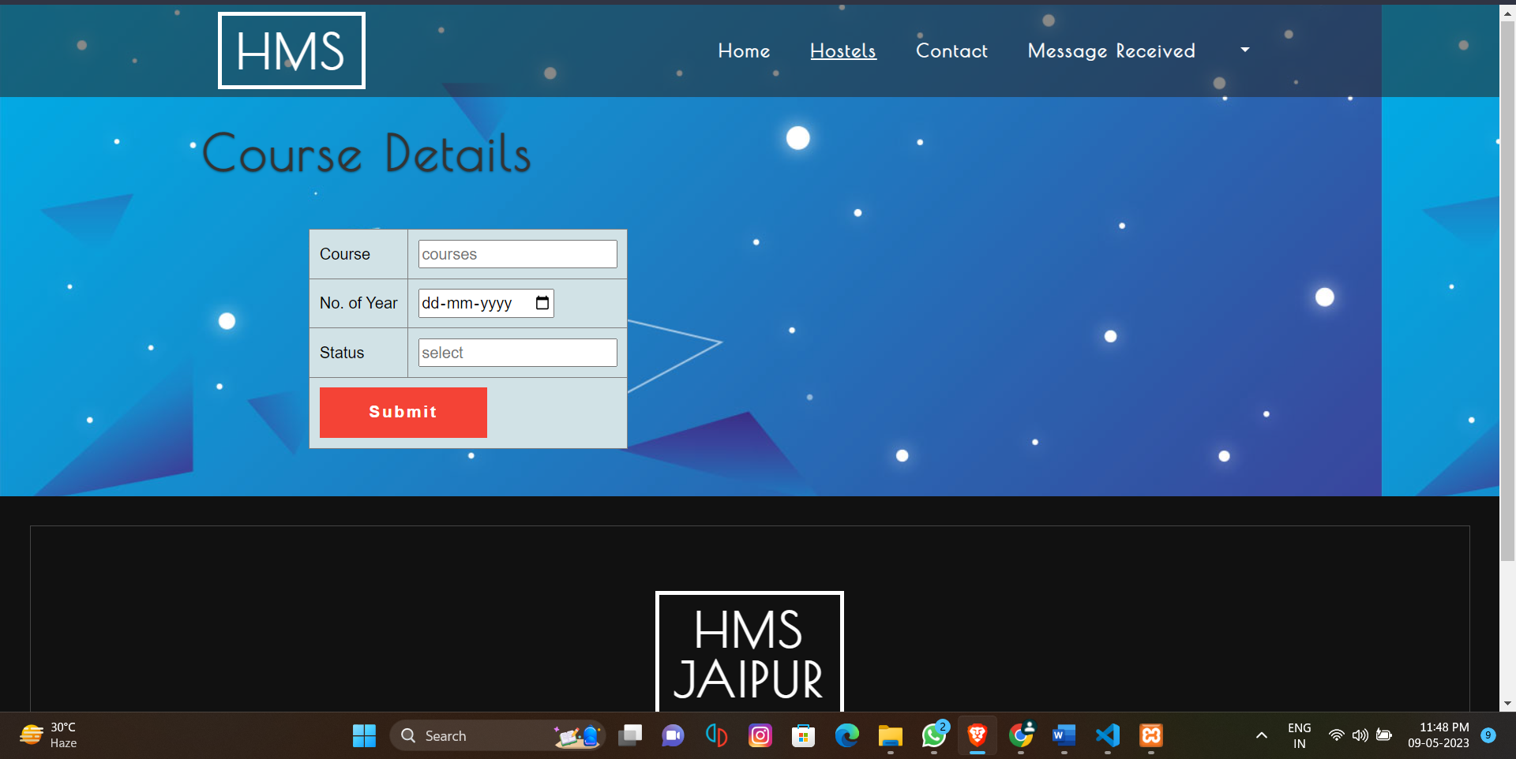

1. **SEAT BLOCKED**

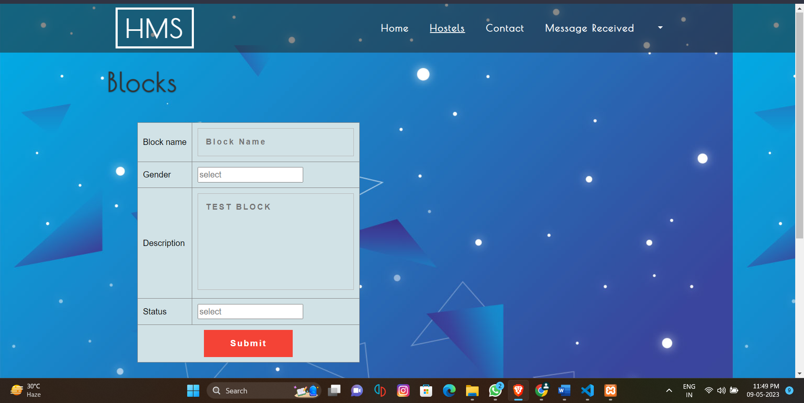

1. **MESSCARD DETAILS**

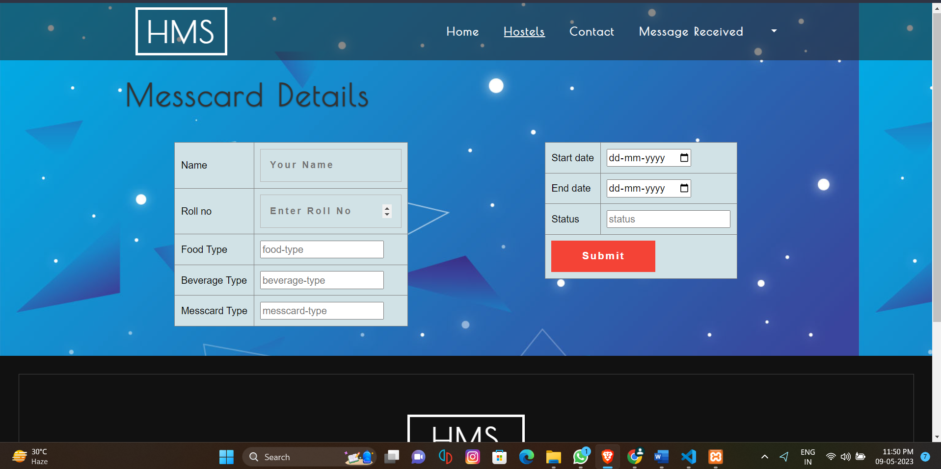

**11. CONTACT**

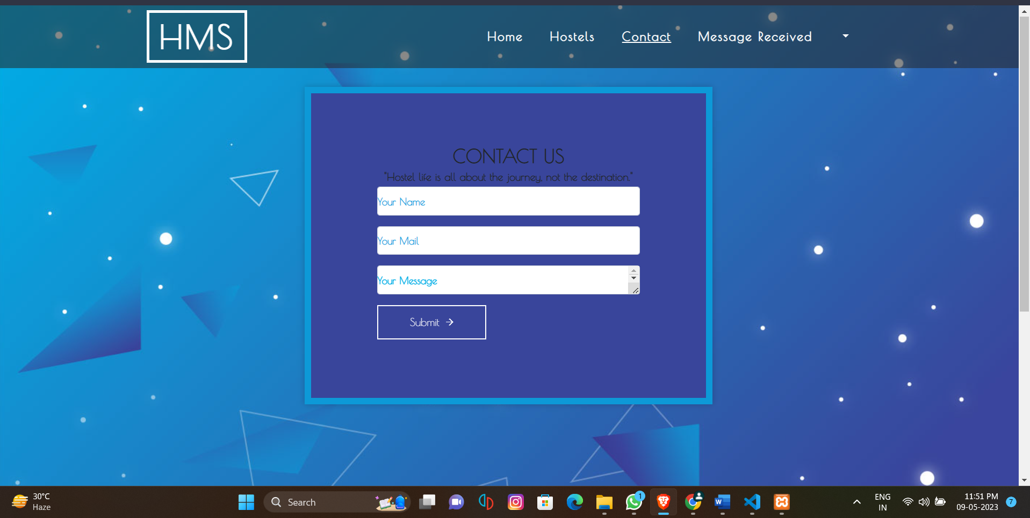

**12. PROFILE**

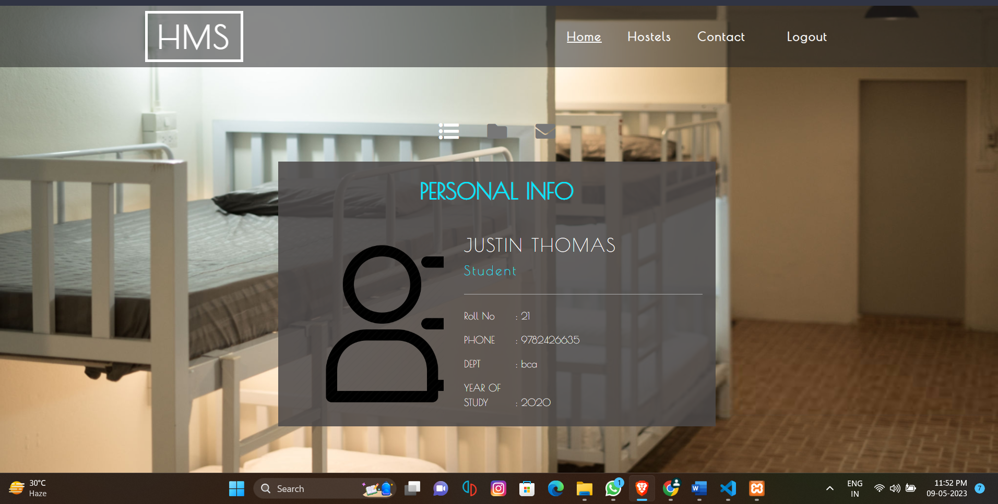

**13. ADMIN HOME PAGE**

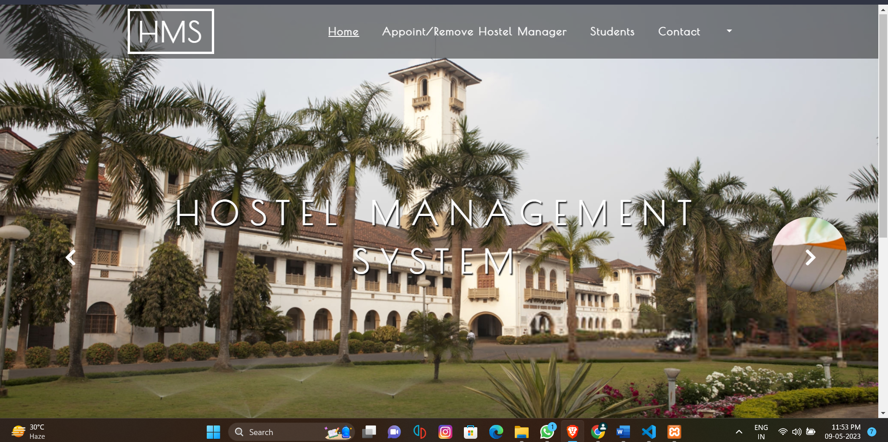

**14. MANAGER APPOINT AND REMOVE**

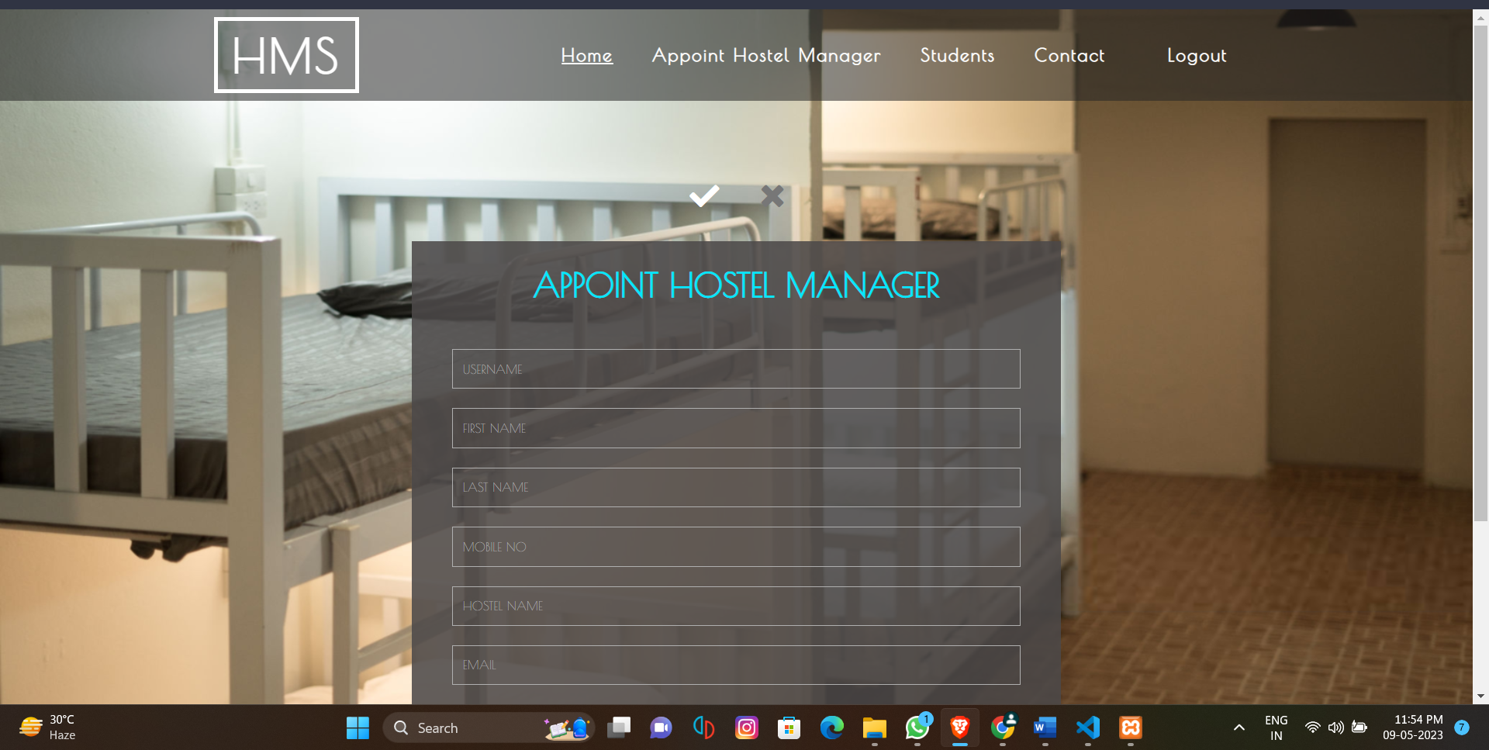

**15. VIEW STUDENT DETAILS**

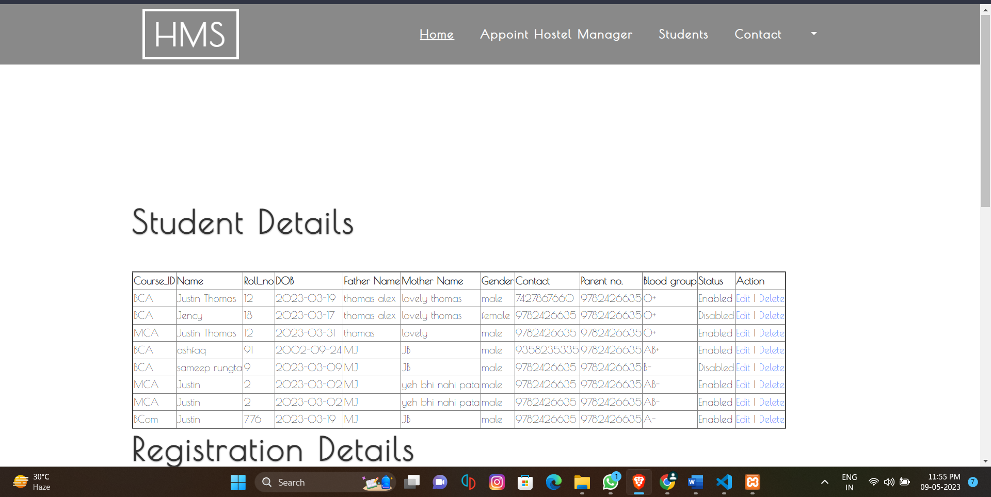

**16. ADMIN PROFILE**

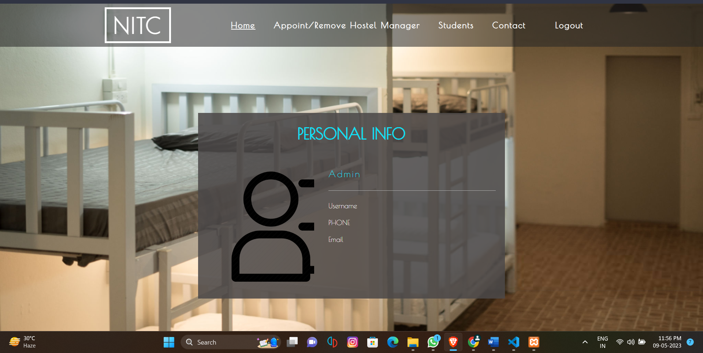

# CHAPTER 9: REFERENCES/BIBLIOGRAPHY

    [*https://edu.google.com/intl/ALL_us/code-with-google*](https://edu.google.com/intl/ALL_us/code-with-google)

    [*https://developer.android.com/design/get-started/principles.html*](https://developer.android.com/design/get-started/principles.html)

    [*https://Javaprograms·GitHubTopics·GitHub*](https://Javaprograms·GitHubTopics·GitHub)

    *https://ebookcentral.proquest.com/lib/qut/detail.action?docID=255361*

    [*https://github.com/scaleracademy/MC-JS-BootCamp-09OCT2022*](https://github.com/scaleracademy/MC-JS-BootCamp-09OCT2022)

    [*https://academy.pega.com/topic/app-studio/v1*](https://academy.pega.com/topic/app-studio/v1)

    [*https://www.bing.com/search?q=basic+vscode+extensions&qs=SC&pq=basic+vs+c ode&sk=SC1&sc=10*](https://www.bing.com/search?q=basic+vscode+extensions&qs=SC&pq=basic+vs+c%20ode&sk=SC1&sc=10-%20)

    [*https://www.programiz.com/C++Examples/Programiz*](https://www.programiz.com/C++Examples/Programiz)

    [*https://www.programiz.com/C++Standard_Library/Programiz*](https://www.programiz.com/C++Standard_Library/Programiz)

------------THE END------------